TRAINING SUPPORT PACKAGE (TSP)

TSP Number 158-E-1361

Title Develop a Unit Counseling Program

Task Number 158-100-1361
Title Develop a Unit Counseling Program

Effective 10 November 2005
Date

Supersedes TSP 158-E-1361 dated 1 September 1999
TSP(s)

TSP User Use this TSP in the Captains Career Course and Warrant Officer Advanced Course.

Proponent The proponent for this document is the Center for Army Leadership, U.S. Army Command and General Staff College, 250 Gibbon Avenue, Fort Leavenworth, KS 66027-2314.

Comments/ Send comments and recommendations directly to: Commandant, U.S. Army Command Recommen- and General Staff College, 250 Gibbon Avenue, Fort Leavenworth, KS 66027-2314
dation

Foreign This product has been reviewed by the product developers in coordination with the Fort
Disclosure Leavenworth (PMO Security Office) foreign disclosure authority. This product is Restrictions releasable to military students from all requesting foreign countries without restrictions.

PREFACE

Purpose This training support package provides the instructor with a standardized lesson plan for presenting instruction for:

Task number: | 158-100-1361
Task title: | Develop a Unit Counseling Program
Conditions: | While performing duties as a company commander or leader in a company level organization, you determine that you need to assess your unit's current counseling program.
Standard: | Developed unit counseling program which sustained or improved the program IAW Student Handout, The Unit Counseling Program (Appendix D), FM 22-100, Appendix C, The Leadership Developmental Review and Developmental Counseling (1999 version) and the Army Mentorship Handbook (2005 version).

This TSP
contains
TABLE OF CONTENTS
Page
Lesson | Preface | 2
Plan | Section I - Administrative Data | 3
 | Section II - Introduction | 6
 | Terminal Learning Objective - Develop a Unit Counseling Program | 6
 | Section III - Presentation | 9
 | A - Enabling Learning Objective A - Describe Developmental Counseling as outlined in FM 22-100 (1999 version), Appendix C. | 9
 | B - Enabling Learning Objective B - Identify a company level leader's responsibility in establishing or maintaining a unit counseling program. | 19
 | C - Enabling Learning Objective C - Identify the effects of a counseling program on the organization. | 22
 | D - Enabling Learning Objective D - Assess the unit counseling program. | 23
 | E- Enabling Learning Objective E- Define the roles of leaders in the unit counseling program. | 30
 | F - Enabling Learning Objective F - Develop a group plan to sustain or improve the unit counseling program. | 33
 | Section IV - Summary | 35
 | Section V - Student Evaluation | 36
Appendixes | A - Viewgraph Masters | A-1
 | B - Test and Test Solution | B-1
 | C - Practical Exercise/Solution | C-1
 | D - Student Handout | D-1

DEVELOP A UNIT COUNSELING PROGRAM
10 November 2005

SECTION I. ADMINISTRATIVE DATA

All Courses course number course title
Including This Captains Career Course (CCC)
Lesson Warrant Officer Advanced Course (WOAC)

Task(s) task number task title
Taught or 158-100-1373 Develop Subordinate Leaders in a Company
Supported

Reinforced task number task title
Task(s) 158-100-1340 Communicate Effectively as a Unit or Staff Leader
158-100-1332 Establish a Positive Command Climate
158-100-1372 Build a Cohesive Unit or Organization

Academic The academic hours required to teach this course are as follows:
Hours
peacetime mobilization
hours/ methods hours/methods
01:00 / SA (out of class stu asgnmt) 01:00/SA (out of class stu asgnmt)
00:05 / LE 00:05 / LE
01:25 / CO 01:25 / CO
00:55 / PE 00:55 / PE
Test 01:00 / TE 01:00 / TE
Test Review NA NA
________________________________________________________________
Total Hours 03:25 hrs 03:25 hrs

Prerequisite lesson number lesson title
Lesson(s) 158-C-1332 Establish a Positive Command Climate
158-D-1340 Communicate Effectively as a Unit or Staff Leader
121-A-8020 Supervise Unit Personnel and Administration Functions

NOTE: FM22-100 is under revision and expected for publication as FM6-22 in Spring 2006. Instructors refer to FM6-22 when published. This class is an important prerequisite to Develop Subordinate Leaders in a Company instruction. The Develop a Unit Counseling Program instruction sets the doctrinal framework for developmental counseling based on FM 22-100, Army Leadership, Appendix C, The Leadership Development Review and Developmental Counseling. Students must be familiar with and understand the basic doctrinal counseling requirements (information is provided in the out of class student reading assignment) prior to participating in this class. The Develop a Unit Counseling Program TSP will reinforce the counseling requirements outlined in the Supervise Unit Personnel and Administration Functions TSP.

Clearance There are no clearance or access requirements for the lesson.
and Access:

References:
number | title | date | para  no | additional  information
FM 22-100 | Army Leadership | 1999 | Appendix C | Information is provided in the Student Handout until FM 22-100 is available.
 | "The Unit Counseling Program" | 1999 |  | Located in Student Handout
 | Army Mentorship Handbook | 1 Jan 05 | All | www.armyg1.army.mil/hr/MRC.asp

NOTE: IMPORTANT: Students must complete the precourse assignment (Student Handout) prior to beginning the instruction for this course. Below are options for insuring that students complete the precourse requirements.

Option1: Provide the Student Handout (Appendix D) to the student at least one day before the course begins. This could be handled as a preclass session or by having the student “pick up” the package at a designated location.

Option 2: Provide the student with the Student Handout at the beginning of the course. If this option is used, the required time must be accounted for in the course block. Students will need approximately 1 hour to complete the precourse requirement.

Student Students should read the Student Readings and complete the Note Taking Guide prior
Assignments to the course (Student Handout). (See options outlined above.)

Instructor One instructor is required for the course. The instructor must have an understanding of
Requirements counseling and counseling concepts/principles as outlined in FM 22-100 (1999 version). Specifically, the instructor must be familiar with Appendix C within FM 22-100 (1999 version). The instructor must also have an understanding of how to develop a unit counseling program. This reading is included in the Student Handout located in Appendix D.

Instructor Note: The elements of “Army Mentorship” are being inserted in to this TSP and other similar TSPs because of today’s current operational environment and an emphasis on mentorship from Senior Army Leadership (Secretary of the Army, the Chief of Staff of the Army, and the Sergeant Major of the Army). Mentorship is a powerful combat multiplier, the tip of the spear that enhances, accelerates, and supports the leader development that is being accomplished by the chain of command. The Army Mentorship Resource Center, www.armyg1.army.mil/hr/MRC.asp, and the Army’s AKO Mentorship Community (under Personnel Community) are two great resources available to instructors and students to help facilitate the understanding of and the use of the mentorship program.

Additional None
Personnel
Requirements

Equipment Overhead projector and screen, chart pad and pens.
Required
for Instruction

Materials instructor materials: Viewgraphs or equivalent Power Point presentation, TSP,
Required student materials, Student Handout and FM 22-100 (1999 version).

student materials: Student Handout

Classroom One classroom.

Training Area
and Range
Requirements None

Ammunition None.
Requirements

Instructional Course Map:
Guidance 1. Instructor provides students with the Student Handout and a brief introduction to the task prior to the lesson. (As indicated in the options above, this can be accomplished by providing the materials at least one day prior to the class or as the first part of the course. If the materials are presented at the beginning of the course, the time required must be reflected in the course requirements.)

2. Prior to the beginning of the actual instruction, students read the student readings and complete the Student Note Taking Guide. (See Student Handout, Appendix D.)

3. The instructor facilitates a discussion on the fundamentals of counseling, the company level leader’s role in developing the unit counseling program and the importance of the unit counseling program using viewgraphs or PowerPoint presentation.

4. The instructor assigns students to a small group and provides each group the scenario from Appendix C. Each group follows the instruction on the scenario and develops a unit counseling plan. A sample evaluation for the practical exercise is at Appendix C. Each group presents its plan to the group. The instructor and other students provide feedback to the presenters.

5. As the final examination, the instructor will provide each student the counseling program scenario from Appendix B. Each student will develop a unit-counseling plan based on the situation provided. Specific requirements and the final examination are at Appendix B.

6. Instructors use the instructor evaluation notes in Appendix B, the Student Handout (Appendix D), and their leadership experience to evaluate the student’s unit counseling plan. Students must obtain 75 points on the final examination in order to receive a “GO” for the course. See evaluation discussion for further information.

Proponent NAME RANK POSITION DATE
Lesson Mark R. French COL Director, CAL 10 Nov 05
Plan ______________________ ____ __________________________________
Approvals ______________________ ____ __________________________________

SECTION II INTRODUCTION

NOTE: Provide an introduction to the course and explain course requirements.

a. If the students are together prior to class or if the materials are handed out at the beginning of the course, you can use the introduction which follows.

b. If the students are not together prior to the course, the instructor should prepare a course introduction sheet to be handed out with the Student Handout.

Method of instruction: LE
Instructor to student ratio is: 1:16
Time of instruction: 00:05
Media used: Viewgraph #1

NOTE: Show VGT 1
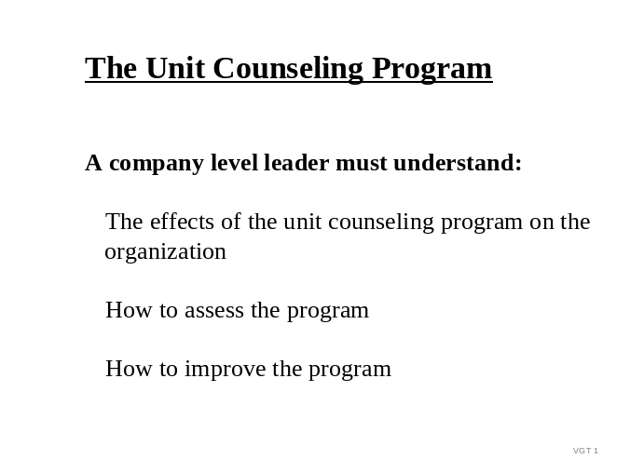

Motivator: Leaders in a company level organization must ensure that the unit has an effective counseling program. This responsibility does not lie solely in the hands of the first sergeant or the company commander. All company level leaders must understand the effects of counseling on the organization and seek to improve the unit counseling program. During this training, you will learn how counseling affects organizations and what you can do to develop and/or maintain an effective counseling program within your organization.

Terminal At the completion of this lesson, you [the student] will:
Learning
Objective

NOTE: Inform the students of the following terminal learning objective requirements.

Action: | Develop a Unit Counseling Program
Conditions: | While performing duties as a company commander, or leader in a company level organization, you determine that you need to assess your unit's current counseling program.
Standard: | Developed a unit counseling program which sustained or improved the program IAW Student Handout, "The Unit Counseling Program" (Appendix D) and Appendix C, The Leadership Development Review and Developmental Counseling of FM 22-100 (1999 version).

Safety None
Requirements

Risk Low
Assessment
Level

Environmental None
Considerations

Evaluation Instructors assign students the scenario in Appendix B. The students are required to develop a Unit Counseling Plan. The Unit Counseling Plan must include assessment, analysis, development, implementation and evaluation components based on the scenario provided. Instructors will grade the student products using evaluation suggestions found in Appendix B, the Student Handout (Appendix D), and their leadership experience.

Students must obtain at least 75 points on the final examination in order to receive a “GO” on the course.

Student participation in a course encourages understanding and retention of the material being presented. It is therefore suggested that in-class participation be included as part of the course evaluation process.

Students must receive a total score of 75 out of 100 possible points to receive credit for this task.

Points Final Grade
90-100 A
80-89 B
70-79 C
0 - 69 U

Grade scale Students will receive an “A” for attaining exceptional mastery of all standards for the course learning objectives.

Students will receive a “B” for achieving all standards for the course learning objectives.

Students will receive a “C” when they marginally meet all the standards for the course learning objectives.

Students will receive a “U” if they fail to achieve any standard for the course learning objectives.

Instructional When most leaders think of “a unit counseling program” they are usually
Lead-in concerned with whether or not the unit leaders are counseling their subordinates. This typically results in the leader “inspecting” counseling records which involves a review of records to either substantiate or refute the presence of a unit counseling program. However, it must be pointed out that an effective program is much more than reviewing counseling records--it is counseling the right individuals for the right reasons, at the right time and in the right manner. Evaluating and improving a unit counseling program is actually a complex task which requires an understanding of counseling principles and how counseling affects the unit.

SECTION III PRESENTATION

A. ENABLING LEARNING OBJECTIVE A

Action: | Describe developmental counseling as outlined in FM 22-100 (1999 version), Appendix C.
Conditions: | Given advance Student Handout (Appendix D) and in-class discussion.
Standard: | Accurately identified the tenets of effective counseling.

1. Learning Step/Activity 1: Students complete the Student Handout requirements prior to beginning the course (reading and Student Note Taking Guide).

Method of instruction: SA (Completed prior to the beginning of course)
Instructor to student ratio is: 1:16
Time of instruction: 01:00 (This is out of class time. If this step is conducted at the beginning of the course, the time should be reflected in the course hours.)
Media: Student Handout

2. Learning Step/Activity 2: Discuss the fundamentals of Developmental Counseling.

Method of instruction: CO
Instructor to student ratio is: 1:16
Time of instruction: 00:25
Media: Viewgraphs #2-15

Instructor note: Learning step/activity 1 is designed to provide students the knowledge required for this ELO. Learning step/activity 2 is designed to give students the opportunity to discuss the topics, surface questions and acquire a deeper understanding of the ELO. Appendix A contains the viewgraphs. Copies of the viewgraphs and notes for the instructor to use in facilitating the discussion are included in the TSP. In addition to the suggested comments and questions provided, the instructor should prepare questions to facilitate further understanding of the material/information covered and long-term retention and use of that information.

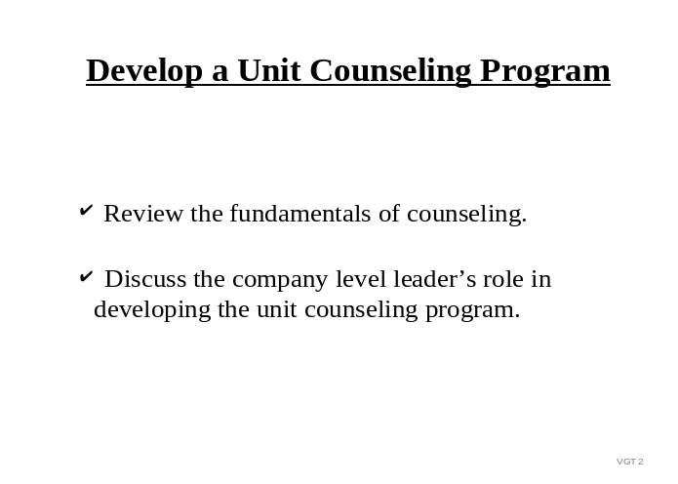 SHOW VGT 2: Develop a Unit Counseling Program

Before leaders can assume responsibility for unit counseling programs, they must first understand the fundamentals of counseling. In this training, we will review the fundamentals of counseling and then discuss a company level leader's role in improving the unit counseling program.

SHOW VGT 3: Counseling
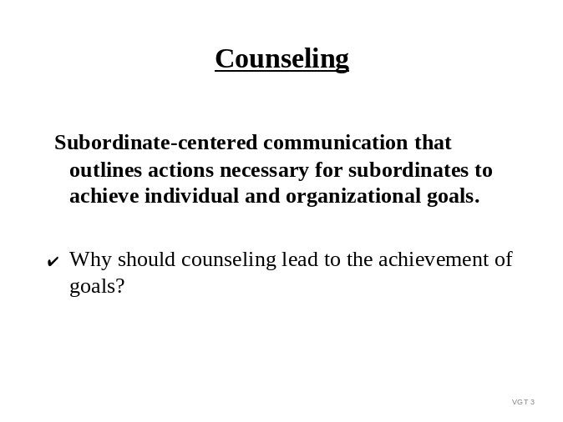

Question: Why should counseling lead to the achievement of goals?

Possible response: Counseling is a type of communication which leaders use to empower subordinates to achieve goals. It is much more than providing feedback or direction. It is communication aimed at developing a subordinate’s ability to achieve goals. Without a goal in mind, or a clear understanding of the goal, counseling may lack focus; the counseling may simply be “conversation”.

SHOW VGT 4: Counseling Cycle Continuous Process

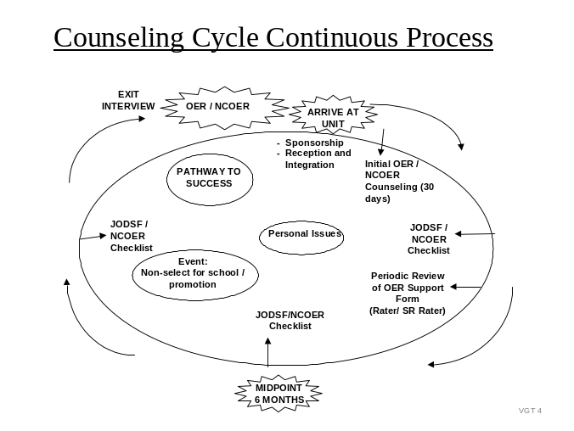
Counseling is a continuous process that starts when the soldier arrives at the unit and continues throughout the soldier’s time within the unit. The final counseling a soldier receives is during his/her exit brief.

Question: Are there other times besides those listed above when you should counsel your subordinates? (Responses will vary)

SHOW VGT 5: Subordinate-Centered (Two-Way) Communication
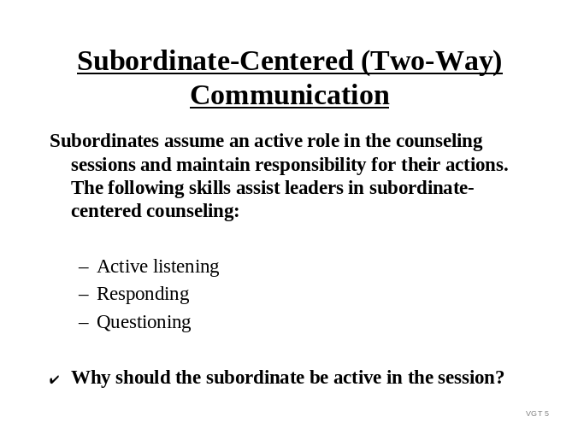

Question: Why should the subordinate be active in the counseling session?

Possible response: Subordinate-centered communication is simply a style of communicating where the subordinate is not a passive listener, but a vital contributor in the communication process. The purpose of subordinate-centered communication is to allow the subordinate to maintain control and responsibility for the issue. This type of communication, where the subordinate plays an active role, takes longer than directive or leader-centered communication. However, subordinate participation is necessary for effective subordinate development. Counseling is not simply imparting directions or giving advice.

The following skills are helpful in maintaining a subordinate-centered session:

Active Listening: Give full attention to subordinates; listening to their words and the way they are spoken. Notice voice tone, eye contact, facial expression and appearance. Transmit an understanding of message through responding.

Responding: Use appropriate eye contact and gestures. Check understanding without talking too much; summarize, interpret and question.

Questioning: Serves as a way to obtain valuable information and get subordinates to think. The majority of questions should be open-ended and structured so that the information received really relates to the session at hand. For example “What position would you like to hold in 2 years?”

SHOW VGT 6: The Leader as Counselor
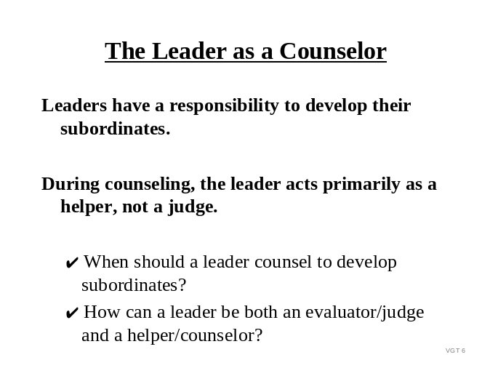
Question: When should a leader counsel to develop subordinates?

Possible response: Leaders often contort the meaning of “counseling” and consider routine feedback and communication “counseling”. Counseling is much more than telling a subordinate how they are doing. Performed correctly, it can be a time consuming endeavor and for that reason, leaders need to plan for and schedule counseling. Minimum counseling requirements are outlined in both the officer and noncommissioned officer evaluation systems. Additionally, command policies typically require quarterly or monthly counseling for all soldiers within the command.

Several programs have counseling requirements associated with them (i.e. reenlistment, family care plan). Under these circumstances, the decision to counsel is made for the leader and the leader simply executes. However, there are also times when a leader is not required to counsel, but chooses to counsel. Whenever there is a need for focused two-way communication aimed at subordinate development, a leader should counsel. Counseling should not be reserved for circumstances involving poor performance or problems. Noting and reinforcing good performance is a very effective way to ensure that positive behavior continues.

Question: How can a leader be both an evaluator/judge and a helper/counselor?

Possible response: It is challenging for a leader to act as both the evaluator and counselor for the subordinate. The best way to assume the role of helper versus evaluator during the counseling session is to be open and honest with the subordinate. There are several leader qualities which can assist the leader in assuming the role of a helper.

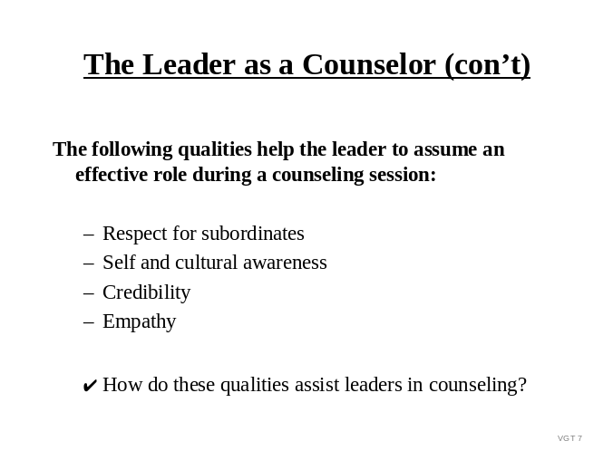SHOW VGT 7: The Leader as Counselor (cont)

Question: How do the qualities listed above assist leaders in counseling?

Possible response: It is difficult to achieve meaningful communication without first exhibiting the qualities listed on this slide. I’m sure most of us would agree that we would not be open to listen to a leader whom we felt did not respect us, tried to project his values onto us, was not honest, and did not understand our situation.

We will be going in to more detail about cultural awareness during the next ELO.

SHOW VGT 8: The Reason for Counseling

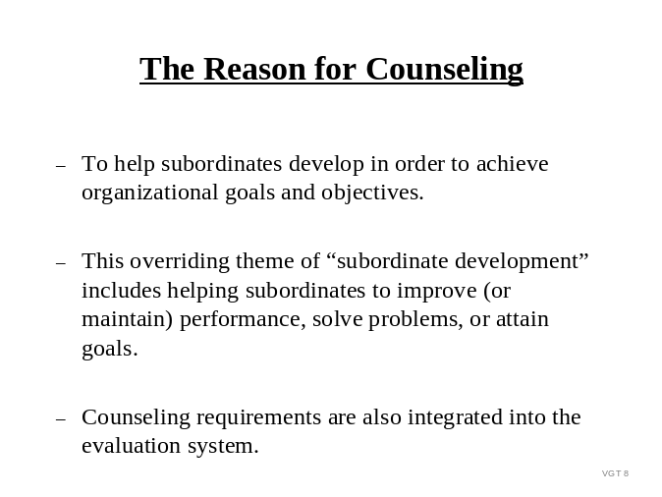As we stated earlier, the main reason for developmental counseling is to assist subordinates in their development in order to achieve individual and organizational goals and objectives. Oftentimes, counseling is directed by regulation (for example, family care plan, and overweight counseling requirements) or local policy (mandatory monthly performance counseling for SPC and below).

While the reason for counseling is to develop subordinates, leaders often categorize counseling based on the topic of the session.

The two general types of counseling are Event-oriented and Performance/Professional Growth.
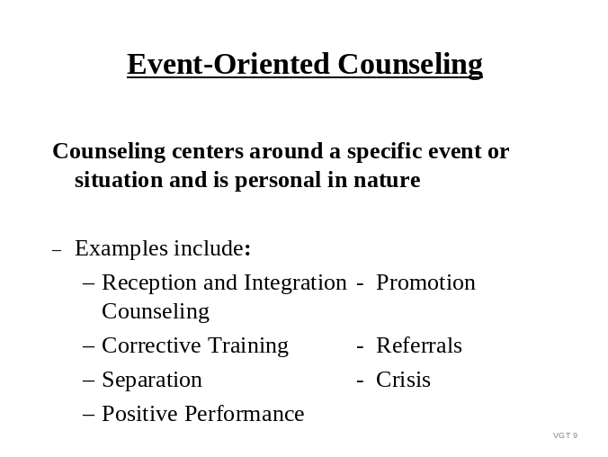
SHOW VGT 9: Event-Oriented Counseling

Question: What is event-oriented counseling?

Possible response: Event-oriented counseling involves counseling a subordinate on a specific event or situation. It may precede events, such as going to a promotion board or attending a school; or it may follow events, such as a noteworthy duty performance, a problem with performance or mission accomplishment, or a personal problem. Some examples of event-oriented counseling are listed on this slide.

SHOW VGT 10: Performance Counseling
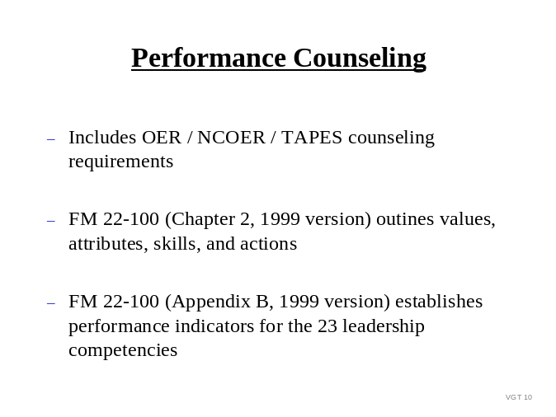
Question: How do you describe performance counseling?

Possible response: During performance counseling, the leader communicates his/her assessment of the subordinate’s duty performance during a certain period. The leader and subordinate should jointly establish objectives and performance standards for the next period. Rather than dwelling on the past, leaders should focus the session on the subordinate’s strengths, areas needing improvement, and potential.

Question: How is counseling integrated into the evaluation system?

Possible response: Counseling at the beginning of and during the evaluation period facilitates the subordinate’s involvement in the evaluation process. Performance counseling communicates standards and is an opportunity for leaders to establish and clarify the expected values, attributes, skills, and actions. Part IV (Leader Attributes/Skills/Actions) of the OER Form (DA Form 67-9) serves as an excellent tool for leaders doing performance counseling. For lieutenants and warrant officers only, the major performance objectives on the OER Support Form are used as the basis for determining the developmental task on the Junior Officer Developmental Support Form. Quarterly face-to-face performance and developmental counseling is required for these junior officers as outlined in AR 623-105.

SHOW VGT 11: Professional Growth Counseling

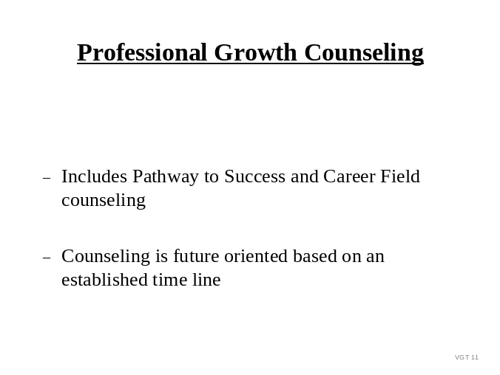
Question: Describe professional growth counseling:

Possible response: As part of professional growth counseling, a leader may choose to discuss and develop a “pathway to success” with the subordinate. This future-oriented counseling establishes near- and long-term goals and objectives. The discussion may include opportunities for civilian or military schooling, future duty assignments, special programs, and reenlistment options. Every person’s needs are different, and leaders must apply specific courses of action tailored to each soldier.

Career field counseling is another type of professional growth counseling. Career field counseling is required for lieutenants and captains prior to attending the major's board. Raters and senior raters, in conjunction with the rated officer, need to determine where the officer's skills best fit the needs of the Army. During career field counseling, consideration must be given to the rated officer's preference and his abilities (both performance and academic). The rater and senior rater should discuss career field designation with the officer prior to making a recommendation on the rated officer's OER.

SHOW VGT 12: The Stages of a Counseling Session
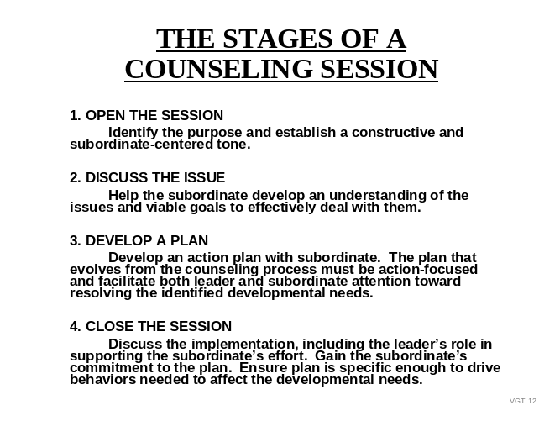

Regardless of the type of counseling session, this slide outlines the four basic phases of a counseling session that guide the leader as he/she conducts the counseling session. Let’s take a closer look at stages 3 and 4

SHOW VGT 13: Develop a Plan of Action
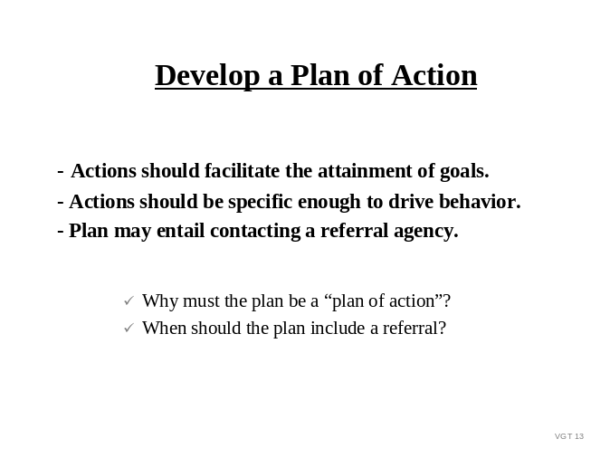

Instructor Note: Stages 1 and 2 are covered in the Student Handout.

Question: Why must the plan be a “plan of action”?

Possible response: A plan of action is simply a plan which addresses the intended actions to achieve the desired result. The plan is what the subordinate must do to achieve the agreed upon goal, whether it be to improve or maintain performance, solve a problem or attain a career goal. Counseling is just “talk” unless there is a plan to energize “good intentions” into action. A plan of action must include measurable, specific tasks that outline specific requirements that the subordinate must achieve in order to work towards completing the agreed upon objective.

Question: When should the plan include a referral?

Possible response: Sometimes the leader will not have the expertise or the resources to assist an individual soldier work through a personal situation or unique situation. In these situations, the leader should recognize his limitations and after assisting the subordinate in identifying the problem, refer the subordinate to an appropriate resource, such as those found on page D-8 in the Student Handout.

Instructor Note: Recommend you have the students refer to the Student Handout, page D-8 to review the referral list. Answer any questions they have on particular services an agency provides.

SHOW VGT 14: Record and Close the Session
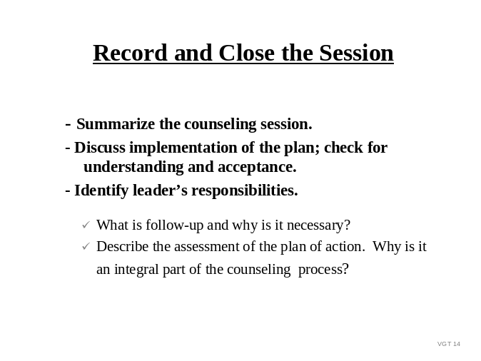

Question: What is follow-up and why is it necessary?

Possible response: The leader’s responsibilities after the counseling session are a very important part of the counseling process. It includes the leader’s support throughout the implementation of the plan and observation and assessment of the plan. Leaders can support the subordinate in many ways: teaching, coaching, providing resources, such as time, equipment, training aids, etc.

Question: Describe the assessment of the plan of action step. Why is it an integral part of the counseling process?

During the assessment, the leader and subordinate review the plan of action to determine if the desired results were achieved. The assessment of the plan of action provides useful information for future follow-up counseling sessions.

SHOW VGT 15: Preparation for Counseling
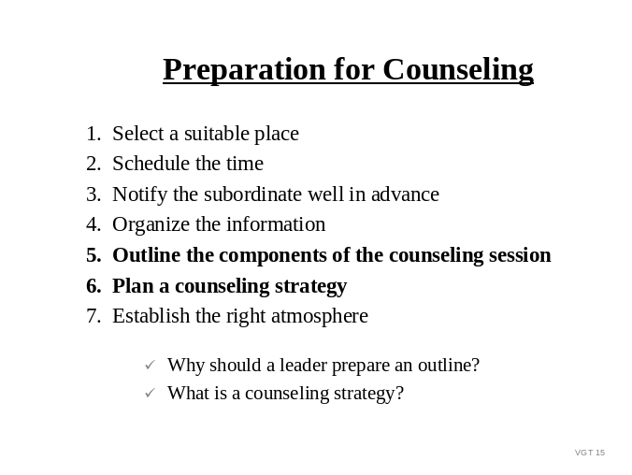

Question: Why should a leader prepare an outline?

Possible response: An outline forces you to think about the counseling. The outline should not be thought of as an additional requirement to make the process even more time consuming, but as an instrument to ensure that the counseling will be effective. In the process of outlining the counseling session, the leader should devote time to thinking about and making notes on the purpose of the session, points relevant to the issue, possible questions, possible actions, etc. With an outline, leaders will not forget to bring up key points, ask important questions or relate the issue to a goal. An outline is a way for you to ensure that you are well prepared for the counseling session.

In addition to preparing an outline, NCOER, OER, and JODSF counseling will also require you to review the leadership doctrine (FM 22-100).

Question: What is a counseling strategy?

Possible response: A counseling strategy is how the leader plans on developing the counseling session to achieve the intended results. Some subordinates readily participate in the counseling, while others resist involvement. Some subordinates will want to dispute every statement while others will readily agree to anything. Some will understand hints and the leader’s intent, while others will need things explicitly stated. It is difficult to know how subordinates will react to each counseling. Base your strategy on the personality of the subordinate and the nature of the issue. Although you should prepare a counseling strategy, you must be prepared to adjust that strategy as the counseling session develops and you are provided more information.

Instructor Note: Summarize ELO A:

Leaders who are new to the job are sometimes uncomfortable confronting a subordinate who is not performing to standard. Remember that counseling is not about how comfortable or uncomfortable you are; counseling is about developing and/or maintaining the character of the subordinate. Therefore, be honest and frank with your subordinates during developmental counseling. Your comfort level is far down on the priority list. If you let your people get away with substandard behavior because you want them to like you or because you are afraid to make a hard call, you are sacrificing Army standards for your personal welfare – and you are not developing your subordinates.

Instructor Note: Ask the students if they have any questions; answer the students' questions and concerns and then move on to ELO B.

B. ENABLING LEARNING OBJECTIVE B

Action: | Identify a company level leader’s responsibility in establishing or maintaining a unit counseling program.
Conditions: | Given advance Student Handout (Appendix D) and in-class discussion.
Standard: | Identified that cultural awareness is an important leader attribute IAW FM 22-100, Chapter 2 and is an important leader attribute needed for a successful unit counseling program.

1. Learning Step/Activity

Method of instruction: CO
Instructor to student ratio is: 1:16
Time of instruction: 00:15
Media: Viewgraphs # 16-19

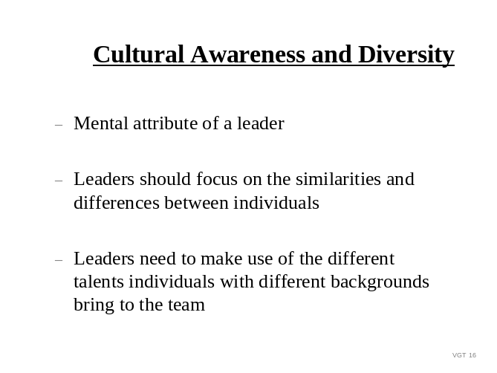SHOW VGT 16: Cultural Awareness and Diversity

The company level leadership needs to ensure that subordinate leaders are maintaining cultural awareness and ensure that all counseling sessions are individualized and geared towards the subordinate’s needs.

Culture is the sum total of beliefs, values and assumptions about what is important that may be shared by groups of people. Within the Army, soldiers come from widely different cultures that were shaped by their schooling, their ethnic background, their religion, and a host of other influences. Even though they share the same Army values, an African American woman from rural Texas will look differently at many things compared to, say, a third generation Irish-American man who grew up in Philadelphia or a Native American man from the Pacific Northwest. Leaders must keep these points in mind as they counsel their subordinates.

However, it is critical to remember that not only must YOU be aware of cultural issues which influence the behaviors and beliefs of your subordinates, but you must also be aware of YOUR OWN cultural background and how that influences your views towards, and beliefs about, others. For example, your own religious, ethnic, race, gender, or place of origin colors how you relate to and view others. As a leader, you must be aware of your own cultural biases and how they can influence your actions.

Instructor Note: The following information is provided to assist you in discussing cultural awareness issues. Our values, beliefs, backgrounds, perceptions, insecurities, pride, and so on play a part in how we respond to others and how we treat others. All of these factors color our perceptions of others and influence how we interact with others. They form the basis for our stereotypes. It can't be emphasized enough; leaders must be aware of their own stereotypes so that these stereotypes don't overshadow their ability to be objective, contributing leaders.

But what is a stereotype? Our stereotypes are the fixed unchanging ideas about someone, some group, or something which may have little relationship to fact. Our stereotypes color the way we view others and can increase our biases, lower our expectations of groups we do not hold in high regard, or may increase the status we give those we view as “special” or “chosen.” Thus, our stereotypes can lead to discrimination in favor of a group we view as “good” or discrimination against a group we view as “less than” others.

The key to your cultural awareness is to recognize and work to correct your stereotypes. Your personal biases can affect the way you relate to others and can result in your giving recognition and rewards to those you positively stereotype while being less objective towards and penalizing or failing to reward those for whom you have negative stereotypes.

Instructor Note: A general psychology text will provide additional information on stereotypes and how they influence an individual’s actions.

SHOW VGT 17: Cultural Awareness Within the Unit Counseling Program
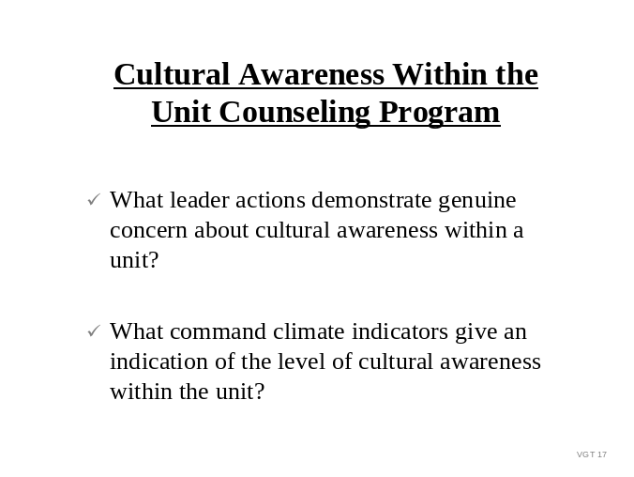

Question: What are some leader actions that demonstrate concern about cultural awareness within a unit?

Possible response:
- Genuine/active observing and listening to what is going on in the unit
- Involves getting out of the office and listening to soldiers - in the mess hall, motor pool, outside of your comfort zone and within theirs
- Building trust - don’t blow everything out of proportion and validate information prior to acting upon it
- Respect the subordinate’s perspective on the issue
- Reception and integration in-briefs can be used to build initial trust much more than a policy statement. Ask questions to get to know your soldiers (their backgrounds, unique situations, etc.)
- Valuing soldiers for being different and unique; finding the “good” qualities in everyone and maximizing these qualities
- Identify how your own cultural background affects your beliefs and actions. You may need to change some of your stereotypes.

Question: What are some command climate indicators that give an indication of the level of cultural awareness within a unit?

Possible response:
- Confederate flags being displayed
- Soldiers of one race always eating together in the mess hall
- Soldiers living in the barracks working longer hours than married/single soldiers
- Pornographic material being displayed in barracks rooms
- Inappropriate joke telling (spouse jokes, female jokes, ethnic jokes, etc.)
- Differences in performance expectations for males and females

SHOW VGT 18: Cultural Awareness Within the Unit Counseling Program (con’t)
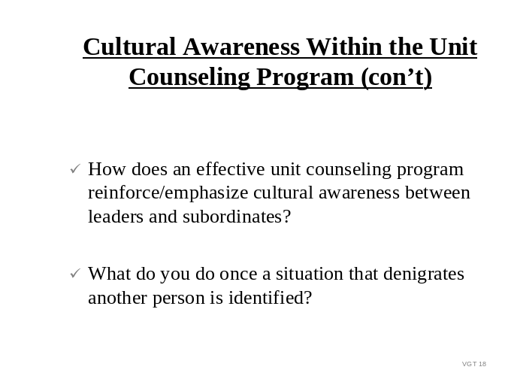

Question: How does an effective unit counseling program reinforce/emphasize cultural awareness between leaders and subordinates?

Possible response: An effective unit counseling program establishes an atmosphere of open, two-way communication in the unit. This openness encourages mutual respect between the leader and subordinate. The subordinate recognizes that the leader cares about him/her and his/her abilities and opinions and that he/she is respected as an individual.

Question: What should you do once a situation that denigrates another person is identified?

Possible response:
- Validate the information with another source, if possible
- Dispel rumors
- Respect the individual’s (who is making the complaint/observation) right to privacy
- If required, conduct a Commander’s Inquiry or AR 15-6 investigation
- Utilize agencies on post for assistance (IG’s office, Chaplain services, etc.)

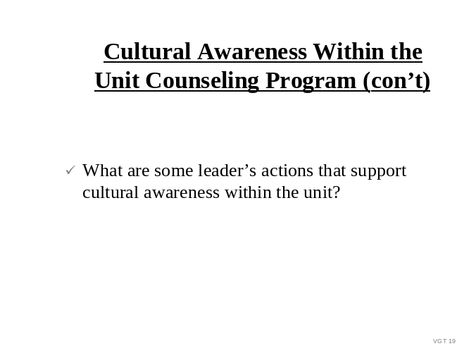SHOW VGT 19: Cultural Awareness Within the Unit Counseling Program (con’t)

Question: What are some leader’s actions that support cultural awareness within the unit?

Possible response:
- Command emphasis
- Enforcement: a policy that clearly articulates the commander’s intent
- Proper role modeling
- Ethnic and gender observances must be emphasized on the training schedule and soldiers must be given the time to attend (i.e. Martin Luther King Day in January; Black History Month in February; Women’s Month in March; Days of Remembrance in April; Asian Heritage Month in May; Women’s Equality Day in August; Hispanic Heritage Month in Sep/Oct; National Disabilities Awareness Month in October; Native American Heritage Month in November)
- Taking actions against offenders (includes investigations when appropriate). When an incident occurs, a leader's actions must be immediate; doing nothing is not an option because there are victims who must be provided support and there may be issues that will cause divisiveness if not resolved quickly.

C. ENABLING LEARNING OBJECTIVE C

Action: | Identify the effects of a counseling program on the organization.
Conditions: | Given advance Student Handout (Appendix D) and in-class discussion.
Standard: | Identify the effects of a counseling program on the organization IAW the Student Handout (Appendix D).

1. Learning Step/Activity

Method of instruction: CO
Instructor to student ratio is: 1:16
Time of instruction: 00:10
Media: Viewgraphs # 20-22

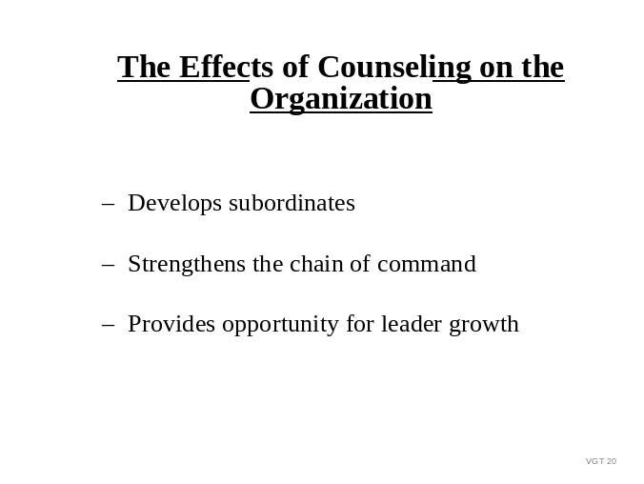SHOW VGT 20: The Effects of Counseling on the Organization

Question: Who in the organization benefits from an effective unit counseling program?

Possible response: Everyone in the organization benefits from an effective counseling program; subordinates receive help in improving performance, solving problems or achieving goals; leaders learn more about themselves and their subordinates; and the leader-subordinate relationship is strengthened.

SHOW VGT 21: A Unit Counseling Program Shoud
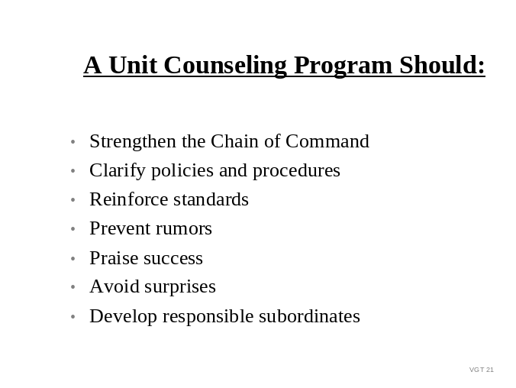

Counseling does not always achieve the effects listed on this slide. Clearly, a leader who counsels in a hurried and directive manner can weaken the senior-subordinate relationship and negate the positive aspects of the program.

SHOW VGT 22: Counseling and Leader Growth
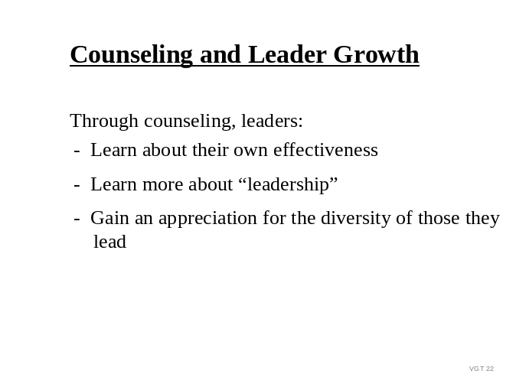

Question: What have you learned from counseling subordinates?

Possible response: Let students relate some personal experiences concerning ways they’ve grown through counseling.

Instructor Note: Emphasize that leaders must make a deliberate effort to learn from each counseling session. If subordinates have performance shortcomings or other problems, leaders should think about why the shortcoming exists or how the situation could have been avoided. Is the situation isolated or widespread in the unit? How can my leadership have a positive impact on the situation? The same sort of thought also applies in positive counseling situations. Each time leaders counsel they not only improve their skills as counselors but learn more about themselves and those they lead.

D. ENABLING LEARNING OBJECTIVE D

Action: | Assess the unit counseling program.
Conditions: | Given advance Student Handout (Appendix D) and in-class discussion.
Standard: | Assessed the unit counseling program IAW class discussion.

1. Learning Step/Activity 1

Method of instruction: CO
Instructor to student ratio is: 1:16
Time of instruction: 00:10
Media: Viewgraphs #23-28

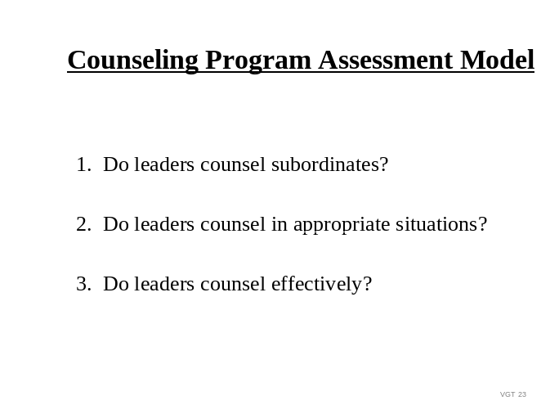SHOW VGT 23: Counseling Program Assessment Model

The three questions above help to form a “complete picture” of the unit counseling program. If a leader assesses the program without considering each of the questions, he/she is missing an important aspect of the counseling program.

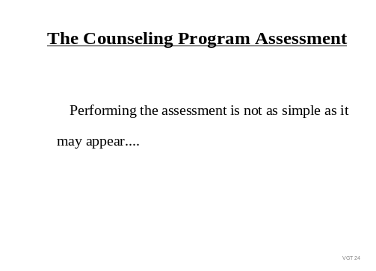SHOW VGT 24: The Counseling Program Assessment

Question: Why isn’t conducting an assessment of the unit counseling program simple?

Possible response: As an assessor of the unit counseling program, you must understand that the assessment questions do not have a single “correct” or “accepted” answer. In evaluating the counseling program, leaders must recognize the wide array of opinions and perceptions concerning counseling and expect these perceptions to be evident in the assessment. (e.g., During a recent company evaluation, part of the evaluation involved evaluating a unit counseling program. During the evaluation, a squad leader said that he frequently counseled his subordinate, while the subordinate said that he was never counseled.)

The squad leader and the subordinate have differing perceptions of “counseling.” The leader should not conclude that one of the individuals is lying or misrepresenting the truth.

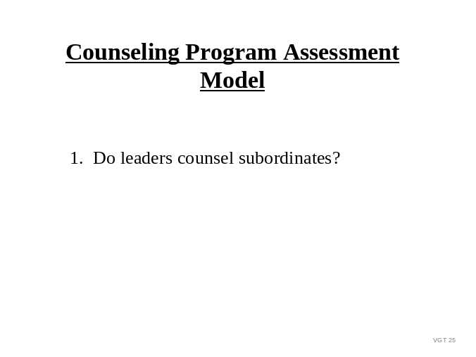SHOW VGT 25: Counseling Program Assessment Model

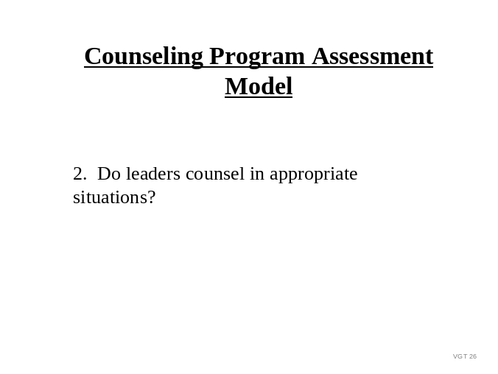SHOW VGT 26: Counseling Program Assessment Model

Instructor Note: Ask students to answer the question, “when should leaders counsel?”
With the responses, construct a list of situations to illustrate the many appropriate situations for counseling.
e.g. - NCO-ER / OER related counseling - reenlistment
- separation or bar to reenlistment - prior to promotion board
- prior to school - weight control
- family care plan - pregnancy

(You may get additional responses which are also correct.)

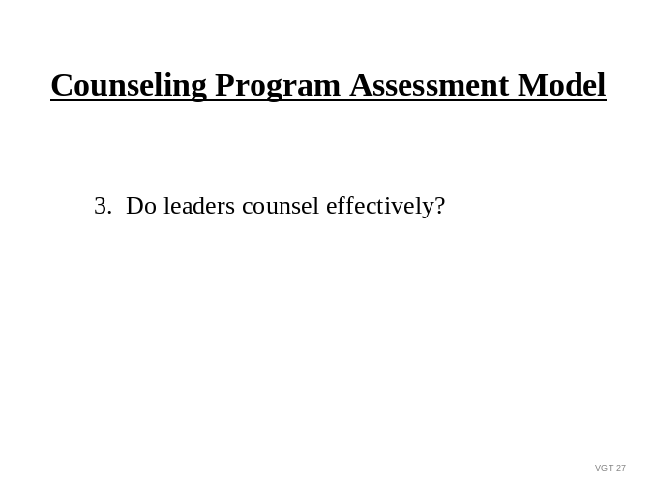SHOW VGT 27: Counseling Program Assessment Model

In order to determine if leaders counsel effectively, we must first revisit what effective counseling is.

Question: As we discussed earlier, what is effective counseling?

Possible response: Effective counseling is subordinate-centered communication that produces a plan of action outlining actions necessary for subordinates to achieve organizational or individual goals. Subordinate-centered communication is a process in which the subordinates take an active part and are not merely passive listeners. All counseling should result in the development of a plan of action. This plan focuses the person’s behavior toward specific actions that will facilitate achieving identified goals or objectives. Counseling is a two-way person team effort. Leaders do their part to help develop a plan of action and support subordinates through the implementation of the plan. Through subordinate-centered counseling, subordinates maintain responsibility for their actions and develop skills necessary to achieve goals.

Question: Now that we have described effective counseling, “Do leaders counsel effectively?” What are some examples of effective counseling situations which you have observed or experienced?

Why were those situations effective?

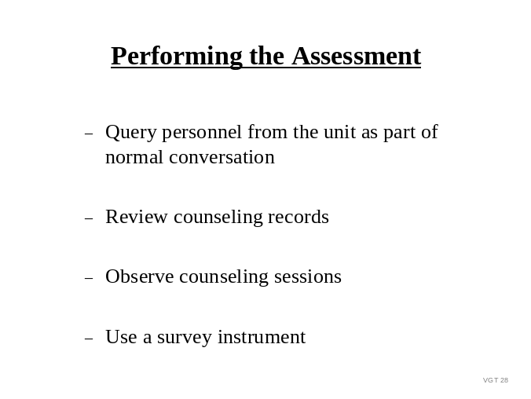SHOW VGT 28: Performing the Assessment
When performing a unit counseling program assessment (evaluation), you must determine how you are going to evaluate the program. In addition to determining how you will evaluate the unit program, you must determine when to conduct the evaluation. As the leader, you should keep a continual pulse on the unit counseling program similar to the manner in which you monitor a maintenance or training program. The assessment is not done once a year nor should the counseling program "peak" at anytime during the year. It is an ongoing responsibility to assess the unit counseling program.

On the slide are some of the means you may choose to use in evaluating your program. Just as a leader may observe preventive maintenance checks and services (PMCS) or a training class, you may observe the way the unit leaders counsel. Leaders may inspect counseling records, just as a leader inspects maintenance records. You must determine the most effective means for evaluating your program.

Question: In addition to the methods on the slide, what other ways could you evaluate your unit counseling program?

(Answers/responses will vary.)

2. Learning Step/Activity 2

Method of instruction: CO
Instructor to student ratio is: 1:16
Time of instruction: 00:10
Media: Viewgraphs # 29-31

SHOW VGT 29: Improving a Unit Counseling Program
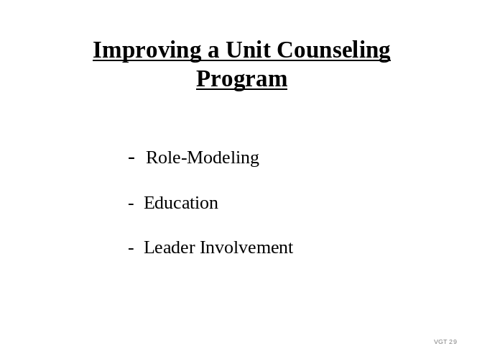

Three recommended methods to improve the unit counseling program are listed on the slide.

Question: Describe how each of the above methods improves a unit counseling program.

Possible Responses: Role-Modeling: When leaders counsel they are modeling “proper” counseling for their subordinates. If a leader wants to teach subordinates to counsel, one of the most effective ways is to demonstrate the behavior that you want to occur.

Education: Subordinate leaders may be misguided or misinformed on counseling related issues. There are several ways to educate subordinate leaders on counseling ranging from formal classes, to informal conversation, to policy memorandums.

Leader Involvement: Leaders can show that counseling is important by allocating time for counseling and frequently talking about and encouraging counseling. A leader’s attitudes and actions concerning counseling pervade the unit. If company level leaders want subordinate leaders to counsel, the company level leaders must demonstrate concern for the unit’s program.

Question: What should a leader do if the evaluation indicates that the unit has a good program?

Possible response: If the unit has a good counseling program, the above items will help to sustain the strengths of the program.

SHOW VGT 30: Improving a Unit Counseling Program
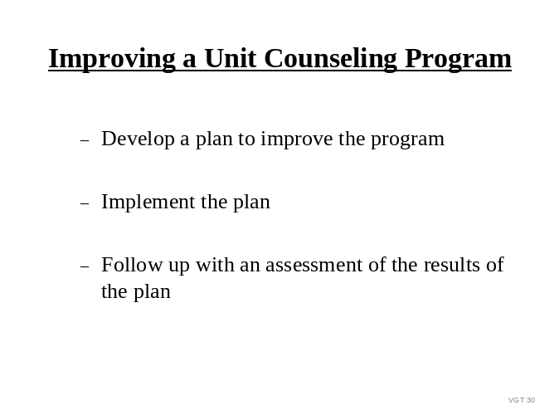

Just as a counselor must follow up to evaluate the results of counseling, a company level leader must follow up to evaluate the effects of the improvement plan. If the plan is not working, the leader must refine or modify it. If the plan is producing positive effects, the leader should strive to sustain the positive effects.

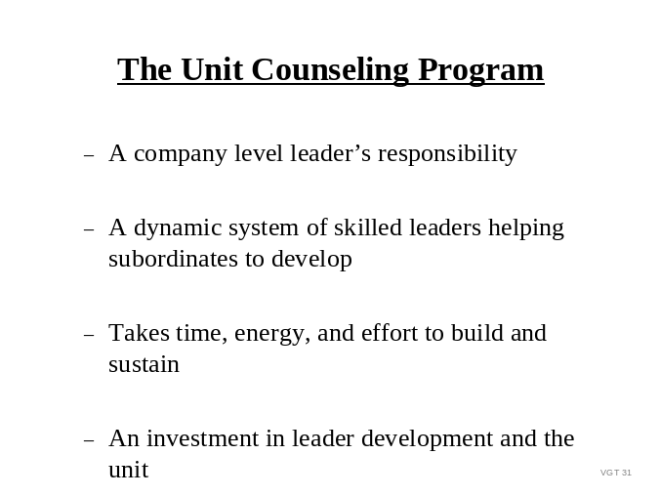SHOW VGT 31: The Unit Counseling Program

Company level leaders truly set the tone for the unit counseling program. Counseling programs are not built with policy memorandums or directives; they are built through leader attention and involvement.

Some of you will soon be leading units, which will have very effective counseling programs, while others will soon find yourselves in units where counseling programs are abysmal.

SUMMARY Ask the students if they have any questions about the materials they have covered.

E. ENABLING LEARNING OBJECTIVE E

Action: | Define the roles of leaders in the unit’s counseling program.
Conditions: | As a company leader, you determine that you need to update your unit’s current counseling program using the Army’s Mentorship handbook.
Standard: | Defined the role of leaders in the unit’s counseling program to include supervisors and mentors.

Learning Step/Activity

Method of instruction: CO
Instructor to student ratio is: 1:16
Time of instruction: 00:10
Media: Viewgraphs # 32 - 35

We have discussed the importance of a unit’s counseling program in a company level unit. During the next half hour, we are going review and discuss the roles of leaders in developing a unit’s counseling program using the Army’s mentorship handbook.

First, let us review the basics of the Army mentorship strategy. Mentoring is not a new concept for the Army. It has been a crucial part of professional and leader development programs. The Army is now asking each military and civilian leader to make a commitment to mentor one person beyond the chain of command.

The Army’s mentorship resource center and AKO mentorship community are two great resources available to all soldiers, civilians, spouses, retirees and veterans to help facilitate bringing mentors and individuals seeking mentors together in person and online.

SHOW VGT 32: Army Mentorship

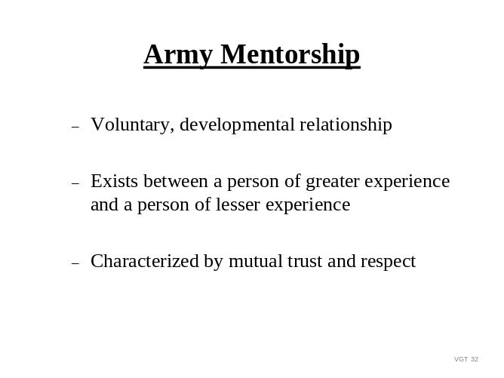

Army mentorship defined as the voluntary, developmental relationship that exists between a person of greater experience and a person of lesser experience that characterized by mutual trust and respect.

Question: What tools are available for mentors when building mentorship skills?

SHOW VGT 33: Army Mentorship Tools

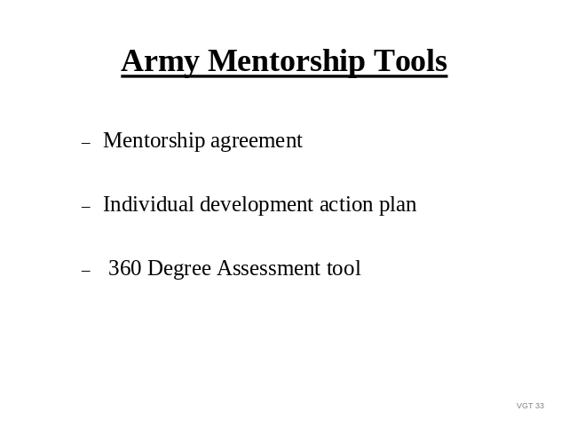

Possible response: The Army’s mentorship handbook recommends three tools, which a mentor and mentee can use to enhance communication between the mentor and mentee. They are a mentorship agreement and the individual development action plan (IDAP) and the 360 degree assessment tool. The mentorship agreement is an acknowledgement between the mentor and mentee that they have discussed this relationship and understand it to be an important developmental opportunity for both. They agree to respect the other’s personal requests and to maintain confidentiality before, during and after the mentoring period. The IDAP allows mentors to create written individual development action plan (IDAP) for the mentee assuring goals are reached by outlining specific actions needed to achieve them. The 360-degree assessment tool provides feedback to the mentee on what other people perceive to be his or her strengths, weaknesses and developmental needs. This tool is prepared from information from the mentee’s supervisor, peers and subordinates and can provide useful baseline data to know where to focus developmental activities. If a mentee does not want to share this information with their mentor, they should consider finding another mentor. Results of this assessment provide a basis for developing the IDAP.

SHOW VGT 34: Role of the Mentor

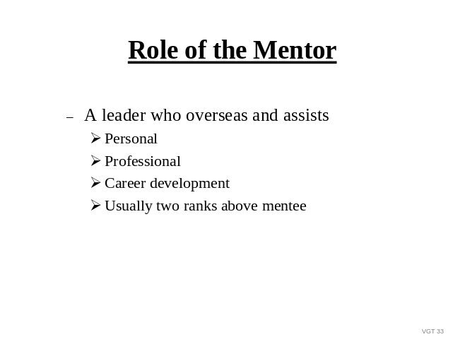

The mentor helps a mentee clarify personal, professional and career goals while developing actions to improve attributes skills and competencies. Mentors, generally coach, serve as a teacher, motivator, counselor, guide, advisor and or role model.

Question: Why do you think the Army encourages mentorship?

Possible response: It is beneficial to the mentor and to the Army. It can increase commitment to the Army and increase retention, improve performance and leader development.

Question: During the development of a unit’s counseling program, how would you incorporate the Army’s mentorship strategy?

Possible response: Clearly define the role of the mentor and the role of the supervisor. A mentor never bypasses normal and appropriate procedures or chains of command, or exerts pressure or influence on an individual, such as the mentee’s supervisor, who is the appropriate decision authority for the mentee.

Now that we understand the role of the mentor and the Army mentorship strategy let’s review the supervisors role in this process.

Question: What information or decisions do you think supervisors provide in the mentorship process?

SHOW VGT 35: Supervisor’s Role

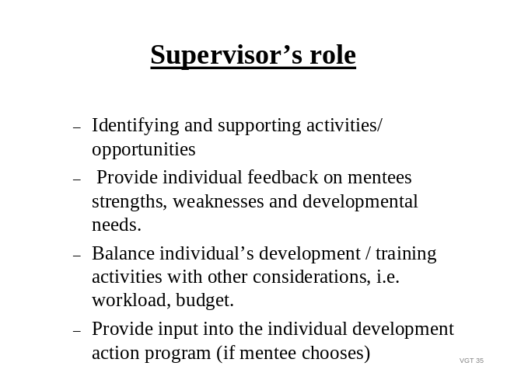

Possible answer: Supervisors have a critical role in the individual’s professional/leader development. When developing counseling programs supervisors provide direct feedback and support on duty performance and leader development through quarterly counseling, support form objectives and NCOER checklist, developmental counseling form, as well as informal counseling. If the mentee chooses, the supervisor can provide input into the IDAP, as well as with identifying and supporting specific developmental activities / opportunities for the mentee.

Instructor Note: Summarize ELO E

When developing a counseling program leaders must integrate current Army doctrine and strategies to ensure there program is relevant and effective. The Army’s mentorship strategy is not new but reflects the Army’s wiliness to provide mentorship to all personnel associated with the Army through all available means. However, when developing your counseling program clearly define the role of the mentor and the role of the supervisor assuring an effectively coordinated program.

F ENABLING LEARNING OBJECTIVE F

Action: | Develop a group plan to sustain or improve the unit counseling program.
Conditions: | Given a scenario to be worked as part of a small group, in-class discussions, Student Handout (Appendix D) and a time requirement.
Standard: | Developed a plan to sustain or improve the unit counseling program reflected in the scenario provided. Plan included an assessment of the situation, an analysis of the situation, a proposed plan of action, a proposed implementation plan and a proposed evaluation plan IAW the Student Handout (Appendix D).

1. Learning Step/Activity 1: (Small group development of a unit counseling plan)

Method of instruction: PE
Instructor to student ratio is: 1:16
Time of instruction: 00:55
Media: Scenario, chart paper and pens

We have discussed the importance of a unit counseling program to a company level unit. During the next hour we are going to work in small groups. I am going to provide you a scenario. You are to appoint a group leader and a group recorder. Using the knowledge you have about unit counseling and developing plans of actions, you are to complete the following requirements:

a. Assess the situation (scenario) provided and identify the factors affecting the unit counseling program indicated by the information contained in the scenario. List only the information. Do not make value judgments about the information at this time.

b. Analyze the information you gathered in your assessment. This is where you identify the strengths and weaknesses of the unit counseling program as indicated in the scenario.

c. Develop a plan.

(1) Based on the scenario provided, develop a plan of action to improve the unit counseling program.

(2) Explain how you could implement your plan.

(3) Explain how you would evaluate the effectiveness of your plan.

(The instructions are also listed on the scenario sheet.)

Instructor Note: After explaining the requirement and dividing students into small groups of 3-5 students, pass out the scenario at Appendix C. Tell the students that they are going to have 30 minutes to complete the requirements. Tell them that they are to write their group products in outline format on the chart paper provided and that they will brief their product to the class. Tell them that they will have 3-5 minutes to brief their product.

After 25 minutes have passed, tell the students that they have 5 minutes left. (If they are all working, you may want to extend the time a few minutes in order to allow them to complete the task.)

After 30 minutes (or time allotted), pair the groups for feedback. For instance, if there are five groups, have group 1 brief first and group 5 serve as the primary evaluators for group 1’s products. After group 5 provides feedback, allow other group members to comment on the plan. Then group 2 will brief and group 1 will evaluate and so on. Encourage maximum participation in the evaluation process. Ask questions to encourage student response and participation.

Instructor Note: Solution guidance is at Appendix C. Although this is a sample solution, accept ideas/plans which differ but which are logical, feasible and related to the scenario.

SUMMARY: As you have seen, there is no one solution to any situation. You must first gather information about the counseling situation in the unit before you can begin to analyze the information and develop a plan.

QUESTION: What were some of the sources we identified for the information?

Possible responses: Observations, records, interviews.

So, first we must assess the situation. By this we mean, gather information. This is not the time to eliminate information or determine the value of the information. During this step, we collect all of the available information. During the second step, the analysis step, we determine if the responses we collected contradict one another or support each other. For example, do subordinates indicate that they have not been counseled while leaders indicate that they counsel all subordinates? We then decide which information to accept and what additional information we need in order to objectively analyze the situation.

QUESTION: After we collect the information, we analyze it. So after we analyze the data, what do we do?

Possible response: Develop a plan of action. We determine our options and identify the plan we are going to use.

Correct, first, we collect information, we then analyze the information and then we determine our options for action. We weigh our options and we settle on one option. That option forms the basis for our action plan. And we must remember that in our plan, we identify not only what we intend to do, but we identify how we are going to implement our selected action and how we are going to determine if we achieved our goal or met our plan or evaluate our plan. Each part of the plan development process contributes an important part to the desired action. No component should be skipped.

SECTION IV SUMMARY

Method of instruction: CO
Instructor to student ratio is: 1:16
Time of instruction: 00:05
Media: Viewgraph #32

Review/ SHOW VGT 36: Summary
Summarize
Lesson
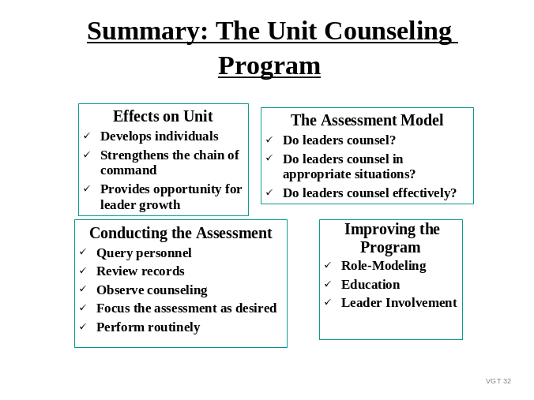
The process of developing a unit counseling program is not simple; however leaders who understand and employ the fundamentals above will not only effect improvements in the unit's counseling program, but in the entire functioning of the organization.

Instructor Note: Determine if students have learned the material presented by soliciting student questions and explanations. Ask the students questions and correct misunderstandings. Tailor your questions to your students.

Check on Question: How does a unit counseling program affect the organization?
Learning
Possible response: The primary purpose of counseling is subordinate development, yet the secondary effects of counseling greatly influence the unit as a whole. An effective counseling program strengthens the chain of command while providing opportunity for individual leader development.

Instructor Note: The following narrative is the lead in to the next question.

As you counsel it is important for you to be very aware of the cultural atmosphere of your unit as well as be aware of your own cultural attitudes and biases. When you become aware of your own biases you can more easily and effectively deal with cultural issues, biases, and stereotypes. Remember, even positive stereotypes/biases are damaging to the unit cohesiveness. They skew your opinions about the “favored” groups so that you are not objective about the group and tend to give them credit for performance they might not deserve with the result that others, who are achieving, may not be recognized.

Question: What would be an example of a positive stereotype or bias?

Possible response:

“Women make the best admin personnel.”
“Those with college credits are smarter.”
“Men are stronger.”

As a counselor and leader evaluate your beliefs, stereotypes and biases. You cannot be objective in evaluating your unit climate or in counseling unless you know yourself.

Ask other questions based on your student’s needs and performance.

SECTION V STUDENT EVALUATION

Testing Instructors assign students the unit counseling program scenario from Appendix B which
Requirements: requires the students to describe the effects of a counseling program on the organization, assess and analyze the information provided in the scenario, and develop a plan to improve or sustain the program. The plan will include procedures for implementation of the plan and the method(s) by which the plan will be evaluated. Instructors will grade the student products using the solution suggestions at Appendix B and the Student Handout (Appendix D) as the evaluation basis. Since there is more than one approach to any situation, instructors should give credit to products which are well thought-out, IAW the Student Handout (Appendix D) and realistic for a company level unit.

Students must obtain at least 75 points on the final examination in order to receive a “GO” on the course.

Student participation in a course encourages understanding of, and retention of, the material being presented. It is therefore suggested that in-class participation be included as part of the course evaluation process.

Points Final Grade
90-100 A
80-89 B
70-79 C
0 - 69 U

NOTE: Rapid, immediate feedback is essential to effective learning. Schedule and provide feedback on the evaluation and any information to help answer students’ questions about the test. Provide remedial training as needed.

APPENDIX A

VIEWGRAPH MASTERS

See MS Office Files VGT1361.pp

APPENDIX B

TEST AND TEST SOLUTIONS
(Includes Student Note Taking Guide Solutions)

SEE MS OFFICE FILES TST1361.DOC AND TAN1361.DOC
Appendix C

Practical Exercise/Solution

SEE MS OFFICE FILES PE1361.DOC AND PAN1361.DOC

Appendix D - Student Handout

Develop a Unit Counseling Program
(158-E-1361)
Student Handout

