TRAINING SUPPORT PACKAGE (TSP)

TSP Number 158-C-1135
Title Apply Leadership Fundamentals to Create a Climate that Fosters Ethical Behavior

Task Number 158-100-1135
Title Apply Leadership Fundamentals to Create a Climate that Fosters Ethical Behavior.

Effective 30 June 2005

Date
158-C-1135, Apply Leadership Fundamentals to Create a Climate that Fosters
Supersedes Ethical Behavior, 1 September 1999

TSP(s)

TSP User Use this TSP in Precommissioning, Warrant Officer Candidate School (WOCS), and Basic Noncommissioned Officer Course (BNCOC).

Proponent The proponent for this document is the Center for Army Leadership, U.S. Army Command and General Staff College, 250 Gibbon Avenue, Fort Leavenworth, KS 66027-2314.

Comments/ Send comments and recommendations directly to: Director, Center for Army Leadership, U.S.
Recommen- Army Command and General Staff College, 250 Gibbon Avenue, Fort Leavenworth, KS
dations 66027-2314.

Foreign This product has been reviewed by the product developers in coordination with the Fort
Disclosure Leavenworth (PMO Security Office) foreign disclosure authority. This product is
Restrictions releasable to military students from all requesting foreign countries without restrictions.

PREFACE

Purpose This training support package provides the instructor with a standardized lesson plan for presenting instruction for:

Task number: | 158-100-1135
Task title: | Apply Leadership Fundamentals to Create a Climate that Fosters Ethical Behavior.
Conditions: | You are a leader in an organization. You have analyzed the Army values and operational values in a case study. You will take action to create a positive ethical climate.
Standard: | Identified at least two behavioral values of the command climate to change and determined leadership behaviors to improve the ethical climate. The assessment will include how you will change these behavioral values to support Army values.

This TSP
contains
TABLE OF CONTENTS
Page
Preface |  | 2
Lesson | Section I - Administrative Data | 3
Plan | Section II - Introduction | 6
 | Terminal Learning Objective: Determine leadership fundamentals to improve the ethical climate within an organization or unit. | 6
 | Section III - Presentation | 7
 | Enabling Learning Objective - Analyze the ethical climate of your unit. | 7
 | Section IV - Summary | 16
 | Section V - Student Evaluation | 16
Appendixes | A - Viewgraphs | A-1
 | B - Test and Test Solutions | B-1
 | C - Case studies and Solutions  PE 1 “The Platoon Sergeant” is Mandatory Training  (DETAINEE OPS)  CS 1 – The Platoon Sergeant (Student Handout)  CS 1 Part I: The Platoon Sergeant (Student Handout)  CS 1 Part I: The Platoon Sergeant (Instructor Sheet)  CS 1 Part II: The Platoon Sergeant (Student Handout)  CS 1 Part II: The Platoon Sergeant (Instructor Sheet)  CS 1 Part III: The Platoon Sergeant (Student Handout)  CS 1 Part III: The Platoon Sergeant (NO Instructor Sheet)  CS 2 – Desertion Case Study (Student Handout)  CS 2 Part I: Desertion Work Sheet (Student Handout)  CS 2 Part I: Desertion (Solution Sheet)  CS 2 Part II: Desertion Work Sheet (Student Handout)  CS 2 Part II: Desertion Work Sheet (Solution Sheet)  CS 2 Part III: Desertion Work Sheet (Student Handout)  CS 2 Part III: Desertion Work Sheet (Solution Sheet) | C-1  C-2  C-3  C-4  C-5  C-6  C-7  C-8  C-9  C-10  C-11  C-12  C-13  C-14  C-15  C-16  C-17
 | D - Student Handouts (provide if FM 22-100 is not available)  Chapter 1 thru 3 FM 22-100 (D-2 thru D-72) | D-1  D-2

APPLY LEADERSHIP FUNDAMENTALS TO CREATE A CLIMATE

THAT FOSTERS ETHICAL BEHAVIOR (158-100-1135)
(1 July 2005)

SECTION I. ADMINISTRATIVE DATA

All Courses course number course title
Including This ____________ Precommissioning Courses
Lesson ____________ Warrant Officer Candidate School (WOCS)
____________ Basic Noncommissioned Officer Course (BNCOC)

Task(s) task number task title
Taught or 158-100-1135 Apply Leadership Fundamentals to Create a Climate that
Supported Fosters Ethical Behavior
158-100-1134 Resolve an Ethical Dilemma
158-100-1150 Motivate Subordinates to Improve Performance
158-100-1170 Apply Team Development Techniques to Enhance Unit Performance

Reinforced TASK NUMBER TASK TITLE
Task(s) None None

Academic The academic hours required to teach this course are as follows:

Hours
peacetime mobilization
hours/methods hours/methods
00:05/LE 00:05/LE
00:35/CO 00:35/CO
01:40/PE 01:40/PE
Test 01:00/TE 01:00/TE

Total Hours 03:20 03:20
(Approximately 01:00 / SA of homework is required)

Prerequisite None

Lesson(s)

Clearance There are no clearance or access requirements for this lesson.
and Access

References
number | title | date | additional  information
Interim Update to  AR 190-8 | Enemy Prisoners of War, Retained Personnel, Civilian Internees and Other Detainees | 26 July 2004
FM 22-100 | Army Leadership | 31 August 1999 | Chapters 1-3

Instructor Note: Make homework assignments so as to allow sufficient time for the students to complete the assignments by the desired due date.

Student Students must read and become familiar with FM 22-100, Army Leadership (Chapter 2
Study and Appendix D) before the class begins.

Assignments

Instructor Develop a student course sheet which briefly describes the course and identifies the
Requirements reading requirements which students must complete prior to class. One instructor required. No special qualification required.

Additional None

Personnel

Requirements

Equipment Overhead projector or computer with a large screen monitor. Copies of the practical
Required exercises.
for Instruction

Materials INSTRUCTOR MATERIALS:
Required Viewgraphs or equivalent PowerPoint Presentation.

STUDENT MATERIALS:
Handouts. Butcher paper and marking pens or white board and marking pens (chalkboard and chalk)

Classroom, One classroom

Training Area,
and Range

Requirements

Ammunition None.

Requirements

Instructor Note: Before presenting this lesson, instructors must thoroughly prepare by studying this lesson and identified reference material.

Instructional The intent of this class is to familiarize students with analyzing the ethical climate in their
Guidance unit and then develop a plan to sustain or improve it.

A. Instructional Outline

1. Students must read and become familiar with FM 22-100, Army Leadership
(Chapter 2 and Appendix D) before the day of the class.
a. Prepare to discuss how you can use the Army values to analyze command climate.
b. Prepare to discuss how you motivate soldiers. Include in your preparation your own experiences and observations.
2. The instructor facilitates a discussion of the course requirements.
3. The instructor facilitates a discussion of the student homework.
4. The instructor facilitates a discussion of a unit's ethical climate using viewgraphs or PowerPoint presentation.
- Students as a group analyze a case study and identify Army values and unit operating values.
6. The instructor facilitates a discussion of Army values and the effect on an ethical climate using viewgraphs or PowerPoint presentation.
7. Students as a group compare a unit's behavioral values with Army values.
8. Students as a group develop concepts to change the ethical climate.
9. The student evaluation. Students are required to analyze a given case study. The analysis must:
a. Assess the ethical climate of the unit to identify gaps or inconsistencies between the Army values and the command climate depicted.
b. Select behavioral values which are not consistent with Army values and tell why the values chosen were the most important.
c. Recommend leadership behaviors to change the ethical climate.

Instructor Note: This TSP contains two Case studies (CS). The CS “The Platoon Sergeant” is MANDATORY and must be taught. The other case study may be covered as time permits.

Due to today’s current operational environment and events that have occurred recently this CS has been incorporated into this TSP. The intent of the CS is to expose future leaders to the leadership aspects of Detainee Operations and not to make them experts in the area of Detainee Operations. The CS and follow on questions will challenge the students to explore and apply leadership doctrine and Army Values, in their class work.

B. Instructor requirements.

1. Reproduce class case study and final exam.
2. Reproduce VGTs (appendix A).

Proponent NAME Rank Position Date
Lesson Mark R. French COL Director, CAL 30 June 2005
Plan ______________________ ____ _____________________________ ________
Approvals ______________________ ____ _____________________________ ________

SECTION II INTRODUCTION

Method of instruction: CO
Instructor to student ratio is 1:16
Time of instruction 00:05
Media: Viewgraphs or PowerPoint Presentation

Motivator As future leaders, you will be in a position to help make the Army an organization that will make the nation proud. You will be major contributors to the ethical climate of your unit. Your ability to analyze and, more importantly, influence the ethical climate of your unit is a significant responsibility and will be a critical factor in assessing your effectiveness as a leader.

Instructor Note: Inform the students of the following terminal learning objective requirements.

Terminal Learning
Objective | Action: | Determine leadership fundamentals to improve the ethical climate within an organization or unit.
 | Conditions: | You are a leader in an organization. You are given a case study in class for you to determine leadership behaviors to improve the unit's ethical climate.
 | Standard: | Identified behavioral values in the climate to change which included how you will change these behavioral values to support Army values. Determined leadership behaviors that improve the unit’s ethical climate.

Safety None

Requirements

Risk Assess- Low

ment Level

Environmental None

Considerations

Evaluation Using class notes, students will produce a plan to improve the ethical climate of a unit. The plan must:
a. Assess the ethical climate of the unit to identify inconsistencies between the Army values and the climate demonstrated.
b. Select behavioral values in the climate which are not consistent with Army values and tell why the values chosen were the most important.

Instructional The Army throughout its long history has had its share of strong and weak leaders.
Lead-in The Army's greatest successes and failures have reflected its leadership. As a leader you are in a position to help the Army achieve new heights of success. Your ability to analyze and influence your unit’s ethical climate will determine your effectiveness as a leader in peace and war. Your task is to foster Army values in the unit and its members.

Today's lesson will identify those factors which affect your unit's ethical climate, how they relate to the Army's values, and how leadership behaviors improve and maintain the ethical climate in your unit.

SECTION III PRESENTATION

ENABLING LEARNING OBJECTIVE

Instructor Note: Inform the students of the enabling learning objective requirements.

Action: | Analyze the ethical climate of your unit.
Conditions: | Given class readings and a case study.
Standards: | Identified behaviors, which are inconsistent with Army values.

1. Learning Step/Activity 1 - Instructor led overview of the course requirements.

Method of instruction: CO
Instructor to student ratio is: 1:16
Time of instruction is: 00:05
Media: Viewgraphs or PowerPoint Presentation

Discuss the student requirements for this course.
a. Case study completed as a group.
b. Case study testing your ability to determine leadership behaviors to improve the ethical climate of a unit.

2. Learning Step/Activity 2 - Instructor led discussion of the homework.

Method of instruction: CO
Instructor to student ratio is: 1:16
Time of instruction is: 00:05
Media: None

Review and discuss questions which students have on the homework reading (Army Leadership, Chapter 2 to FM 22-100 and Appendix D to FM 22-100 located at Appendix D to this TSP)

3. Learning Step/Activity 3 - Instructor led overview of the unit ethical climate.

Method of instruction: CO
Instructor to student ratio is: 1:16

Time of instruction: 00:15

Media: Overhead Projector

a. Appendix A contains slides to facilitate the 15-minute discussion. Slides 1-3 pertain to Learning Step/Activity 3. The notes for each slide are contained below.

- This presentation is intended to get the students to think about how ethical behavior relates to leadership and how they will practice this complex task in the context of supporting the Army values.

Presentation: a. This block of instruction will assist in the identification and assessment of a unit's ethical climate. We will identify the factors which affect the ethical climate and determine how they contribute or detract from ethical conduct.

b. Every Army unit (large or small) has an ethical climate which reflects the character of the individual members, the policies and practices of the organization, actions of the leaders, the environment, and the unit's mission. The ethical climate determines the day-to-day behavior of the unit and its membership.

c. The Army's leadership has identified seven key values that soldiers and units must practice: Loyalty, Duty, Respect, Selfless-service, Honor, Integrity, and Personal Courage. Soldiers are to practice these values. Soldiers bear true faith and allegiance to other soldiers, the unit, the Army, and the U.S. Constitution. We call this loyalty. Soldiers fulfill their obligations. They perform their duty. Soldiers treat people as they should be treated; that is, they respect each other. Soldiers put the welfare of the other soldiers, the Army and the nation before their own; that is, they show selfless-service. Soldiers live up to all the Army values (honor). Soldiers do what's right legally and morally (integrity). Soldiers face fear, danger or adversity (physical or moral) with personal courage.

Instructor Note: Show VGT 1135-1: Army Values

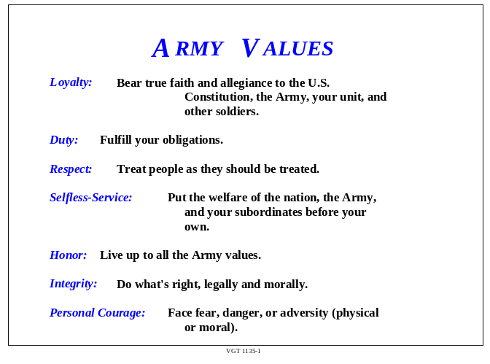
d. For example, selfless-service, as a traditional value, places the accomplishment of the mission ahead of individual desires.

e. Consider the following scenario.

Instructor Note: (1) Show VGT 1135-2: Selfless Service Scenario (Deadlined Vehicle)
(2) Answer first question before going to second. Record on the white board or butcher paper the student responses.

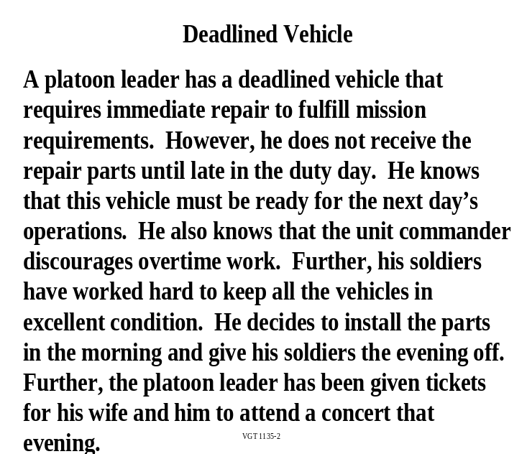

f. Questions:

1. What are the values in this scenario?
2. How do these values support the Army values?

3. Is there a conflict?
4. Why?

Expected Responses: Students may suggest something like:
1. Self-service; respect for soldiers; personal courage; loyalty to soldiers but not strong loyalty to mission.
2. All the values but "self-service" and "limited loyalty" support the seven Army Values.
3. The conflict is with "self-service" and "selfless-service." "Self-service" focuses on the interests and needs of the individual. "Selfless-service" allows leaders to focus on "loyalty" to soldiers while accomplishing the unit's mission. Thus there is a conflict between the Army value of selfless-service and the unit's climate which encourages self-service.
4. The unit's leadership has a loyalty to the troops but not to the larger unit of which it is a part.

InstructorNote: (1) Show Viewgraph 1135-3: Sources of Impact
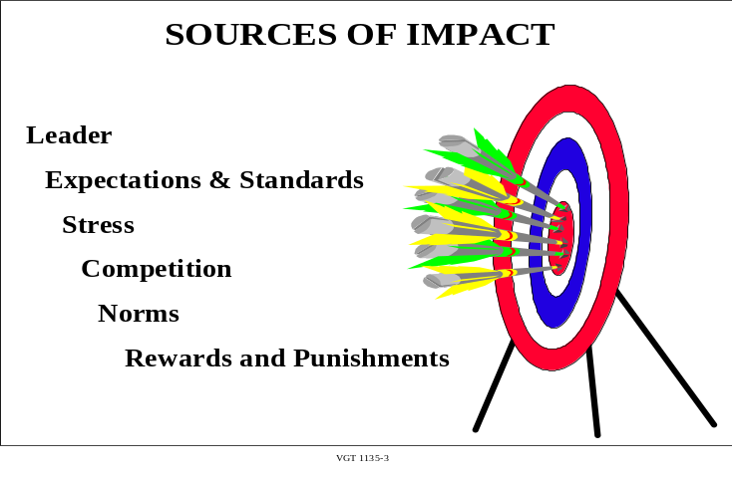

g. There are several factors that influence a unit's climate. How these factors are
managed influences a unit's climate. The major factors are:

(1) Leader. The behavior of a unit's leaders is the most important influence on the unit's climate. Leaders set the example. They send out a powerful message about what is acceptable and what is not. Leaders reinforce or do not reinforce Army values and they may or may not correct unethical behavior.

(2) Expectations and standards. Leaders must ensure that their policies, directives or orders are clear and understandable. Leaders must also ensure that their standards are clearly understood and enforced. If your soldiers do not understand what standard you expect, the unit will not fulfill your expectations.

(3) Stress. Stress has both positive and negative affects.

Question: Can you tell me what happens to a unit when we remove all stress?

Expected Responses:
1. An attitude may develop where nobody cares what happens.
2. Deadlines arrive and nothing happens.
3. Performance and judgment suffer.
4. Moral behavior suffers.

Question: Can you tell me what happens to a unit where there is extreme stress?

Expected Responses:

Similar to the above.

Too much stress, like too little, is the opposite side of the same coin. Too much or too little stress affects moral behavior. Performance and judgment may suffer.

Many things can cause stressors. Two factors are role overload and role conflict.

1 Role overload includes: too many things to do, insufficient resources, inadequate guidance, and unrealistic deadlines that increase the pressure to cut corners. An example of role overload is a conflict between a directive and its effect on subordinates (e.g., a directive that all SGTs (E5s) and below must move back into the barracks with no exceptions for married personnel).

2 A second type of stress is role conflict. This, for example, could involve the off-duty relationship between a superior and a subordinate. These role conflicts might result in unethical situations.

(4) Competition. Competition is healthy. Healthy competition can help create a team with a positive attitude. The problem, however, occurs when we see our purpose is to "win at all costs." This can create pressures that may compromise ethical standards.

(5) Norms. Norms describe how the unit functions. They include both formal and informal rules and regulations that govern the behavior of the members. The informal norms, however, are those which are more powerful than the formal norms. Note that in the scenario of the platoon leader with a deadlined vehicle (VGT 1135-2), it was the informal norms that seemed to have a stronger influence on the leader's decision. Leaders need to examine a unit's norms to determine what effect they are having on the unit's climate.

(6) Rewards and punishments strongly influence the unit's climate. Soldiers need rewarding for the good work they do. Leaders must ensure that they reward the good work of their soldiers. Leaders must also administer rewards consistently and fairly. At the same time leaders need to consistently and fairly correct any behavior that violates the Army values. Soldiers catch on quickly to what behavior is rewarded and what is not.

h. Soldiers, individually and collectively, learn how to behave by observing fellow soldiers. We learn not only appropriate and inappropriate actions, but also the consequences of those actions. Soldiers must be able to observe ethical behavior in the actions of the leader. Your behavior in and out of the unit will reinforce or negate the Army values. Your soldiers will know what is important to you by the example you set.

i. We have seen how the factors that impact the unit and the leader's consistent and fair use of rewards and punishments directly influence the unit's climate. Now we will consider those characteristics that produce a healthy command climate.

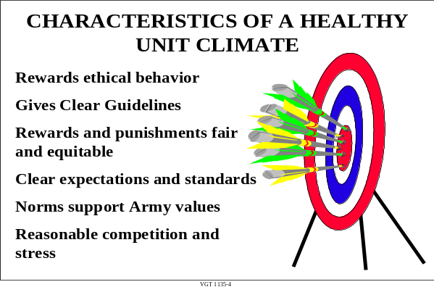Instructor Note: Show Viewgraph 1135-4: Characteristics of a Healthy Unit Climate

(1) Rewards Ethical Behavior. The unit commander publicly rewards ethical behavior.

(2) Clear Guidelines. There are clear guidelines as to what is or is not ethical.

(3) Rewards and Punishments Fair and Equitable. The command distributes all rewards and punishments fairly and equitably.

(4) Clear Expectations and Standards. The command has clearly defined its expectations and standards.

(5) Norms Support Army Values. The unit's informal norms support the Army values: loyalty, duty, respect, selfless-service, honor, integrity, and personal courage.

(6) Reasonable Competition and Stress. The levels of competition and stress are relatively low.

j. As part of your advanced readings, you were asked to read about the Ethical Climate Assessment Survey (ECAS, FM 22-100 (located in Appendix D to this TSP). Although we will not discuss the ECAS in class, you should familiarize yourself with the instrument. It is an important "hip pocket" tool which you can make use of when you need it.

k. During the next portion of this lesson you will assess the ethical climate of a unit.

Instructor Note: Conduct a check on learning and summarize the learning activity.

4. Learning Step/Activity 4 - Analyze in-class CS, “The Platoon Sergeant” (DETAINEE OPS)
Method of instruction: CS (Group)
Instructor to student ratio is: 1:16
Time of instruction is: 00:50

Media: Handout

Reference: FM 22-100, Chapters 1-3, dated 31 August 1999

Classification: Unclassified

Instructor Note: Hand out to students the in-class CS “The Platoon Sergeant” Scenario and Part I (see Appendix C). Using “The Platoon Sergeant” scenario and Part I and II handouts, the instructor guidance to students for analyzing the in-class CS.

a. At this time, I want you to get into groups of three or four.

b. The case study “The Platoon Sergeant” (in-class student handout) is about ethical behavior in a combat environment. You will need to:
(1) Identify leader actions (Questions 1-3)
(2) Identify two behavioral values of change and improve the ethical climate of the organization (Question 4)

c. Use Chapter 2 of FM 22-100 (handout in Appendix D) to assist you in completing the case study “The Platoon Sergeant” (see Appendix C). Spend the next 10 minutes reading the case study and answering the questions (Part I of “The Platoon Sergeant”) individually. After working individually, spend the next 10 minutes discussing your individual answers within your group. Develop a group position and select one individual from you group to present the group position (answer) to the class. Next using Part II of the in-class case study “The Platoon Sergeant” Student Worksheet, Appendix C, we will discuss application of Army and operational values to the case study, and their subsequent effect on command climate. For this part of the CS, you will
(1) Identify how application of the Army values in this scenario may cause internal conflicts
(2) Identify acceptable leader behaviors
(3) Identify the observed behavior that causes conflict, e.g., the prisoners appear to have been abused.

Instructor Note: Use the instructor sheet to facilitate responses and discussion of Parts I and II of the CS “The Platoon Sergeant”. If time permits, use Part III to further discuss leader responsibilities using “The Platoon Sergeant” case study. No solution sheet to Part III is provided. Use FM 22-100 to determine appropriate responses. After the student discussions, summarize the main points.

- Learning Step/Activity 5 - Analyze CS “Desertion”

Method of instruction: CS (Group)
Instructor to student ratio is: 1:16
Time of instruction is: 00:30

Media: Paper, butcher paper or white board.

Reference: FM 22-100, Chapters 1-3, dated 31 August 1999

Classification: Unclassified

Instructor Note: Hand out to students the CS “Desertion” In-Class Case Study and Part I (see Appendix C). Break class into 2 – 3 groups (not more than 6 students in each group). Inform the groups that they will each have to brief out a portion of their findings. Give groups 10 minutes to do the CS “Desertion” (See Appendix C).

a. The following case study (in-class student handout “Desertion”) involves a young soldier with family medical problems.

b. To complete the case study, you need to:.
(1) Identify the command climate in the case study as demonstrated by unit members.
(2) Identify who is responsible for developing and maintaining an ethical climate in the case study.
(3) Identify behaviors which need changing.

Instructor Note: Assist the students as they work the case study. At the end of the 10 minutes, have each group brief at least one of the four guidance questions. Ask the other groups if they came up with different results and for any other feedback they may have. Finish by adding any points they may have overlooked from the solution sheet for CS “Desertion” Part I (See Appendix C).

6. Learning Step/Activity 6 - Instructor led discussion of Army values.

Method of instruction: CO
Instructor to student ratio is: 1:16
Time of instruction is: 00:05
Media: Viewgraphs or PowerPoint Presentation

a. This block of instruction will present the Army values, how the American people's trust in their Army depends on the Army's implementation of these values, how these values define the Army's character, and how they serve as the Army's moral compass.

Instructor Note: Show Viewgraph 1135-5: Army Values
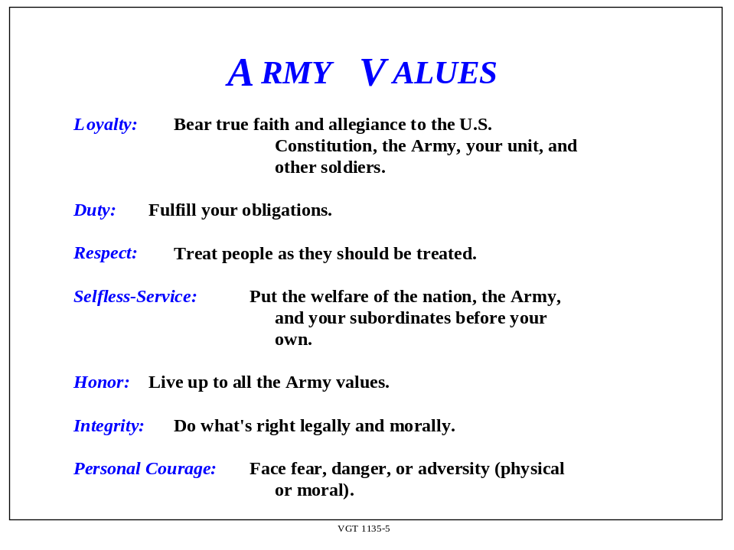
(1) The professional Army ethic provides the moral context for the Army in its service to the Nation. The moral values of the Constitution and the individual values which strengthen the Army ethic are integrated into a unit by the actions of its members.

(2) Army values are essentially "the way things should be." They establish the standards of required behavior for all soldiers. An Army unit which possesses a positive ethical climate reinforces each of these values in its behavior. Day-to-day operations and tactical training reflect a healthy ethical climate because unit members do things the way they should be done.

(3) As noted earlier, climate is essentially "the way things are." During your group’s analysis of the case study you identified several values that reflect the climate. Most likely you identified some values that may differ from Army values.

- During your next CS you will compare your previous case study with Army values.

7. Learning Step/Activity 7 - As a group, compare behaviors in the CS “Desertion” Part II with Army values.

Method of instruction: CS (Group)
Instructor to student ratio is: 1:16

Time of instruction: 00:30

Media: Paper and butcher paper or white board.

Reference: FM 22-100, Chapters 1-3, dated 31 August 1999

Classification: Unclassified

Instructor Note: Break class into 2 – 3 groups (not more than 6 students in each group). Inform the groups that they will each have to brief out a portion of their findings. Handout Part II “Desertion” CS. At 10 minutes inform the group they have 5 minutes to complete this task. Instructor guidance to students for analyzing the in-class case study:

During this CS consider the following questions:

(1) Identify the Army values in the case study as demonstrated by unit members.

(2) Identify any conflicts between the Army values and the command climate and how the command climate contributed to the conflicts.

(3) Identify the behaviors which support or conflict with the Army values.

Instructor Note: Assist the students as they work the case study. At the end of the 15 minutes, have each group brief at least one of the three guidance questions. Ask the other groups if they came up with different results and for any other feedback they may have. Finish by adding any points they may have overlooked from the solution sheet for CS “Desertion” Part II in Appendix C.

8 Learning Step/Activity 8 – Using Part III of CS “Desertion” identify leadership behaviors needed to change ethical climate so that Army values are reinforced and inappropriate values are eliminated.

Method of instruction: CS (Group)
Instructor to student ratio is: 1:16

Time of instruction: 00:40

Media: Paper and butcher paper or white board.

Reference: FM 22-100, Chapters 1-3, dated 31 August 1999

Classification: Unclassified

a. Now that we have looked at conflicts in Army values and direct behavior of leaders and subordinates using a case study, you will build on your previous work and determine which leadership behaviors are needed to make this a climate that fosters ethical behavior.

Instructor Note: Break class into 2 – 3 groups (not more than 6 students in each group). Handout out Part III of CS “Desertion.” Inform the groups that they will each have to brief out a portion of their findings. Give groups 20 minutes to develop a plan (See Appendix C). At 15 minutes announce there are 5 minutes remaining to complete the CS. Instructor guidance to students for analyzing Part III CS “Desertion”.

b. Determine which leadership behaviors are needed to make this a climate that fosters ethical behavior.

c. To assist in this CS look at the factors you looked at in the previous CSs.

(1) The overall command climate.
(2) Responsible personnel.
(3) Behaviors that need to be changed
(4) Army Values and conflicts to those values.

d. You will brief your responses to the other groups.

Instructor Note: Assist the students as they work the case study. At the end of the 20 minutes, have each group brief their plan. Ask for feedback from the other groups. When all groups are completed, lead a discussion on differences in the plans. Finish by adding any points they may have overlooked from the solution sheet for Part III CS “Desertion” in Appendix C.

SECTION IV SUMMARY.

Method of instruction: LE
Instructor to student ratio is: 1:16
Time of instruction: 00:05
Media: None

Review/ We have discussed what may be the greatest challenge of your leadership
Summarize abilities, ensuring Army values are part of your unit's performance. You have
Lesson considered how you can apply your leadership skills to create a climate that fosters ethical behavior in the command. Your understanding of the relationship between leadership, Army values, and the command climate will help you apply your skills to creating a positive command climate.

Instructor Note: Make sure you repeat the terminal learning objective of the lesson. Determine if students have learned the material presented by soliciting student questions and explanations. Ask the students questions and correct misunderstandings.

SECTION V STUDENT EVALUATION

Testing None

Requirements

Evaluation The student is provided a scenario giving indicators of the ethical climate of the unit. In order to receive a passing grade, the student must correctly:
a. Assess the ethical climate of the unit.
b. Identify the Army values illustrated in the case study.
c. Identify the gaps or inconsistencies between the Army values and the unit's climate demonstrated in the case study.
d. Identify who is responsible for creating or tolerating the unit's climate.
e. Identify the sources of impact which affect the Army values.
f. Identify the leadership behaviors that you can use to improve the unit's climate.

Instructor Note: (1) Include this information also in the Student Evaluation Plan which documents course
graduation requirements. The using school assigns course weight to the evaluation.
(2) Rapid, immediate feedback is essential to effective learning. Schedule and provide
feedback on the evaluation and any information to help answer student’s questions about the test. Provide remedial training as needed.

Feedback Discuss the students’ responses on the case study.

Requirement

APPENDIX A

VIEWGRAPHS

See MS Office File VGT1135.doc

VGT 1135-1 Army Values

VGT 1135-2 Deadlined Vehicle

VGT 1135-3 Sources of Impact

VGT 1135-4 Characteristics of a Healthy Unit Climate

VGT 1135-5 Army Values

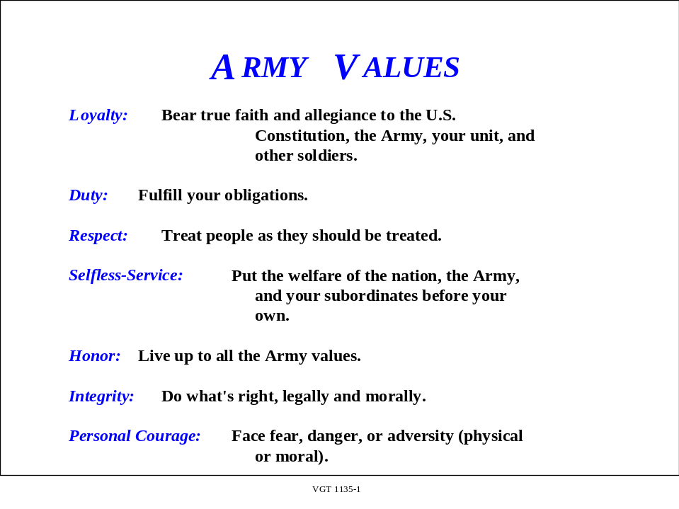

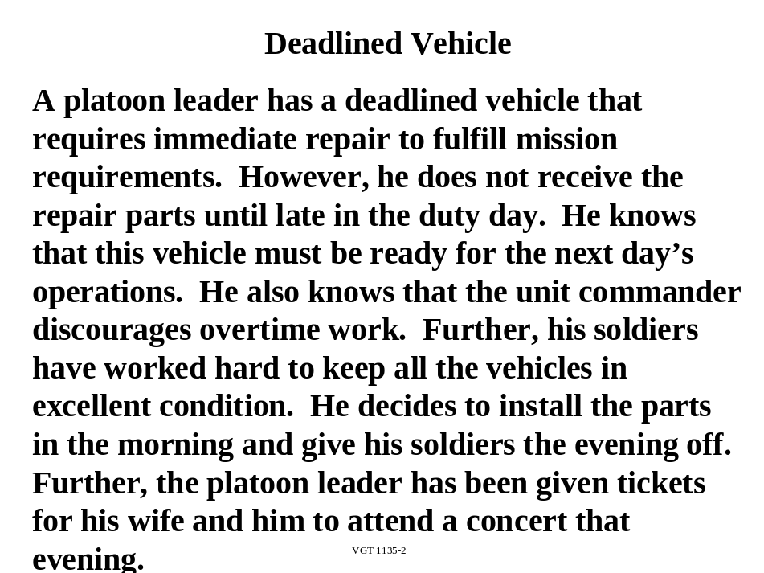

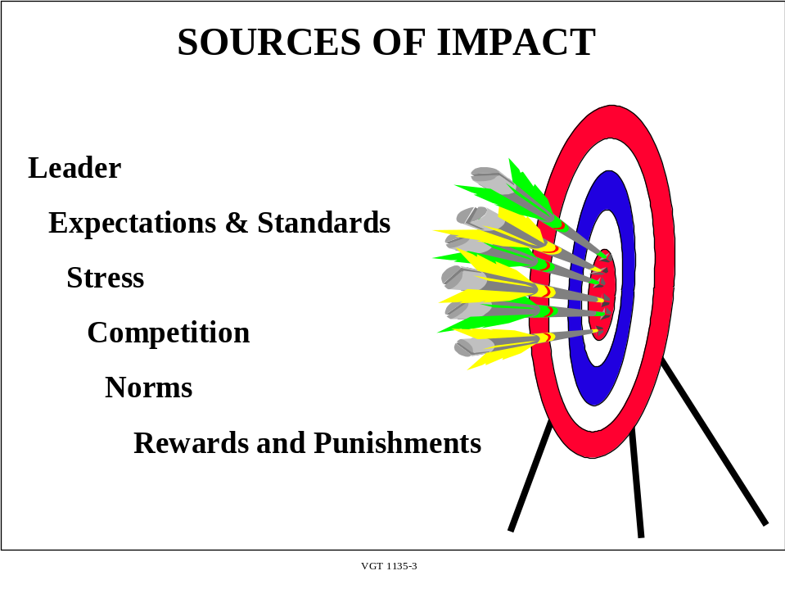

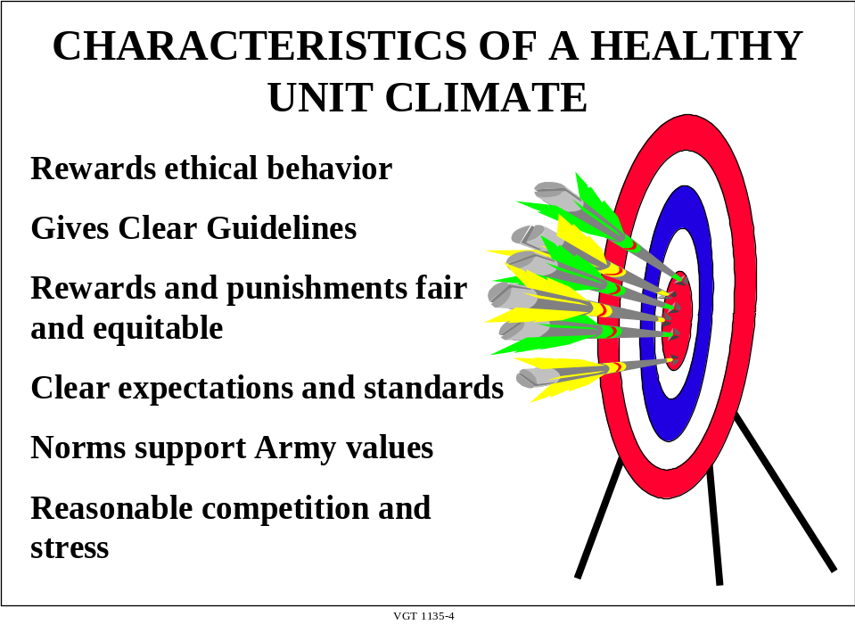

APPENDIX B

TEST AND TEST SOLUTIONS

SEE MS OFFICE FILES TST1135.DOC AND TAN1135.DOC

APPENDIX C

CASE STUDIES AND SOLUTIONS

See MS Office Files CS1135.doc and PAN1135.doc

CS 1 IS A MANDATORY TRAINING REQUIREMENT

CS 1 The Platoon Sergeant (Detainee Ops)

CS 2 Desertion

APPENDIX D

TSP 158-100-1135

Handouts

(Instructors, provide to students only if the 1999 version of FM 22-100 is not available)

Pages

Ethical Climate Assessment Survey

Appendix D, FM 22-100 D-2 thru D-7

The leader and Leadership:

What the Leader Must Be, Know, and Do

Chapter 2, FM 22-100 D-8 thru D-33

Appendix D (Handouts) to TSP 158-10-1135
Appendix D, FM 22-100
(pages D-3 thru D-8)
A Leader’s Plan of Action and the ECAS Example
The leader’s plan of action consists of a method, a game plan, or a series of developmental tasks enabling him to improve, sustain, or reinforce a standard of performance within the organization. This plan identifies specific leader actions to sustain or improve individual, leader, group, or organizational performance. The leader may follow all or part of the process shown in Figure D-1, depending on the situation. Even though this example uses the Ethical Climate Assessment Survey (ECAS), leaders should develop a plan of action with developmental counseling as a part of leader development.
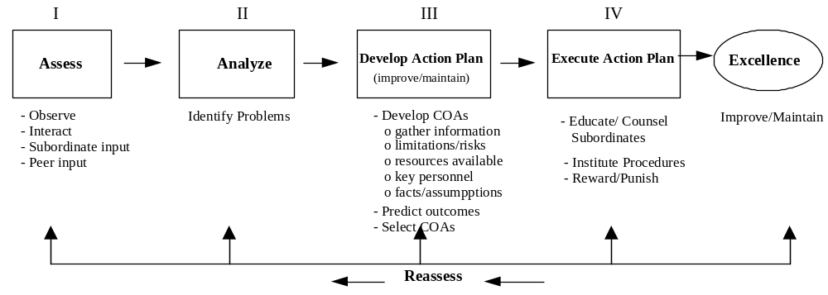 Figure D-1. The Development Process for a Leader’s Plan of Action
The leader begins his plan of action by assessing his unit (Step I). He observes, interacts, and gathers feedback from others or conducts formal assessments of the workplace. The leader then analyzes the gathered information to identify areas that need improvement (Step II). Once identified, he can begin to develop courses of action to address these areas.
In Step III, the leader develops his plan of action. First he develops and considers several possible courses of action to correct identified weaknesses. He gathers important information, assesses the limitations and risks associated with various actions, identifies available key personnel and resources, and verifies facts and assumptions. For each possible course of action, the leader attempts to predict the outcomes produced. Based on these predicted outcomes, he can select a course of action.
The leader’s plan of action should include several leader actions to address specific areas needing attention. He executes this plan of action by (Step IV) by educating, training, or counseling his subordinates; instituting new policies or procedures; and revising or enforcing proper systems of rewards and punishment. His organization moves towards excellence by improving in those unacceptable areas and maintaining in those areas that meet or exceed the high expectations for Army organizations. Finally, the leader periodically reassesses his unit to identify new areas of concern or to evaluate the effectiveness of current leader actions.
Army leaders can utilize this process for many areas of interest within the organization. A sample leader’s plan of action based on his ECAS follows with a case study that demonstrates how he gathered the information to complete the survey.
PREPARATION OF AN ECAS
LT Christina Ortega has been a military police platoon leader for almost eight months. When she first came to the platoon, it was a well-trained, cohesive group. Within two months of her taking charge, she and her platoon deployed on a six-month rotation to support operations in Bosnia. The unit performed well and she quickly earned a reputation as a leader with high standards for herself and her unit. Now redeployed, in two months she must have her platoon ready for a rotation at the Combat Maneuver Training Center (CMTC). She realizes that within that time she must get the unit's equipment ready for deployment, train her soldiers on different missions they will encounter at the CMTC, and provide them some much needed and deserved time off.
As LT Ortega reflects on her first eight months of leadership, she remembers how she took charge of the platoon. She spoke individually with the leaders in the platoon about her expectations and gathered information about her subordinates. She stayed up all night completing the "Leadership Philosophy" memorandum that she gave to every member of her platoon. After getting her feet on the ground and becoming familiar with her soldiers, she assessed the platoon’s ethical climate using the ECAS. Her unit's overall ECAS score was very good. She committed herself to maintaining that positive ethical climate by continuing the established policies and by monitoring the climate periodically.
With the increased number of deployments and a recent influx of some new soldiers, LT Ortega decides to complete another ECAS. She heads to the unit motor pool to observe her soldiers preparing for the next day's training exercise. The platoon is deploying to the local training area to compete for the title “Best Squad” prior to the upcoming ARTEP evaluation at the CMTC. “The Best Squad Competition has really become a big deal in the company,” she thinks. “Squad rivalry is fierce, and every squad leader seems to be looking for an edge so they can come out on top and win the weekend pass that goes to the winning squad.”
She talks to as many of her soldiers as she can, paying particular attention to the newest members of the unit. One new soldier, a vehicle driver for the 2nd Squad Leader, appears very nervous and anxious. During her subsequent conversation with the soldier, LT Ortega discovers some disturbing information.
The new soldier, PFC O’Brien, worries about his vehicle’s maintenance and readiness for the next day. His squad leader has told him to "get the parts no matter what.” PFC O’Brien says that he admires SSG Smith because he realizes that SSG Smith just wants to perform well and keep up the high standards of his previous driver. He recounts that SSG Smith has vowed to win the next day’s land navigation competition. “SSG Smith even went so far as to say that he knows we'll win because he already knows the location of the points for the course. He saw them on the XO’s desk last night and wrote them on his map.”
LT Ortega thanks the soldier for talking so freely with her and immediately sets him straight on the proper, and improper, way to “acquire” repair parts. By the time she leaves, PFC O’Brien knows that LT Ortega has high standards and will not tolerate improper means for meeting them. Meanwhile, LT Ortega heads back towards the company headquarters to find the XO.
She finds the XO busily scribbling numbers and dates on pieces of paper. He is obviously involved and frantic. He quickly looks up at her and manages a quick “Hi, Christina,” before returning to his task. LT Ortega soon figures out he is revising the company’s monthly Unit Status Report because the battalion XO “didn’t like the numbers” on his initial version. Apparently, the battalion XO didn’t like how the report portrayed the status of the maintenance in the battalion and refused to send that report higher. He ordered the company XO to “fix” the reports before the end of the day. Not completely familiar with the status report, she goes to the Battalion Motor Officer (BMO) to get some more information. After talking to a few more people in her platoon, LT Ortega completes the ECAS shown in Figure D-2

An Ethical Climate is one in which our stated Army values are routinely articulated, supported, practiced and respected. The Ethical climate of an organization is determined by a variety of factors, including the individual character of unit members, the policies and practices within the organization, the actions of unit leaders, and environmental and mission factors. Leaders should periodically assess their unit's ethical climate and take appropriate actions to maintain the high ethical standards expected of all Army organizations. This survey will assist you in making these assessments and in identifying the actions necessary to accomplish this vital leader function. FM 22-100, Army Leadership, provides specific leader actions necessary to sustain or improve your ethical climate, as necessary.

Figure D-2 Example Ethical Climate Assessment Survey

INSTRUCTIONS
Answer the questions in this survey according to how you currently perceive your unit and your own leader actions, NOT according to how you would prefer them to be or how you think they should be. This information is for your use (not your chain of command's) to determine if you need to take action to improve the ethical climate in your organization. Use the following scale for all questions in Sections I and II.
Strongly Neither Agree Strongly
Disagree Disagree Nor Disagree Agree Agree
1- - - - - - - - - - - 2 - - - - - - - - - - - 3 - - - - - - - - - - - - 4 - - - - - - - - -5

I. Individual Character - Who are we?" This section focuses on your organization's members' commitment to Army values. Please answer the following questions based on your observations of the ethical commitment in your unit. (This means your immediate unit. If you are a squad leader, it means you and your squad. If you are a civilian supervisor, it means you and your section.)
4

2

5
11
A. In general, the members of my unit demonstrate a commitment to Army values (honor, selfless-service, integrity, loyalty, courage, duty and respect).
B. The members of my unit typically accomplish a mission by "doing the right thing" rather than compromising Army values.
C. I understand, and I am committed to, the Army's values as outlined in FM 22-100, Army Leadership.
Section I Total

II. Unit/Workplace Policies & Practices - "What do we do?" This section focuses on what you, and the leaders who report to you, do to maintain an ethical climate in your workplace. (This does not mean your superiors. Their actions will be addressed in Section IV.)
A. We provide clear instructions which help prevent unethical behavior.
B. We promote an environment in which subordinates can learn from their mistakes.
C. We maintain appropriate, not dysfunctional, levels of stress and competition in our unit.
D. We discuss ethical behavior and issues during regular counseling sessions.
E. We maintain an organizational creed, motto, and/or philosophy that is consistent with Army values.
2
5
1
3

4

3
4

5
4
31
F. We submit unit reports that reflect accurate information.
G. We ensure unit members are aware of, and are comfortable using the various channels available to report unethical behavior.
H. We treat fairly those individuals in our unit who report unethical behavior.
I. We hold accountable (i.e., report and/or punish) members of our organization who behave unethically.
Section II Total
Use the following scale for all questions in Section III.

Never Hardly Ever Sometimes Almost Always Always
1 - - - - - - - - 2 - - - - - - - - - - 3 - - - - - - - - - - 4 - - - - - - - - - - - 5

III. Unit Leader Actions - "What do I do?" This section focuses on what you do as the leader of your organization to encourage an ethical climate.
5

5

5

3

5

4

5

32
A. I discuss Army values in orientation programs when I welcome new members to my organization.
B. I routinely assess the ethical climate of my unit (i.e., sensing sessions, climate surveys, etc.
C. I communicate my expectations regarding ethical behavior in my unit, and require subordinates to perform tasks in an ethical manner.
D. I encourage discussions of ethical issues in After Action Reviews, training meetings, seminars, and workshops.
E. I encourage unit members to raise ethical questions and concerns to the chain of command or other individuals, if needed (i.e., chaplain, IG, etc.)
F. I consider ethical behavior in performance evaluations, award and promotion recommendations, and adverse personnel actions.
G. I include maintaining a strong ethical climate as one of my unit's goals and objectives.
Section III Total

IV. Environmental/Mission Factors - "What surrounds us?" This section focuses on the external environment surrounding your organization. Answer the following questions to assess the impact of these factors on the ethical behavior in your organization.
Use the following scale for all questions in Section IV. *** Instructor Note: The scale is reversed for this section (Strongly Agree is scored as a "1", not a "5"0.

Sttongly Niether Agree Strongly
Agree Agree nor Disagree Disagree Disagree
1 - - - - - - - - - 2 - - - - - - - - - - 3 - - - - - - - - - - - - 4 - - - - - - - - -5

A. My unit is currently under an excessive amount of stress (i.e., inspections, limited resources, frequent deployments, training events, deadlines, etc.)
1
1
1
2

5
1
11
B. My higher unit leaders foster a "zero defects" outlook on performance, such that they do not tolerate mistakes.
C. My higher unit leaders over-emphasize competition between units.
D. My higher unit leaders appear to be unconcerned with unethical behavior as long as the mission is accomplished.
E. I do not feel comfortable bringing up ethical issues with my supervisors.
F. My peers in my unit do not seem to take ethical behavior very seriously.
Section IV Total

Place the Total Score from each section in the spaces below: (A score of 1 or 2
on any question requires some immediate leader action.)

Section I - Individual Character Total Score
11
31
32
11
Section II - Leader Action Total Score
Section III - Unit Policies and Procedures Total Score
Section IV - Environmental Mission Factors Total Score
ECAS Total Score (I + II + III + IV) 85

25-75 76-100 101-125
Take immediate Action to Take Actions to improve Maintain a Healthy
Improve Ethical Climate Ethical Climate Ethical Climate

PREPARATION OF A LEADER’S PLAN OF ACTION
LT Ortega looks at her ECAS score and determines that she needs to take action to improve the ethical climate in her platoon. To help determine where she should begin, LT Ortega goes back to the ECAS and looks at the scores for each question. She knows that any question receiving a "1" or "2" must be addressed immediately in her plan of action. As LT Ortega reviews the rest of the scores for her unit, she identifies additional problem areas to correct. Furthermore, she decides to look at a few areas in which her unit excels and to identify ways to sustain these areas. As she continues the leader’s plan of action development process, she looks at each area she has identified. She next develops her plan to get the unit’s ethical climate moving in the proper direction.
Review the development process for a leader’s plan of action in Figure D-3. LT Ortega has already completed the first two steps in the process (Assess and Analyze) and has begun the third (Develop a plan of action). Based on her scores, she develops the leader’s plan of action.
The leader’s plan of action. The leader next writes out a plan to correct the deficiencies noted during the ECAS assessment. At the bottom of the form, the leader lists at least two actions to take to maintain the positive aspects of the organization’s ethical climate.
____________________________________________________________________________________
Problem: Dysfunctional competition/stress in the unit (the competition is causing some members of the unit to seek ways to gain an unfair advantage over others).
[ECAS question # II.C., IV.A. & IV.C.]

Action:
- Postpone the platoon competition; focus on the readiness of equipment and soldier preparation rather than competition.
- Build some time in the long-range calendar to allow soldiers time to get away from work and relax.
- Focus on the group’s accomplishment of the mission (unit excellence). Reward the platoon, not squads, for excellent performance. Reward teamwork.

Figure D-3. Example Leader’s Plan of Action

Problem: Battalion XO “ordering” the changing of reports [IV B., D. & F.]

Action:
- Go see the Company XO first and discuss what he should do (or go to the company commander).
- If the XO won't deal with it, see the commander myself to raise the issue.
_____________________________________________________________________________
Problem: Squad Leader's unethical behavior [I.B. & II.A.]

Action:
- Reprimand the squad leader for getting the land navigation points unfairly.
- Counsel the squad leader on appropriate ways to give instructions and accomplish the mission without compromising values.
_____________________________________________________________________________

Problem: Unclear instructions given by the squad leader (“get the parts no matter what”) [II.A.]

Action:
- Have the PSG give a class (NCOPD) on proper guidelines for giving instructions and appropriate ethical considerations when asking subordinates to complete a task.
- Have the PSG counsel the squad leader(s) on the importance of using proper supply procedures.
_____________________________________________________________________________

Problem: Company XO “changing report” to meet battalion XO’s needs [IV.B. and F.]

Action:
- Have an informal discussion with the company XO about correct reporting or see the company commander to raise the issue about the battalion XO.
_____________________________________________________________________________

Actions to maintain positive aspects of the ethical climate in the organization or workplace:
_____________________________________________________________________________

Maintain: Continue to hold feedback (sensing) sessions and conduct ECAS assessments to maintain a feel for how the platoon is accomplishing its mission. [II.D. and G.; III.A. and B.]

Maintain: Continue to reward those who perform to high standards without compromising values and punish those caught compromising them. [III.E. and F.]

Maintain: Review FM 22-100, Army Leadership. [I.C.] Have SSG Smith read the chapter on Army values in FM 22-100 and discuss with me the importance of ascribing to those values. [I.A. and B.]

Figure D-3 (continued). Example Leader’s Plan of Action

PART 2 Chapter 2, FM 22-100

- The Leader and Leadership:
- What The Leader Must Be, Know, and Do
I do solemnly swear (or affirm) that I will support and defend the Constitution of the United States against all enemies, foreign and domestic; that I will bear true faith and allegiance to the same; and that I will obey the orders of the President of the United States and the orders of the officers appointed over me, according to regulations and the Uniform Code of Military Justice. So help me God.

Oath of Enlistment
I [full name], having been appointed a [rank] in the United States [military service], do solemnly swear (or affirm) that I will support and defend the Constitution of the United States against all enemies, foreign and domestic; that I will bear true faith and allegiance to the same; that I take this obligation freely, without any mental reservation or purpose of evasion, and that I will well and faithfully discharge the duties of the office upon which I am about to enter, So help me God.

Oath of office taken by commissioned officers and civilians

2-1. Beneath the leadership framework in Chapter 1, thirty words spell out your job as a leader: “Leaders of character and competence act to achieve excellence by developing a force that can fight and win the nation’s wars and serve the common defense of the United States.” It is an understatement to say there is a lot in that sentence. In this chapter we will look at it in detail.

CHARACTER: WHAT A LEADER
MUST BE 2-2
Army Values 2-2
Attributes 2-8
Focus On
Character 2-16
Character
Development 2-17
Character And
Ethics 2-18
COMPETENCE: WHAT A
LEADER MUST KNOW 2-22
LEADERSHIP: WHAT A
LEADER MUST DO 2-24
Influencing 2-24
Operating 2-25
Improving 2-25
SUMMARY 2-25
2-2. Army leadership doctrine addresses what makes leaders of character and competence and what makes leadership. (See Figure 2-1.) To continue the discussion begun in Chapter 1, character describes what a leader must BE, competence refers to what a leader must KNOW, and action is

what a leader must DO. Although we discuss these concepts one at a time, they do not stand alone: they are closely connected and together make up who we are (leaders of character and competence) and what we do (leadership). Appendix B lists performance indicators for Army values and leader skills, attributes, and actions.

SECTION I

CHARACTER: WHAT A LEADER MUST BE

Everywhere you look⎯on the fields of athletic competition, in combat training, operation, and in civilian communities⎯soldiers are doing what is right.

Sergeant Major of the Army Julius W. Gates

2-3. Character—who you are—contributes significantly to how you act. Character helps you know what is right and do what is right, all the time and at whatever the cost. Character is made up of two interacting parts: values and attributes. Stephen Ambrose, speaking about the Civil War, says that “at the pivotal point in the war it was always the character of individuals that made the difference.” Army leaders must be those critical individuals of character themselves and in turn develop character in those they lead.

- ARMY VALUES

Figure 2-1. Army Values

2-4. Everything begins with values, your attitudes about the worth of people, concepts, and other things. Your subordinates enter the Army with their own values, developed in childhood and nurtured through experience. We are all shaped by what we have seen, what we have learned, and whom we have met. But when soldiers and civilians take the oath, they promise to live by Army values. These are more than a system of rules. They are not just a code tucked away in a drawer or a list in a dusty book. These values tell us what we need to be, every day, in every action we take. Army values form the very identity of America’s Army, the solid rock upon which everything else stands, especially in combat. They are the glue that binds us together as members of a noble profession. As a result, the whole is much greater than the sum of the parts. The values are nonnegotiable: they apply to everyone throughout the Army and in every situation.
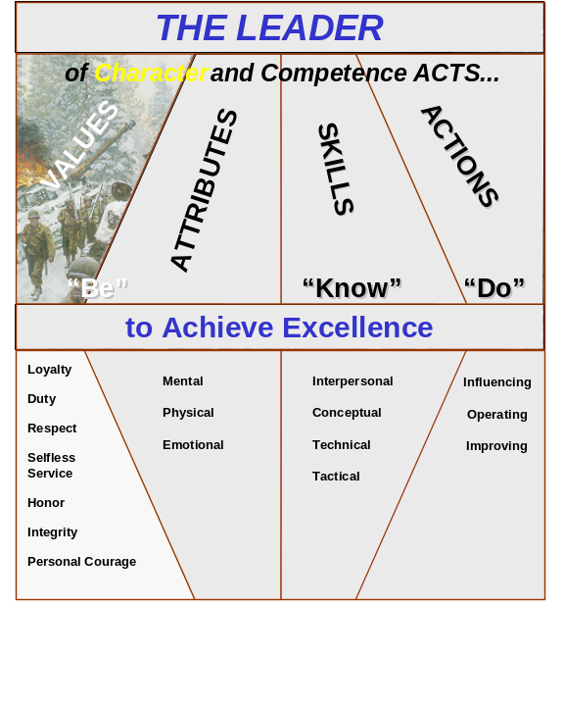

2-5. Army values remind us and tell the rest of the world—the civilian government we serve, the nation we protect, even our enemies—who we are and what we stand for. The trust soldiers have for one another and the trust the American people have in us depends on how well we live up to these values. They are the fundamental building blocks that enable us to discern right from wrong in any given situation or action. Finally, Army core values are consistent; they support one another. You cannot follow one value and ignore another.

2-6. These are the seven values that guide you, the leader, and the rest of America’s Army. They form the acronym LDRSHIP:

Loyalty
Duty
Respect
Selfless-service
Honor
Integrity
Personal Courage

Use this acronym to help you remember the Army values. Use this doctrine to help you understand what they mean and how the values work together in leadership.

2-7. The following discussions can help you understand these values, but understanding is only the first step. As a leader, you must not only understand them; you must believe in them, model them in your own actions, and teach others to accept and live by them.

- LOYALTY

Bear true faith and allegiance to the
U. S. Constitution, the Army, your unit, and other soldiers.

Loyalty is the big thing, the greatest battle asset of all. But no man ever wins the loyalty of troops by preaching loyalty. It is given to him as he proves his possession of the other virtues.

Brigadier General S. L. A. Marshall
Men Against Fire

2-8. Soldiers fight for each other—loyalty is commitment. You began your Army career by swearing allegiance to the Constitution, the basis of our government and laws. (It’s in Appendix F, if you have never read it or if it has been a while.). Pay particular attention to Article II, Section 8, which outlines Congressional responsibilities regarding the armed forces and Article III, Section 2, which designates the president as commander in chief.

2-9. From the founding of the republic, America’s Army has respected its subordination to our civilian political leaders. This subordination is fundamental to preserving our liberty. Beyond that, you have an obligation to be faithful to the Army—the institution and its people—and to your unit or organization. Loyalty is an obligation to subordinates, peers, and the larger organization (up to and including the nation). Loyalty is a two-way street: one should not expect loyalty without being prepared to give it as well. A leader can neither demand loyalty nor win it from his soldiers by talking about it. The loyalty of your soldiers is a gift they give you when, and only when, you deserve it—when you train them well, treat them fairly, and live by the concepts you talk about. The leader who is loyal to his subordinates never lets them be misused.

    - DUTY

Fulfill your obligations.

Duty is the sublimest word in our language. Do your duty in all things. You cannot do more; you should never wish to do less.

General Robert E. Lee

2-10. Duty begins with everything required of us by law, regulation, and orders; but it includes much more than that. We do our work not just to the minimum standard, but to the very best of our ability. Soldiers commit to excellence in all aspects of their professional responsibility so that when the job is done they can look back and say, “I couldn’t have given any more.”

2-11. Leaders take the initiative, figuring out what needs to be done before they must be told what to do. What is more, leaders take full responsibility for their actions and those of their subordinates. The leader never shades the truth to make the unit look good or even to make his subordinates feel good. Instead, he follows his higher duty to the Army. Leaders do not set the minimum standards as goals.

2-12. When a platoon sergeant tells a squad leader to inspect weapons, the squad leader has fulfilled his minimum obligation when he has checked the weapons. He has done what he was told to do. But if the squad leader finds weapons that are not clean or serviced, his sense of duty tells him to go beyond the platoon sergeant’s instructions. The squad leader does his duty when he corrects the problem and ensures the weapons are up to standard.

2-13. In extremely rare cases, you may receive an illegal order. Duty requires that you refuse to obey it. You have no choice but to do what is morally and legally correct. Use the Army values as your guide.

- RESPECT

Treat people as they should be treated.

The discipline which makes the soldiers of a free country reliable in battle is not to be gained by harsh or tyrannical treatment. On the contrary, such treatment is far more likely to destroy than to make an army. It is possible to impart instruction and to give commands in such manner and such a tone of voice to inspire in the soldier no feeling but an intense desire to obey, while the opposite manner and tone of voice cannot fail to excite strong resentment and a desire to disobey. The one mode or the other of dealing with subordinates springs from a corresponding spirit in the breast of the commander. He who feels the respect which is due to others cannot fail to inspire in them regard for himself, while he who feels, and hence manifests, disrespect toward others, especially his inferiors, cannot fail to inspire hatred against himself.

Major General John M. Schofield
in an address to the United States Military Academy Corps of Cadets
11 August 1879

2-14. Respect for the individual forms the basis for the rule of law, the very essence of what makes America. In the Army respect means recognizing and appreciating the inherent dignity and worth of all people. This value reminds the leader that soldiers are his greatest resource. Leaders honor the absolute value of being human and everyone’s individual worth by treating all people with dignity and respect.

2-15. As America becomes more culturally diverse, leaders must be aware that they will deal with people from a wider range of ethnic, racial, and religious backgrounds. Effective leaders are tolerant of beliefs different from their own as long as those beliefs do not conflict with Army values or are illegal or unethical. Leaders must also become students of culture in order to avoid misunderstandings that arise from cultural differences. This enables them to more effectively counsel their soldiers. In addition, trying to understand where soldiers are coming from and what is important to them shows respect.

2-16. Leaders must also foster a climate in which everyone is treated with dignity and respect regardless of race, gender, creed, or religious belief. Such a climate promotes consideration for others, fairness in all dealings, and equal opportunity for everyone. In essence, they treat others as they would wish to be treated if they were in that situation.

2-17. As part of this consideration, leaders create an environment where subordinates are challenged, where they can reach their full potential and be all they can be. Providing tough training does not demean subordinates; in fact, building their capabilities and showing faith in their potential is the essence of respect. Leaders take the time to learn what their subordinates want to accomplish. They advise their soldiers on how they can grow, personally and professionally. Not all of your subordinates will succeed and you may not like all of them, but they all deserve respect. GEN Douglas MacArthur said the leader must “learn to stand up in the storm but…have compassion for those who fall.”

2-18. The Army value of respect is also an essential component for the development of disciplined, cohesive, and effective warfighting units. In the deadly confusion of combat, soldiers often overcome incredible odds to accomplish the mission and protect the lives of their comrades. This spirit of selfless-service and duty is built on a soldier’s personal trust and regard for his fellow soldiers. A failure to cultivate a climate of respect or a willingness to tolerate discrimination or harassment on any basis eats away at this trust and erodes unit cohesion. But respect goes beyond issues of discrimination and harassment to include the broader issue of civility, the way we as soldiers treat each other and those we come in contact with. It involves being sensitive to diversity and behaviors that others may find insensitive, offensive, or abusive. Army soldiers and civilians, like their leaders, treat everyone with dignity and respect.

- SELFLESS-SERVICE

Put the welfare of the nation, the Army, and subordinates before your own.

The nation today needs men who think in terms of service to their country and not in terms of their country’s debt to them.

General of the Army Omar N. Bradley

2-19. You have often heard the military referred to as “the service.” We work for—that is, we serve—the United States. Selfless-service means doing what is right for the nation, the Army, the organization, and your soldiers—and putting these responsibilities above your own interests. The needs of the Army and the nation come first. This does not mean that you neglect your family or yourself; in fact, such neglect weakens a leader and can cause the Army more harm than good. Selfless-service does not mean that you cannot have a strong ego, high self-esteem, or even healthy ambition. Rather, selfless-service means that you do not make decisions and take actions that will help your image or your career but will hurt others or sabotage the mission. The selfish leader claims credit for work his subordinates do; the selfless leader gives credit to those who earned it. The Army cannot function except as a team, and for a team to work, the individual has to give up self-interest for the good of the whole. Soldiers are not the only members of the Total Army who display selfless-service. DA civilians display this value as well.

2-20. Then Army Chief of Staff, Gordon R. Sullivan assessed the civilian contribution to Operation Desert Storm this way: Not surprisingly most of the civilians deployed to Southwest Asia volunteered to serve there. But the civilian presence in the Gulf region meant more than moral support and filling in for soldiers. Gulf War veterans say that many of the combat soldiers could owe their lives to the DA civilians who helped maintain equipment by speeding up the process of getting parts and other support for 60 logistics agencies Army-wide.

2-21. As GEN Sullivan’s comment indicates, selfless-service is an essential component of teamwork. Members give of themselves so that the team may succeed. In combat, some soldiers give themselves completely so that their fellows may live and the mission accomplished. An example of a soldier who demonstrated the value of selfless-service is Private Rodger A. Young.

Character Example⎯PVT Rodger A. Young

When the draft started for World War II, Rodger Young was not able to pass the entrance physical. But the Ohio National Guard loosened its requirements and he enlisted and shipped out for the Pacific. During the jungle training before the Solomon Island campaign, his physical condition worsened. Believing that he might put his men at risk, he asked to be demoted from platoon sergeant to private.
Later, on New Georgia, the Solomon Islands, intense fire from a Japanese machine gun only 75 yards away pinned Young’s platoon down and wounded him with its initial burst. PVT Young yelled that he could see the enemy emplacement, and started creeping toward it. Another burst from the machine gun wounded him a second time. Despite the wounds PVT Young kept advancing, attracting fire and shooting back. When he got close enough, he threw hand grenades until he was hit again and killed. His selfless-service allowed his platoon to maneuver without loss; PVT Rodger A. Young’s heroism earned him the Medal of Honor.

- HONOR

Live up to all the Army Values.

What is life without honor? Degradation is worse than death.

General Thomas J. “Stonewall” Jackson

2-22. Honor is one of those words that many use but few try to define. You see it carved on public buildings or on your local war memorial. You can read about it in books and hear it used in everything from speeches to combat bravery. It includes reverence for truth (honesty), commitment to justice (fairness), and respect for the property of others. Honor means demonstrating an understanding of what is right and always living so that your reputation is above reproach.

2-23. For the Army, honor’s primary meaning is this: Live up to all the Army values. Implicitly this is what you promised when you pinned on your rank, when you put on your uniform this morning. You made this promise publicly, and the standards—the Army values—are also public. To be an honorable person, you must be true to your oath of enlistment and live the Army values in all you do. Living honorably brings alive the Army values; it means putting the Army values above all other loyalties, above self-interest, above career and comfort—even above self-preservation.

2-24. Honesty and integrity form the foundation of honor. Being honest means being truthful and upright all the time, despite pressures to do otherwise. We are honest to ourselves by being committed to consistently living all the Army values, and we are honest with others by not presenting ourselves or our actions as something other than what they are. In the military, we rely on the sanctity of a soldier’s word of honor. We say what we mean and we do what we say. If we cannot accomplish a mission, we inform the chain of command. If we inadvertently pass bad information, we correct it as soon as we find out it is wrong. This forthrightness is essential for creating a bond of trust among soldiers and between America’s Army and the nation it serves.

2-25. A person of honor has the strength of will to live according to Army values, even when the temptations to do otherwise are strong, even in the face of personal danger. The military’s highest award is the Medal of Honor. Its recipients did not do just what was required of them; they did not even do just what was expected of them. They went above and beyond the call of duty. Some, like PVT Rodger A. Young, gave their own lives so that others could live. They went as far as humanly possible. It is fitting that the word we use to describe their achievement is “honor.”

- INTEGRITY

Do what’s right—legally and morally.

The American people rightly look to their military leaders not only to be skilled in the technical aspects of the profession of arms, but also to be men of integrity.

General J. Lawton Collins
Former Army Chief of Staff

2-26. Your integrity demands that you always act according to personal and professional principles. It means being both morally complete and behaviorally upright. As contrasted with honor, integrity signifies a character manifested by consistency in action. A leader of integrity always acts according to principles to which he is committed. Soldiers of integrity possess high personal moral standards and are honest in word and deed. They show an uncompromising adherence to moral principles; they do the right thing not because it is convenient or because they have no choice. They do right because they have a choice and they choose well. Integrity requires three steps:

- Discerning what is right from what is wrong.
- Acting on what you have discerned, even at personal cost.
- Saying openly that you are acting on your understanding of right from wrong.”

2-27. Leaders cannot hide what they do; that is why you must carefully decide how you act. Now that you are a leader, you are always on display; you must internalize and demonstrate the Army values if you want to instill them in others. Now your personal values (integrity) may include things that are not part of the Army values, things such as your political beliefs. These personal values may add to, but must not conflict with, Army values. The point of having integrity as a value is to ensure personal values are consistent with Army values. Be ready to answer for how you act, not to defend yourself, but to show others what it means to know, do, and say what is legally and morally correct.

- PERSONAL COURAGE

Face fear, danger, or adversity
(physical or moral).

The concept of professional courage does not always mean being as tough as nails either. It also suggests a willingness to listen to the soldiers’ problems, to go to bat for them in a tough situation, and it means knowing just how far they can go. It also means being willing to tell the boss when he’s wrong.

Former Sergeant Major of the Army William Connelly

2-28. Personal courage is not the absence of fear; rather, it is the ability to put fear aside and do what is necessary. It takes two forms, physical and moral. Good leaders demonstrate both.

2-29. Physical courage is the bravery that allows a soldier to take risks in combat in spite of the fear of wounds or death. Physical courage is what gets the soldier at Airborne School out the aircraft door. It is what allows an infantryman to assault a bunker to save his buddies.

2-30. In contrast, moral courage enables leaders to stand up for what they believe is right, regardless of the consequences. The leader who takes responsibility for his decisions and actions, even when things go wrong, displays moral courage. Courageous leaders are willing to look critically inside themselves, consider new ideas, and change what needs changing.

2-31. Moral courage can be overlooked, both in discussions of personal courage and in the everyday rush of business. A DA civilian attending a mobilization planning meeting heard courage mentioned several times in the context of combat. She pointed out that consistent moral courage is every bit as important as momentary physical courage. Situations that require physical courage are rare; situations requiring moral courage can occur continually. Moral courage is essential to living the Army values of integrity and honor every day.

2-32. In combat physical and moral courage may blend together. The right thing to do may not only be unpopular, but dangerous as well. Situations of that sort reveal who is a leader of character and who is not. Consider this example.

Character Example⎯WO1 Thompson at My Lai

Personal courage, whether physical, moral, or a combination of the two, may be manifested in a variety of ways both on and off the battlefield. On March 16, 1968 WO1 Hugh C. Thompson, Jr., and his two-man crew were on a reconnaissance mission over the village of My Lai in the Republic of Vietnam. Thompson watched in horror as he saw an American soldier shoot an injured Vietnamese girl. Minutes later when he observed American soldiers advancing on a number of civilians in a ditch, he landed his helicopter and questioned a young officer about what was happening on the ground. Told that the ground action was none of his business, Thompson took off and continued to circle the area.
When it became apparent that the soldiers were now firing on civilians, WO1 Thompson landed his helicopter between the soldiers and a group of 10 villagers who were headed for a homemade bomb shelter. Ordering his gunner to train his weapon on the approaching American soldiers and to fire if necessary, he personally coaxed the civilians out of the shelter and airlifted them to safety. His radio reports of what was happening were instrumental in bringing about the cease fire order that saved the lives of more civilians. WO1 Thompson’s willingness to place himself in physical danger in order to do the morally right thing is a sterling example of personal courage, the manifestation of physical and moral courage.

ATTRIBUTES

Leadership is not a natural trait, something inherited like the color of eyes or hair…Leadership is a skill that can be studied, learned, and perfected by practice.
The Noncom’s Guide, 1962
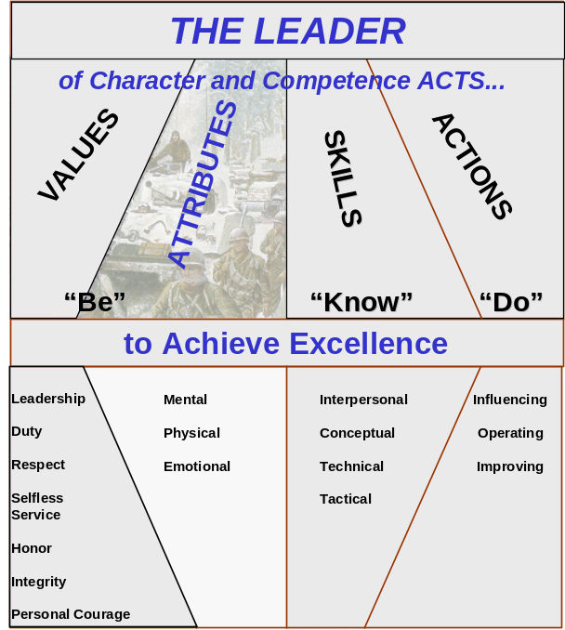

Figure 2-2. Leader Attributes

2-33. Values tell us part of what the leader must BE; the other side of what a leader must BE are the attributes highlighted in Figure 2-2. Leader attributes influence leader actions; leader actions, in turn, always influence the unit or organization. As an example, if you are physically fit, you are more likely to inspire your subordinates to be physically fit.

2-34. Attributes are a person’s fundamental qualities and characteristics. People are born with some attributes; for instance, genetics determine eye, hair, and skin color. However, other attributes are learned and can be changed; successful leaders work to improve those attributes. Leader attributes can be characterized as mental, physical, and emotional.

- MENTAL ATTRIBUTES

2-35. The mental attributes of a leader include will, self-discipline, initiative, judgment, self-confidence, intelligence, and cultural awareness.

Will

The will of soldiers is three times more important than their weapons.

Colonel Dandridge M. “Mike” Malone
Small Unit Leadership: A Commonsense Approach

2-36. Will is the inner drive that compels soldiers and leaders to keep going when they are exhausted, hungry, afraid, cold, and wet—when, in short, it would be easier to quit. Will enables soldiers to press the fight to its conclusion. Yet will without competence is useless. It is not enough that soldiers are willing, or even eager, to fight; they must know how to fight. Likewise, soldiers who have competence but no will do not fight. The leader’s task is to develop a winning spirit by building subordinate's skill and will. That begins with hard, realistic training.
Self-Discipline

2-37. The self-disciplined soldier is master of his impulses. This mastery comes from the habit of doing the right thing. Self-discipline allows leaders to do the right thing regardless of the consequences for them or their subordinates. Under the extreme stress of combat—when you might be cut off and alone, fearing for your life, and having to act without guidance or knowledge of what is going on around you—you, the leader, must still think clearly and act reasonably—just as CPT Murray did. Self-discipline is the key to this kind of behavior.

2-38. In peacetime self-discipline gets the unit out for the hard training. Self-discipline makes the tank commander demand another run-through of a battle drill if the performance is not up to standard—even though everyone is long past ready to quit. This does not mean you never get tired or discouraged—after all, you are only human. It does mean you do what needs to be done in spite of being tired and discouraged.

Historical Example⎯The Fight in the Ia Drang Valley

I took command of the company in the middle of a firefight in the Ia Drang Valley when the commander and first sergeant were killed. I went in with another rifle company, the relief force, and by the time we fought our way through there were thirteen killed and over thirty wounded, including my friend, the dead company commander.
I thought it was going to be the shortest command in history. The enemy had us surrounded. That night we could hear them forming up to attack, hollering and cheering like they were at a pep rally before a football game. I called in indirect fire whenever I heard them.
I'm sitting there in the rain with a pile of bodies, including my predecessor. So I get out my ammo and my grenades and I bring my people in tight and I just hold on. At one point we counted the enemy mortars. You could hear the thud of a round being fired; we counted sixteen rounds in the air before the first one hit, and let me tell you, that's the definition of a long wait.

Captain Charles A. Murray
Company A, 2d Battalion, 35th Infantry
discussing combat action of 2-3 August 1966

Initiative

The leader must be an aggressive thinker⎯always anticipating and analyzing. He must be able to make good judgements and solid tactical judgements.

Brigadier General John. T. Nelson, II

2-39. Initiative is the ability to be a self-starter—to act when there are no clear instructions, to act when the situation changes or when the plan falls apart. In the operational context, it means seizing and dictating the terms of action throughout the battle or operation. An individual leader with initiative is willing to decide and initiate independent actions when the concept of operations no longer applies or when an unanticipated opportunity leading to accomplishment of the commander’s intent presents itself. Initiative drives the leader to seek a better method, anticipate what must be done, and perform without waiting for instructions. Balanced with good judgment, it becomes disciplined initiative, an essential leader attribute. (FM 100-5 discusses initiative as it related to military actions at the operational level. FM 100-34 discusses the relationship of initiative to command and control. FM 100-40 discusses the place of initiative in the art of tactics.)

2-40. As a leader, you cannot just give orders: you must make clear the intent of those orders, the final goal of the mission. In combat, it is critically important for subordinates to understand their commander’s intent because they may be cut off or enemy actions may derail the original plan. Soldiers who understand the intent will apply disciplined initiative to accomplish the mission. Initiative can be bred into a leader just as easily as it can be bred out. Leaders who underwrite honest mistakes will develop subordinates with initiative. Zero defects leaders will strangle initiative in its cradle, the hearts of subordinates.

Historical Example⎯The Quick Reaction Platoon

On 26 December 1994 a group of armed and disgruntled members of the Haitian Army entered the Haitian Army headquarters in Port-au-Prince demanding back pay. A gunfight ensued less that 150 meters from the ground of the Haitian Palace, seat of the new government. American soldiers from C Company, 1-22 Infantry, who had deployed to Haiti as part of Operation Uphold Democracy, were guarding the palace grounds. The quick reaction platoon leader was ordered to deploy and immediately maneuvered his platoon towards the gunfire. The platoon attacked, inflicting at least four casualties and causing the rest of the hostile soldiers to flee. The platoon quelled a potentially explosive situation by responding correctly and aggressively to the orders of their leader, who knew his mission and the commander’s intent.

Judgment

I learned that good judgment comes from experience and that experience grows out of mistakes.

General of the Army Omar N. Bradley

2-41. Good judgment is the ability to size up a situation quickly, determine what is important, and do what needs to be done. It is a key attribute of the art of command and the transformation of knowledge into understanding. (FM 100-34 discusses how leaders take data and information and combine it with analysis, evaluation, and judgement to reach knowledge and understanding. FM 100-6 discusses how this process applies to information operations). Leaders must often juggle hard facts, questionable data, and gut-level intuition to arrive at a decision.

2-42. Good judgment means making the best decision for the situation. You should consider a range of alternatives before you act. You also need to think through the consequences of what you are about to do before you do it. In addition to considering the consequences, you should also think methodically. Some sources that aid judgment are the boss’s intent; the desired goal; rules, laws and regulations; experience; and values. Good judgment also includes the ability to size up subordinates, peers, and the enemy for strengths, weaknesses, and potential actions.

2-43. As mentioned above, judgment and initiative go hand in hand. As an Army leader, you must weigh what you know and make decisions in situations where others do nothing. There will be times when you will have to make decisions under severe time constraints. In all cases, however, the you must take responsibility for your actions. In addition, you must encourage disciplined initiative in, and teach good judgment to, your subordinates. Help your subordinates learn from mistakes by coaching and mentoring them along the way.

Self-Confidence

2-44. Self-confidence comes from competence. Leaders who know their own capabilities and believe in themselves are self-confident. Self-confidence is based on mastery of skills, which takes hard work and dedication. Soldiers want self-confident leaders. In combat, self-confidence helps soldiers control doubt and reduce anxiety. Do not mistake bluster—loud-mouthed bragging or self-promotion—for self-confidence. The truly self-confident leader does not need to advertise; his actions say it all.

Intelligence

2-45. Intelligent leaders think, learn, reflect, and apply what they have learned. Intelligence is more than knowledge, and the ability to think is not the same as book-smarts. All of us have some intellectual ability that, when developed, allows us to analyze and understand a situation. And although some people are smarter than others, all of us can develop the capabilities we have. Napoleon himself observed how a leader’s intellectual development applies directly to battlefield success:

It is not genius which reveals to me suddenly and secretly what I should do in circumstances unexpected by others; it is thought and meditation.

2-46. Knowledge, such as what we gain in Army schools, is only part of the equation. Smart decisions result when you combine professional skills (which your learn through study) with experience (which you gain on the job), and your ability to reason through a problem based on the information available. Reflection is also important. From time to time, you find yourself carefully and thoughtfully considering how leadership, values, and other military principles apply to you and your job. When a mission is accomplished, intelligent leaders are confident enough to step back and ask, “Why did things turn out that way?” Then they are smart enough to avoid making the same mistake again.

2-47. Reflection also contributes to your originality (the ability to innovate, rather than only adopt others’ methods) and intuition (understanding the important aspects of a situation). Remember COL Chamberlain at Little Round Top. To his soldiers it sometimes appeared that he could “see through forests and hills and know what was coming.” But this was no magical ability. Through study and reflection, the colonel had learned how to study terrain and imagine how the enemy might attempt to use it to his advantage. He had applied his intelligence and developed his intellectual capabilities. Good leaders follow COL Chamberlain’s example.

Cultural Awareness

2-48. Culture is the sum total of beliefs, values, and assumptions about what is important that are shared by a group. Even within our Army, soldiers come from widely different backgrounds, shaped by their schooling, ethnicity, and religion as well as a host of other influences. Although they share the same Army values, an African-American man from rural Texas may look at many things differently from, say, a third generation Irish-American man who grew up in Philadelphia or a Native American woman from the Pacific Northwest.

2-49. Army values are part of our Army culture, a starting point for how we as an Army should think and act. Beyond that, leaders not only recognize that people are different; they value them because of their differences, because they are people. Your job as a leader is not to make everyone the same; even if that were possible, it would make a boring team. Rather, your job is to take advantage of the fact that everyone is different. There is great diversity in the Army—religious, ethnic, and social—and people of different backgrounds bring different talents to the table. By joining the Army, these people have agreed to belong to the Army culture. The leader makes this easier by embracing and making use of all those talents. What is more, he creates a team where subordinates know they are valuable, that the talents they bring are important.

2-50. During World War II US Marines from the Navajo nation formed a group of radio communications specialists dubbed the Navajo Code Talkers. The code talkers used their native language—a unique talent—to handle command radio traffic. Not surprisingly, even the best Japanese code breakers could not decipher what was being said.

2-51. Cultural awareness is also crucial when your organization is part of a multinational force. In such situations, leaders take the time to learn the customs and traditions of our partners’ cultures. They learn how and why they think and act as they do. In multinational forces, effective leaders create a “third culture,” which is the bridge or the compromise among partners. Understanding the culture of the operational environment, as well as our partners’ cultures, is equally important.

Historical Example⎯GEN Eisenhower Forms SHAEF

One of GEN Dwight D. Eisenhower’s toughest jobs in the World War II European Theater was to create an environment where the Allies could work together. The forces under his command—American, British, French, Canadian, and Polish—brought not only different languages, but different ways of thinking, different ideas about what was important, and different strategies. GEN Eisenhower could have tried to bend everyone to his will and his way of thinking; he was the boss, after all. But it is doubtful the Allies would have fought as well for a bullying commander or that a bullying commander would have survived politically. Instead, he created a positive command climate that made best use of the various capabilities of his subordinates. This kind of work takes tact, patience, and trust. It does not destroy existing cultures but creates a new one.

- PHYSICAL ATTRIBUTES

2-52. Physical attributes—health fitness, physical fitness, military bearing, and professional bearing—can be developed. While there is no standard of physical fitness or military bearing for civilians, many characteristics of the four physical attributes apply. Army leaders maintain the appropriate level of physical fitness and military bearing.

Health Fitness

Disease was the chief killer in the [American Civil] war. Two soldiers died of it for every one killed in battle…In one year, 995 of every thousand men in the Union army contracted diarrhea and dysentery.

Geoffrey C. Ward
The Civil War

2-53. Health fitness is everything the leader does to maintain good health, such things as undergoing routine physical exams, practicing good dental hygiene, maintaining deployability standards, and even personal grooming and cleanliness. A soldier unable to fight because of dysentery is as much of a loss as one who is wounded. Healthy soldiers can perform under extremes in temperature, humidity, and other conditions better than unhealthy ones. Health fitness also includes avoiding those things that are bad for one's health such as substance abuse, obesity, and smoking.

Physical Fitness

Fatigue makes cowards of us all.

General George S. Patton, Jr.
Commanding General, Third Army, World War II

2-54. Unit readiness begins with physically fit soldiers and leaders. Combat drains soldiers physically, mentally, and emotionally. To minimize those effects, leaders are physically fit, and they make sure their subordinates are fit also. Physically fit soldiers perform better in all areas, and physically fit leaders are better able to think, decide, and act appropriately under pressure. Physical readiness provides a foundation for combat readiness, and it is up to you, the leader, to get your soldiers ready.

2-55. Although physical fitness is a crucial element of success in battle, it is not just for frontline soldiers. Wherever they are, people who are physically fit feel more competent and confident. That attitude reassures and inspires those around them. Physically fit soldiers and DA civilians can handle stress better, work longer and harder, and recover faster than ones who are not fit. These payoffs are valuable in both peace and war.
2-56. The physical demands of leadership positions, prolonged deployments, and continuous operations can erode more than just physical attributes. Soldiers must show up ready for deprivations because it is difficult to maintain high levels of fitness during deployments and demanding operations. Trying to get fit under those conditions is even harder. Without appropriate physical fitness, the effects of additional stress snowball until mental and emotional fitness are also compromised. Leaders’ physical fitness has greater significance, since their decisions affect their units’ combat effectiveness, health, and safety—not just their own.

2-57. The APFT is an important tool for measuring physical fitness; but it is not a final goal. Pushups develop upper body strength—and that is good—but no one is going to ask a soldier to do pushups in battle. Unit fitness programs that only work to improve soldiers’ APFT scores will probably be boring and may not prepare those soldiers for the varied stresses of combat. Effective leaders devise varied, interesting, and challenging physical training that is focused on battle skills. They build their subordinates’ desire to gain and maintain the physical fitness needed in battle. FM 21-20 offers help and ideas for physical training programs.

2-58. GEN George C. Marshall summed up the importance of physical fitness this way:

You have to lead men in war by requiring more from the individual than he thinks he can do. You have to lead men in war by bringing them along to endure and to display qualities of fortitude that are beyond the average man’s thought of what he should be expected to do. You have to inspire them when they are hungry and exhausted and desperately uncomfortable and in great danger; and only a man of positive characteristics of leadership, with the physical stamina [fitness] that goes with it, can function under those conditions.

Military and Professional Bearing

2-59. As a military leader, you are expected to look like a soldier. Know how to wear the uniform and wear it with pride at all times. Maintain physical fitness and meet height and weight standards. By the way you carry yourself and through their military courtesy and appearance, you send a signal: I am proud of my uniform, my unit, and myself. Skillful use of your professional bearing⎯fitness, courtesy, and military appearance⎯can often help you manage difficult situations. A professional, DA civilian or soldier, presents a professional appearance, but there is more to being an Army professional than looking good. Professionals are competent as well; the Army requires you to both look good and be good.

- EMOTIONAL ATTRIBUTES

Anyone can become angry—that is easy. But to be angry with the right person, to the right degree, at the right time, for the right purpose, and in the right way--that is not easy.

Aristotle
Greek philosopher and tutor to Alexander the Great

2-60. As a leader, your emotional attributes—self-control, balance, and stability—contribute to how you feel and therefore to how you interact with others. Your people are human beings with hopes, fears, concerns, and dreams. When you understand that will and endurance come from emotional energy, you wield a powerful leadership tool. The feedback you give can help your subordinates use emotional energy to accomplish amazing feats in tough times.

2-61. Emotional attributes also help leaders make the right moral choices. Important ethical decisions “in life stem from the…ability to use self-control, to remain balanced and to be stable in the face of adversity. [The leader] is not at the mercy of impulse.” The most effective leaders display self-control and remain calm under pressure. They “watch their lanes” and expend energy on things they can fix. They inform their boss of those things they cannot. They do not worry about things they cannot affect.

Character Example⎯Self Control in Combat

An American infantry company in Vietnam had been taking a lot of casualties from booby traps. The soldiers were frustrated because they could not fight back. One night, snipers ambushed the company near a village, killing two soldiers. The rest of the company—scared, anguished, and frustrated—wanted to enter the village, but the commander—who was just as angry—knew that the snipers were long gone. Further, he knew that there was a danger his soldiers would let their emotions get the upper hand, that they might injure or kill some villagers out of a desire to strike back at something. Besides being criminal, such killings would drive more villagers to the Viet Cong. The commander maintained control of his emotions, and the company avoided the village.

2-62. Leaders who are emotionally mature also have a better awareness of their own strengths and weaknesses. Mature leaders spend their energy on self-improvement, whereas immature leaders spend their energy denying there is anything wrong. Mature, less defensive leaders benefit from constructive criticism in ways that immature people cannot.

Self-Control

2-63. Leaders keep a handle on their emotions. No one wants to work for a hysterical leader⎯he might lose control in a tough situation. This does not mean you never show emotion. Instead, you must display the proper amount of emotion and passion⎯somewhere between too much and too little⎯required to tap into the emotional wellsprings of your subordinates. Maintaining self-control inspires calm confidence in subordinates—the coolness under fire so essential to a successful unit—and encourages subordinate feedback that expands the leader’s sense of what is really going on.

Balance

2-64. Emotionally balanced leaders display the right emotion for the situation and can also read others’ emotional state. These leaders know when it is time to send a message that things are urgent, and how to do that without sending the unit into a tailspin. They also know how to encourage soldiers at the toughest moments and keep them driving on.

Stability

Never let yourself be driven by impatience or anger. One always regrets having followed the first dictates of his emotions.
Marshall de Belle-Isle
French Minister of War, 1757-1760

2-65. Effective leaders are steady, level-headed under pressure, and calm in the face of danger. By this they calm their subordinates, who are always looking to their example. Display the emotions you want your people to display; don’t give in to the temptation to do what feels good for you. If you are under great stress, it might feel better to vent—scream, throw things, kick furniture—but that will not help the unit. If you want your subordinates to be calm and rational under pressure, you must be also.

Historical Example—BG Jackson at First Bull Run

At a crucial juncture in the First Battle of Bull Run, the Confederate line was being beaten back from Matthews Hill by Union forces. Confederate BG Thomas J. Jackson and his 2,000-man brigade of Virginians, hearing the sounds of battle to the left of their position, pressed on to the action. In spite of a painful shrapnel wound, BG Jackson calmly placed his men in a defensive position on Henry Hill and offered them reassurances that all was well. As men of the broken regiments flowed past, one of the officers, BG Barnard E. Bee, exclaimed to BG Jackson, “General, they are driving us!” Looking toward the direction of the enemy, GEN Jackson replied, “Sir, we will give them the bayonet.” Impressed by Jackson’s confidence and self-control, BG Bee rode off towards what was left of the officers and men of his brigade. As he rode into the throng he gestured with his sword toward Henry Hill and shouted, “Look, men! There is Jackson standing like a stone wall! Let us determine to die here, and we will conquer! Follow me!” BG Bee would later be mortally wounded, but the Confederate line stiffened and the nickname he gave to BG Jackson would live on in American military history. This is a prime example of how one leader’s self-control under fire affected not only his own soldiers, but the leaders and soldiers of another unit, thereby turning the tide of battle.

- FOCUS ON CHARACTER

2-66. Earlier in the chapter, you read how character is made up of two interacting sets of principles: values and attributes. People enter the Army with values and attributes they have developed over the course of a lifetime, but those are just the starting points for further character development. Leaders continuously develop in themselves and their subordinates the Army values and leader attributes shown in Figure 1-1. This is not just an academic exercise, another lecture topic to be addressed once a year. A person's character comes through in his actions on and off duty.

2-67. Character helps you determine what is right and do it, regardless of the circumstances or the consequences. What is more, an informed moral conscience consistent with Army values steels you for making the right choices when faced with tough questions. Since Army leaders seek to do what is right and inspire others to do the same, you must be concerned with character development. Examine the actions described below and consider the aspects of character that contributed to them.

Historical Example—Character and Prisoners

The morning of [28 February 1991], about a half hour prior to the cease-fire, we had a T-55 tank in front of us and we were getting ready [to engage it with a TOW]. We had the TOW up and we were tracking him and my wingman saw him just stop and a head pop up out of it. And Neil started calling me saying, “Don’t shoot, don’t shoot, I think they're getting off the tank.” And they did. Three of them jumped off the tank and ran around a sand dune. I told my wingman, “I’ll cover the tank, you go on down and check around the back side and see what's down there.” He went down there and found about 150 POWs, so the only way we could handle that many was just to line them up and run them through…a little gauntlet, and we had to check them for weapons and stuff and we lined them up and called for the POW handlers to pick them up. It was just amazing. We had to blow the tank up. My instructions were to destroy the tank, so I told them to go ahead and move it around the back side of the berm a little bit to safeguard us, so we wouldn’t catch any shrapnel or ammunition coming off. When the tank blew up, these guys started yelling and screaming at my soldiers, “Don’t shoot us, don’t shoot us,” and one of my soldiers said, “Hey, we’re from America; we don’t shoot our prisoners.” That sort of stuck with me.

A Platoon Sergeant, Desert Storm

2-68. The soldier’s comment at the end of this story captures the essence of character. He said, “We’re from America…” He defined, in a very simple way, the connection between who we are—our character—and what we do. This example illustrates character—shared values and attributes—telling soldiers what to do and what not to do. However, it is interesting for other reasons. Read the piece again: You can almost feel the surprise the soldiers felt when they realized what the Iraqi prisoners were afraid of. You can picture the young soldier, nervous, hands on his weapon, but still managing to be a bit amused. The right thing, the moral choice, was so deeply ingrained in these soldiers that it never occurred to them to do anything other than safeguard the prisoners.

Historical Example⎯The Battle of the Bulge

In December 1944 the German Army launched its last major offensive on the Western Front, sending massive infantry and armor formations into a lightly-held sector of the Allied line in Belgium. American units were overrun. Thousands of green troops, sent to that sector because it was quiet, were captured. The German war machine was on the move again, and for two desperate weeks the Allies fought to check the enemy advance. The 101st Airborne Division was sent to the town of Bastogne. The Germans needed to control the crossroads there to move equipment to the front; the 101st was there to stop them.
Outnumbered, surrounded, low on ammunition, out of medical supplies, and with wounded piling up, the 101st, elements of the 9th and 10th Armored Divisions, and a tank destroyer battalion fought off repeated attacks through some of the coldest weather Europe had seen in fifty years. Wounded men froze to death in their foxholes. Paratroopers fought tanks. Nonetheless, when the German commander demanded American surrender, BG Anthony C. McAuliffe, acting division commander, sent a one word reply: “Nuts.”
The Americans held. By the time the Allies regained control of the area and pushed the Germans back, Hitler’s “Thousand Year Reich” had fewer than four months to live.

2-69. BG McAuliffe spoke based on what he knew his soldiers were capable of, even in the most extreme circumstances. This kind of courage and toughness did not develop overnight. Every man on the Allied side brought a lifetime’s worth of character to that battle; that character was the foundation for everything else that made them successful.

Character Example⎯GEN Eisenhower’s Message

On 5 June 1944 with his hundreds of thousands of soldiers, sailors and airmen poised to invade France, GEN Dwight D. Eisenhower took a few minutes to draft a message he hoped he would never deliver. It was, according to Paul Fussell in his book Wartime, the “statement he wrote out to have ready when the invasion was repulsed, his troops torn apart for nothing, his planes ripped and smashed to no end, his warships sunk, his reputation blasted.”
In his hand written statement, he began, “Our landings in the Cherbourg-Havre area have failed to gain a satisfactory foothold and I have withdrawn the troops.” Originally he had written, the “troops have been withdrawn,” a use of the passive voice that conceals the actor. But he changed the wording to reflect his acceptance of full personal accountability.
GEN Eisenhower goes on to say, “My decision to attack at this time and place was based on the best information available.” And after recognizing the courage and sacrifice of the troops he says, “If any blame or fault attaches to this attempt, it is mine alone.”

2-70. GEN Eisenhower, in command of the largest invasion force ever assembled and poised on the eve of a battle that would decide the fate of millions of people, was guided by the same values and attributes that shaped the actions of the soldiers in the Desert Storm example. His character allowed for nothing less than acceptance of total personal responsibility. If things went badly, he was ready to take the blame. When things went well, he gave credit to his subordinates. The Army values GEN Eisenhower personified provide a powerful example for all soldiers.

- CHARACTER DEVELOPMENT

2-71. Soldiers come to the Army with a character formed by their background, religious or philosophical beliefs, education, and experience. A leader’s job would be a great deal easier if we could check the new soldier's values the way we check teeth or run a blood test. We could figure out what values were missing by a quick glance at Figure 1-1 and administer the right combination, maybe with an injection or magic pill.

2-72. But character development is a complex, lifelong process. No scientist can point to a person and say, “This is when it all happens.” But there are a few things we can count on. We build character in subordinates by creating units in which Army values are not just a table in a book, but are the precepts for what we do. We help to build subordinates’ character by acting the way we want them to act. We teach by example, and we coach along the way. When we hold ourselves and our subordinates to the highest standards, we reinforce the values those standards embody. They spread throughout the unit, throughout the Army, like the waves from a pebble dropped into a pond.

- CHARACTER AND ETHICS

2-73. When we talk about character, we help soldiers answer the question, What kind of person should I be? Character is important in living a consistent, moral life, but character does not always provide the final answer to the specific question, What should I do? Finding that answer can be called ethical reasoning. We must not only embrace the Army's values and attributes but also use them to think, reason, and—after reflection—act.

- ETHICAL REASONING

2-74. Leaders strive to do the right things for the right reasons all the time, even when no one is watching. But the right action in the situation you face may not be in regulations or field manuals. Even the most exhaustive regulations cannot predict every situation. Remember COL Chamberlain on Little Round Top. The drill manuals he had studied did not contain the solution to the tactical problem he faced; neither will this nor any other manual contain the cookbook solutions to any ethical questions you might confront. COL Chamberlain applied the doctrine he learned from the drill manuals. So must you apply the Army values to any decision you make. The ethical reasoning process below can help you do this.

2-75. Useful steps for ethical reasoning are⎯

- Define the problem.
- Know the principles.
- Develop and evaluate courses of action.
- Choose the course of action which best represents Army Values.

2-76. These steps correspond to some of the steps of the decision making leadership action discussed in Chapter 5. Thus, ethical reasoning is not a separate process you trot out only when you think you are facing an ethical question. It should be part of the thought process you use to make any decision. Your soldiers count on you to do more than make decisions that are tactically sound. They rely on you to make decisions that are morally right as well. You should always consider ethical factors and, when necessary, use the Army values as a gauge of what is right.

2-77. That said, not every decision is an ethical problem. In fact, most decisions are ethically neutral. But that doesn’t mean you don’t have to think about the ethical consequences of your actions. Only if you reflect, from time to time, on whether what you are asked to do or what you ask your soldiers to do accords with the Army values will you develop that sense of right and wrong that marks moral people and great leaders. That sense of right and wrong will alert you to the presence ethical aspects when you face a decision.

2-78. Ethical reasoning is an art, not a science, and sometimes the best answer is going to be hard to determine. Often, the hardest decisions are not between right and wrong, but between shades of right. Regulations may allow more than one choice. There may even be more than one good answer, or there may not be enough time to conduct a long review. In those cases, you must rely on your judgment.

Define the Problem

2-79. Defining the problem is the first step in making any decision. When you think a decision may have ethical aspects or effects, it is especially important to define it precisely. Know who said what, and what—specifically—was said, ordered, or demanded. Do not settle for second-hand information; get the details. Problems can be described in more than one way. This is the hardest step in solving any problem. It is especially difficult for decisions in the face of potential moral conflicts. Too often we come to rapid conclusions about the nature of a problem and end up applying solutions to what are symptoms.

Know the Principles (Rules and Regulations)

2-80. This step is part of fact gathering, the second step in problem solving. Do your homework. Sometimes what looks like an ethical problem may stem from a misunderstanding of a regulation or policy, frustration, or over enthusiasm. Sometimes the person who wrote an order or made a demand did not check the regulation first, and a thorough reading may make the problem go away. Other times, a difficult situation results from trying to do something right in the wrong way. Also, some regulations leave room for interpretation; the problem then becomes a policy matter rather than an ethical matter. If you do perceive an ethical issue, explain it to the person causing it, and try to come up with a better way to do the job.

Develop and Evaluate Courses of Action

2-81. Once you know the rules, lay out possible courses of action. As with the previous steps, you do this whenever you must make a decision. Next, consider these courses of action in view of the Army values. Consider the consequences of your courses of action by asking yourself a few practical questions. Which course of action best upholds the Army values? Do any of the courses of action compromise Army values? Does any course of action violate a principle, rule, or regulation identified in Step 2? Which course of action is in the best interest of the Army and of the nation? This part will feel like a juggling act, but with careful moral reflection, the leader can reduce the chaos, determine the essentials, and choose the best course—even when that choice is the least bad of a set of undesirable options.

Choose the Course of Action That Best Represents Army Values

2-82. The last step in solving any problem is making a decision and acting on it. Leaders are paid to make decisions. As an Army leader, you are expected⎯by you bosses and your people⎯to make decisions that solve problems without violating the Army values.

2-83. As a values-based organization, the Army uses expressed values⎯the Army values⎯to provide its fundamental ethical framework. The Army values lay out the ethical standards expected of soldiers and DA civilians. It uses them to judge its systems, processes, and decisions. Army values and the ethical decision making together provide a moral touchstone and workable process that equip you to confidently make ethical decisions and take right actions.

2-84. The ethical aspects of some decisions are more obvious that those of others. This example contains an obvious ethical problem; the issues will seldom be this clear-cut. However, as you read the example, focus on the steps SGT Kirk follows as he moves toward an ethical decision. Follow the same steps when you seek to do the right thing.

Training Example—The EFMB Test

SGT Kirk, who has already earned the Expert Field Medical Badge (EFMB), is assigned as a grader in the division’s EFMB course. Sergeant Kirk’s squad leader, SSG Michaels, passes through SGT Kirk’s station and fails the task. Just before SGT Kirk records the score, SSG Michaels pulls him aside.
“I need my EFMB to get promoted,” SSG Michaels says. “You can really help me out here; it is only a couple of points anyway. No big deal. Show a little loyalty.”
SGT Kirk wants to help SSG Michaels, who has been an excellent squad leader and who is loyal to his subordinates. SSG Michaels even spent two Saturdays helping SGT Kirk prepare for his sergeant’s board. If SGT Kirk wanted to make this easy on himself, he would say the choice is between honesty and loyalty. Then he could choose loyalty, falsify the score, and send everyone home happy. His life under SSG Michaels would probably be easier.
However, SGT Kirk would not have defined the problem correctly. (Remember, defining the problem is often the hardest step in ethical reasoning.) SGT Kirk knows the choice is not between loyalty and honesty. Loyalty does not require that he lie. In fact, lying would be disloyal to the Army, himself, and the soldiers who met the standard. To falsify the score would also be a violation of the trust and confidence the Army placed in him when he was made an NCO and a grader. SGT Kirk knows that loyalty to the Army and the NCO corps comes first and that giving SSG Michaels a passing score would be granting the squad leader an unfair advantage. SGT Kirk knows it would be wrong to be a coward in the face of this moral choice, just as it would be wrong to be a coward in battle. And if all that was not enough, when SGT Kirk imagines seeing the incident in the newspaper the next morning—Trusted NCO Lies to Help Boss—he knows what he must do.

2-85. When SGT Kirk stands his ground and does the right thing, it may cost him some pain in the short run, but the entire Army benefits. If he makes the wrong choice, he weakens the Army. Whether or not the Army lives by its values is not just up to generals and colonels; it is up to each of the thousands of SGT Kirks, the leaders who have to make tough calls when no one is watching, when the easy thing to do would be the wrong thing to do.

- CHARACTER AND ORDERS

- 2-86. Making the right choice and acting on it when you face an ethical question is never easy. Sometimes it means standing your ground, as SGT King did when faced with pressure to lie. Sometimes it means telling your boss you think he’s wrong, like the finance supervisor in Chapter 1 did. Situations like these can test your character. But a situation in which you think you have received an illegal order can be even more difficult.

- 2-87. In Chapter 1 you read that a good leader executes the boss’s decision with energy and enthusiasm. The only exception to this is your duty to disobey illegal orders. This is not a privilege you can conveniently claim, but a duty you must perform. You take a risk when you disobey what you think is an illegal order. If time permits, always seek legal counsel. However, if you must decide immediately⎯as may happen in the heat of combat⎯make the best judgment possible based on your experience, and your previous study and reflection. It may be the most difficult decision you will ever make, but that’s what leaders do.

- 2-88. While you will never be completely prepared for such a situation, spending time to reflect on the values and attributes that make up your character may help. Key mental attributes involved in making ethical decisions are will, judgment, and self confidence. Key values are loyalty, duty, and personal courage. Talk to your superiors, particularly those who have done what you aspire to do or what you think you will be called on to do; providing counsel of this sort is an important part of mentoring. Obviously, you need to make time to do this before you are faced with a tough call. A fire fight is not the time for reflection.

- BELIEFS

2-89. What role do beliefs play in moral matters? Beliefs are convictions we hold as true; they are based on our upbringing, culture, heritage, families, and traditions. As a result, different moral beliefs have been and will continue to be shaped by diverse religious and philosophical traditions. We serve a nation that takes very seriously the notion that we are free to choose our own beliefs and the basis for those beliefs. In fact, America’s strength comes from that diversity.

2-90. Beliefs matter because they are the way we make sense of what we experience. Leaders who consistently demonstrate the military ethic help their soldiers find meaning in the tasks they perform. They are careful not to require their soldiers to violate their beliefs by ordering or implying any illegal or unethical action. Beliefs also provide the base for our values. Values are moral beliefs that shape our behavior.

2-91. The Constitution reflects our deepest national values. One of these values is the guarantee of freedom of religion. While religious beliefs and practices are left to individual conscience, leaders are responsible for ensuring soldiers’ right to free exercise of religion. Title 10 of the United States Code states, “Each commanding officer shall furnish facilities, including necessary transportation, to any chaplain assigned to his command, to assist the chaplain in performing his duties.” What does this mean for Army leaders? The commander delegates staff responsibility to the chaplain for programs to enhance spiritual fitness since many leaders and subordinates draw moral fortitude and inner strength from a spiritual foundation. At the same time, no leader may apply undue influence or coerce others in matters of religion—whether to practice or not to practice specific religious beliefs.

2-92. Leaders also recognize the role beliefs play in preparing soldiers for battle. Soldiers often fight and win over tremendous odds when they are convinced of the ideals (beliefs) for which they are fighting. Commitment to such beliefs as justice, liberty, freedom, or not letting down your fellow soldier can be essential ingredients in creating and sustaining the will to fight and prevail. A common theme expressed by American prisoners of war during the Vietnam War was the importance of values inculcated through a common American culture in helping them to resist torture and the hardships of captivity.

SECTION II

COMPETENCE: WHAT A LEADER MUST KNOW

The American soldier…demands professional competence in his leaders. In battle, he wants to know that the job is going to be done right, with no unnecessary casualties. The noncommissioned officer wearing the chevron is supposed to be the best soldier in the platoon, and he is supposed to know how to perform all the duties expected of him. The American soldier expects his sergeant to be able to teach him how to do his job. And he expects even more from his officers.
General of the Army Omar N. Bradley

Figure 2-3. Leader Skills: What a Leader
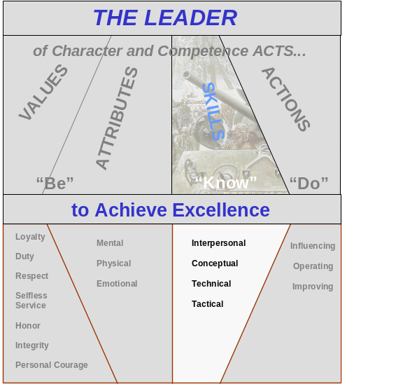
Must Know

2-93. Army values form the foundation of character. Character, in turn, serves as the basis of knowing and doing. The self-discipline that leads to teamwork is rooted in character and values. In the Army, teamwork depends on the actions of competent leaders of proven character who know their profession and act to improve their units. The best leaders constantly strive to improve, to get better at what they do. Their self-discipline focuses on learning more about their profession and continually getting the unit to perform better. They build competence in themselves and their subordinates.

2-94. Competence results from hard, realistic training. That is why Basic Training starts with simple skills, such as drill and marksmanship. The soldier who masters these skills has a couple of victories under his belt. The message from the drill sergeants—explicit or not—is, “You learned how to do those things; now you are ready to take on something tougher.” Soldiers who are led through progressively more complex tasks in this manner develop the confidence and will, the inner drive, to take on the next, more difficult challenge.

2-95. For the leader, competence means much more. It is the basic underpinning of leadership. Leaders are responsible for being personally competent in basic soldier skills, appropriate technical skills, and a host of interpersonal, conceptual, and tactical skills. But even that is not enough, for leaders are responsible for the competence of their soldiers.

2-96. Figure 2-3 highlights the four categories of skills that a leader must KNOW: interpersonal, conceptual, technical, and tactical. Interpersonal skill is competence in dealing with people. It involves coaching, teaching, counseling, motivating, and empowering. Conceptual skill is competence in handling ideas. It involves sound judgment as well as the ability to think creatively and reason analytically, critically, and morally. Technical skill is competence with job-related tasks. Leaders must possess the expertise necessary to accomplish all tasks and functions they are assigned. The first three skill groups are broad categories. The last, tactical skill, enables a leader to make the correct decisions about employment and maneuver of forces on the battlefield. Tactical skill is enhanced by combining skills from the first three to accomplish a mission.

2-97. Leaders in combat use technical, conceptual, and interpersonal skills to accomplish the mission. They must capitalize on their technical skills to employ the right techniques and procedures, fieldcraft, and equipment. They must apply their conceptual skills in any operational environment to determine viable concepts of the operation and execute the required tactics. Finally, leaders must use their interpersonal skills to effectively communicate their intent, make the right decisions, and motivate their soldiers. Interpersonal skill also enables the leader to effectively influence the outcome of the mission when plans go wrong and leadership must make the difference, turning the tide to create success.

2-98. Leader skills increase in scope and complexity as one moves from the direct to the organizational and strategic leadership levels. Chapters 4, 6, and 7 discuss in detail how leaders at the direct, organizational, and strategic levels apply the skills of each skill group.

2-99. You will note that the Army leadership model draws a distinction between developing skills and performing actions. Leaders who take their units to the National Training Center improve their skills by performing actions—by doing their jobs on the ground in the midst of intense
simulated combat. But they do not wait until they arrive at Fort Irwin to develop their skills; they practice ahead of time in command post exercises, in combat drills, on the firing ranges, and even on the PT field.

2-100. Over time, your leader skills will improve as your experience broadens. A platoon sergeant gains valuable experience on the job that will help him be a better first sergeant. Leaders take advantage of every chance to improve: they look for new learning opportunities, ask questions, seek training opportunities and request performance critiques.

SECTION III

LEADERSHIP: WHAT A LEADER MUST DO

He gets his men to go along with him because they want to do it for him and they believe in him.

General of the Army Dwight D. Eisenhower

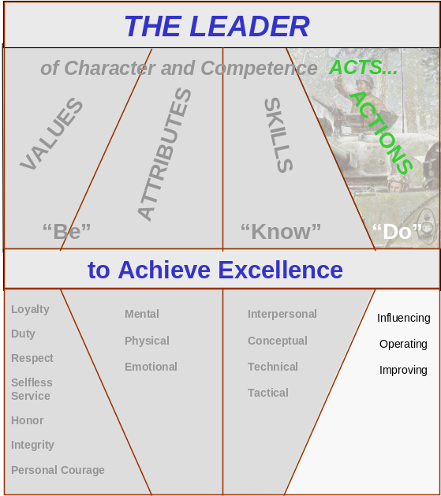

Figure 2-4. Leader Actions

2-101. Leaders act. They bring together everything they are, everything they believe, and everything they know how to do to provide purpose, direction and motivation. Army leaders work to influence people, operate to accomplish the mission, and act to improve their organization. This section introduces leader actions, which Chapters 5, 6, and 7 discuss more fully. As with leader skills, leader actions increase in scope and complexity as one moves from the direct to the organizational and strategic leadership levels.

2-102. Developing the right attributes, skills, and values is only preparation to lead. Leadership does not begin until the leader acts. The leader who lives up to the Army values, who displays competence, who acts at all times as he would have his soldiers act, will succeed. The leader who talks a good game but cannot back it up with action will fail in the long run.

- INFLUENCING

2-103. Leaders use interpersonal skills to guide others toward a goal. Although communication is the biggest part of influencing, this action also includes decision making and motivating. At lower levels in the organization, leaders most often influence subordinates by face-to-face, direct influence—such as when a team leader gives instructions, recognizes achievement, and encourages hard work. At higher echelons, leaders also use indirect influence to guide their organizations. Squad leaders know what the division commander wants, not because the general has briefed each one personally, but because his intent is passed through the chain of command. Leader actions that demonstrate influencing include—
- Communicating: Displaying good oral, written, and listening skills for individuals and groups.
- Decision making: Using sound judgment and logical reasoning; using resources wisely.
- Motivating: Inspiring, and guiding others toward mission accomplishment.

- OPERATING

2-104. Operating is short-term mission accomplishment, getting the job done on time and to standard. It includes planning and preparing, executing, and assessing.

2-105. Leader actions that demonstrate operating include—

- Planning and preparing: Developing detailed, executable plans that are feasible, acceptable, and suitable. Arranging unit support for the exercise or operation. Conducting rehearsals. (Battalion and higher echelons follow the military decision making process (MDMP) when making plans. Company and lower echelons follow the troop leading procedure. FM 101-5 discusses the MDMP.)
- Executing: Meeting mission standards, taking care of people, and efficiently managing resources.
- Assessing: Evaluating the efficiency and effectiveness of any system or plan in terms of its purpose and mission.

2-106. Leaders assess, or judge, performance so they can determine what needs to be done to improve it. This kind of forward thinking is linked to the last action, improving.

- IMPROVING

2-107. Improving often means making a sacrifice now for long-term gains in unit proficiency. There is always a great temptation to pursue short-term gains at the expense of long-term benefits. When a unit sacrifices important training with long-term effects—say, training that leads to true marksmanship skill—and focuses exclusively on short term appearances—qualification scores—the unit’s performance suffers.

2-108. Leaders set priorities and establish a balance among competing demands. In the case of weapons proficiency, qualification is a requirement but true marksmanship skill is the goal. For battlefield success, we need training that leads to understanding and mastery that holds up under the stress of combat. Throw in all the other things vying for a unit’s time and resources and the leader’s job becomes even more difficult. Guidance from higher headquarters may help, but the leader must still make the tough calls. Leader actions that demonstrate improving include—

- Developing: Investing adequate time and effort to develop individual subordinates as leaders. This includes mentoring.
- Building: Spending time and resources to improve teams, groups, and units; fostering an ethical climate.
- Learning: Seeking self-improvement and organizational growth; envisioning, adapting, and leading change

- SUMMARY

2-109. So where have we been? Simply put, leadership in combat, our greatest challenge, requires accepting a set of values that provides a basis for our motivation and will. We call these the Army values. In them are rooted the basis for the character and self-discipline that generate the will to win and the motivation to persevere. From this motivation derives the lifelong work of self-development in the skills that make a successful leader, one who walks the talk of BE, KNOW, DO. In the next chapter we examine the human dimension of leadership before moving to the skills needed and actions performed by direct leaders.

Stephen L. Carter, Integrity.
Pullen, 111.
Daniel Goldman, Emotional Intelligence,
Gary Yukl , Leadership in Organizations,
Paul Fussell, Wartime,

