|  |  |  |
| --- | --- | --- |
| Stage:  Walk |  | SimEx: Drug Proliferation in Kartistan |

This facilitator guide provides step-by-step instructions for running SimEx, including suggested facilitator scripts (italic text) and “Pro Tip” pop-ups, which contain tips for the facilitator to take into consideration as they guide participants through the exercise.

While the facilitator may choose to adapt some of the script language or other execution guidelines depending on personal styles and available resources, we recommend following the guide as closely as possible to ensure that participants receive adequate training on each of the concepts and objectives.

**Exercise Overview**

This exercise is one of several in a program designed to illustrate the principles of sociocultural systems (SCS) thinking. This particular exercise is inspired by the current poppy/opium production problem in Afghanistan.

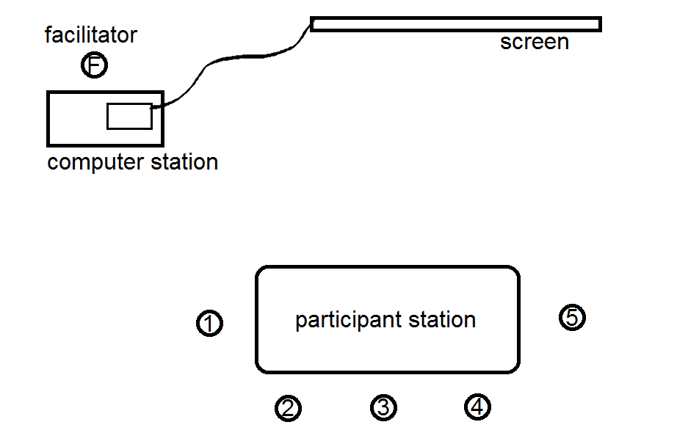

This practical exercise (PE) places multiple participants into active roles in a multi-round simulation, which allows the group to experience firsthand some of the sociocultural systems concepts associated with an operational situation. Each participant in the exercise has specific goals and imperatives, but must interact with other players through communications and exchanges of resources. Conditions change across rounds, forcing participants to challenge their preconceptions and adapt their strategies to new conditions that the simulated system imposes upon itself, such as resource limitations and other players shifting strategies as well. Participants experience how their decisions can interact with those of other participants’ to impact the larger system.

**Sociocultural Systems Thinking Concepts Addressed**

* Multiple players/perspectives
* Goal conflict
* Interdependence and interaction
* Feedback loops
* Co-adapting cycles
* Historical influence
* Second and third order effects
* Self-organization
* Boundaries
* Leverage Points
* Supporting structures
* Sensemaking
* Adaptability

By the end of the exercise, participants should be better able to:

2.1. Understand the range and nature of stakeholder groups in SCS

2.2. Understand the structural characteristics of SCS

2.3. Understand the manifestations of SCS structural characteristics

3.2. Examine multiple perspectives and historical background

3.3. Translate SCS concepts to envision promising, sustainable interventions

3.4. Interpret the results of interventions and adapt courses of action

|  |  |
| --- | --- |
|  | *Preparation* |

This table includes preparatory information for SimEx:

|  |  |
| --- | --- |
| Recommended number of participants | 5 |
| Estimated run time | Approximately 60 to 90 minutes, depending on how many rounds are desired |
| Materials needed | 5 player profiles (US Battalion commander, Kartistani regional governor, Kartistani farmer, Kartistani insurgent leader, and Kartistani drug lord)  5 sets of player communication cards  Computer station, with projector/large screen setup  Scoring spreadsheet (Excel)  Scoring spreadsheet documentation guide  Debrief guide |

|  |  |
| --- | --- |
|  | *Execution Guidelines* |

As mentioned above, SimEx takes place in multiple rounds. Participants are assigned to play the role of one of the stakeholders in Kartistan (e.g., farmer, drug lorg). In the first round, each stakeholder is given a limited amount of resources (e.g., 8) and they can allocate the resources across a series of actions, which vary depending on the stakeholder. For example, farmers’ actions include planting poppy and planting wheat, whereas the regional government’s actions include giving cash to farmers and fight insurgents. The facilitator enters the information into a scoring spreadsheet and provides feedback to participants. In subsequent rounds, the amount of resources each player gets depends on what happened in the previous round.

Before conducting this exercise, it is critical for the facilitator to be able to use the scoring spreadsheet (Attachment A). Attachment B is a guide to help facilitators learn how to use the scoring spreadsheet.

Brief the exercise participants with the following:

*In the following exercise, you will all be participating in a simulation that takes place over multiple rounds. The exercise takes place in Kartistan, a fictional nation that is a new theater for an unfolding conflict that involves a wide variety of stakeholders. Each of you will be assigned a role as one of these stakeholders, and will be given a full description of your motivations and goals in the midst of this conflict.*

Now, pass out the ‘Introduction to Systems Thinking’ handout (Attachment C) to all participants and give them time to review. Then, assign a role to each person in the exercise. If the facilitator is familiar with the group, roles might be assigned in such a way that it pushes participants out of their comfort zones. Otherwise, roles should be assigned randomly. Each participant should receive one profile card (see Attachment D) and its accompanying set of communication cards (see Attachment E). Instruct everyone not to let others see what is written on these materials.

The facilitator should advise everyone *not to share* the information printed on the profile cards with other players. This means not to share their information with one another, not to talk to one another, and not to allow others to see their information. The objective is to maintain naiveté.

Make the following announcement:

*INTRODUCING THE ROLES*

*Now that each of you has been assigned a role for this exercise, take a few moments to review your unique profile. Please do not share the information on your profile card with other players.  
  
Take note that the role you have been assigned has a unique set of goals. Accordingly, the actions your role can perform are tailored to your position in this scenario in Kartistan. Some of the actions you can perform will directly address your unique goals, while some are more indirect.*

Give the participants a few moments to read through their materials. Then resume.

*Are there any questions about your roles?*

*DISCUSSING RESOURCES*

*On the bottom half of your profile, you should see 5 columns corresponding to different rounds. This game progresses from Round 1 on the left and ends at Round 5 on the right.*

*For this exercise, each of you will be given a set of* ***resources****. These resources can be considered a large amount of money or credit or effort, and they are divided into distinct units. The specific number of units you receive will be indicated on your player profile. In this exercise, you must allocate your resources in the spaces provided in the profile card in order to accomplish your goals. At this time, you should begin thinking about how to allocate your resources for Round 1. As the exercise progresses, you will have a chance to make allocations again in Round 2, and 3, and so on.   
  
Choose carefully how to spend your resources. The way you spend your resources will determine how many resources you will receive at the beginning of subsequent rounds, so if you spend too much and rake in too little you may be limited in what impacts you can have. Additionally, the way you assign resources could have direct consequences in terms of how the local and international communities view you, which could make it harder to achieve your goals.   
  
Are there any questions?*

Field any questions.

*BEGINNING THE EXERCISE*

*Commit to your profile’s role for the duration of this exercise. Remember not to share your materials with anyone else.  
  
Take 2-3 more minutes to allocate resources for the first round. After you finish allocating your resources, please turn in your profile cards to me.*

|  |  |
| --- | --- |
| **Pro Tip** | Allow players additional time to read through their materials if they appear immersed. Time lag is permissible here, as it is crucial to digest the profile information. Do not instruct players on how to interpret information written in their profiles as other players may use anything they overhear to their strategic advantage. |

As players begin to turn in their profile forms, the facilitator will record the number of resources assigned to each action using the designated fields in the spreadsheet, on the sheet titled “Round 1.” The worksheet is circled in red.

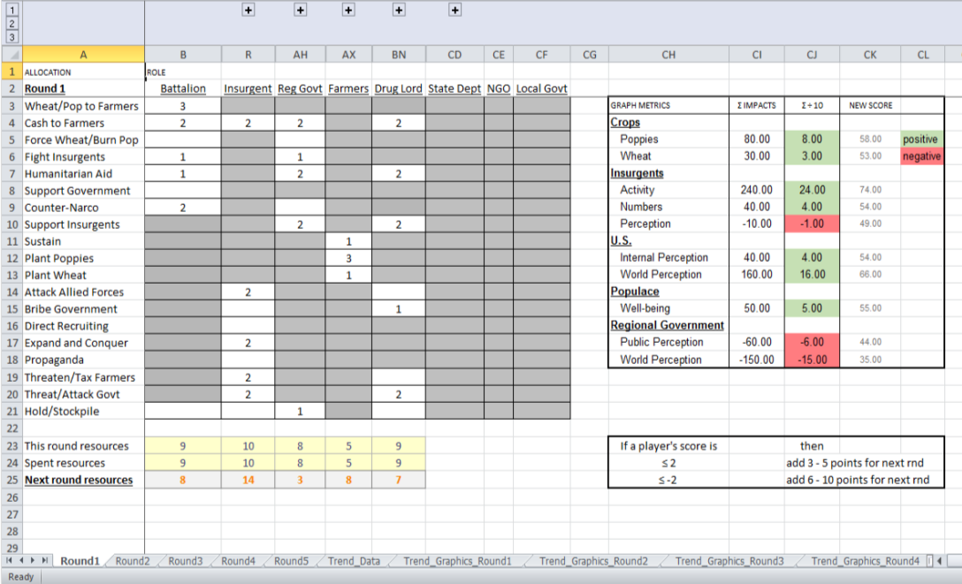

|  |  |
| --- | --- |
| **Pro Tip** | Note, as we have also indicated in the spreadsheet operation guide, *you should make sure that all groups on the spreadsheet have been minimized*. If they are not minimized, there will be dozens of extra columns visible pertaining to algorithm weights, and this will make recording data much more difficult. Do not edit or delete the algorithm weights columns unless you know what you are doing. Only the resource allocation spaces should be visible. |

When you record resource allocations in the spreadsheet, the embedded code will automatically compute resource totals for the next round, which appear below the main table. Refer to the calculations to mark on players’ profile cards how many resources they should receive for the following round. Note, the U.S. Battalion Commander always receives a set number of resources from the US government. Refer to the spreadsheet documentation for additional guidance.

|  |  |
| --- | --- |
| **Pro Tip** | Infrequently, players may obtain a *very low* or *negative* number of resources for the next round. If this happens, refer to the guidelines on the spreadsheet to ensure that no player receives an unworkably low amount of resources. Ideally, all players should begin the next round with more than 5 resource units.  Ex- |

The code in the spreadsheet also generates a series of charts on the sheet titled “Trend_Graphics_Round1.” The charts generated on this page are hypothetical measurements of performance, such as poppy and wheat growth, Kartistani populace well-being, and local/national level perception of insurgent efforts. Each chart display color-coded metrics that will only be understood if players have an interpretation key, which is printed on the player profile cards. Some players will have a thorough understanding of every chart (e.g., U.S. Battalion Commander), while others will have a very limited view (e.g., Kartistani farmer).

After assigning next round’s resources and returning players’ profile cards, display the trend graphics and make the following announcement:

*INTERPRETING TREND GRAPHICS*

*Based on your activities this round, we have run some calculations on the impact of your actions. We summarized those results in the charts here. Your profile sheets may or may not have information that can help you make sense of each chart. Note, it is normal to not have key to help you interpret a chart. Use the information you can interpret to help inform your choices for the next round.*

Next, cue up the sheet titled “Round 2.” Present the following instructions:

*ROUND 2, 3, 4, 5 INSTRUCTIONS*

*Now, we begin Round 2. One big thing is different this time. This round, each of you may exchange communication cards to other players in order to help coordinate how you allocate your resources. Take a communication card from your stack, and deliver it to the facilitator who will then make deliveries. If your card has options that must be circled, use a dry-erase marker to mark the card, but do not write anything extraneous. Do not write your own messages on these cards. I repeat, do not write your own messages, and please only use dry-erase markers so they can be re-used later.*

*Remember, these are just brief communications, not full memorandums or essays. They only communicate a short message and let the sender know where it originated. You may use these cards to strategically inform your choices.*

Finally, announce:

*SETTING UP COMMUNICATIONS*

*You will have 2 minutes to plan, send, and respond to communications at this time. After that time is up, no more communications can be sent, and you must begin allocating resources just like in Round 1.*

Facilitators will need to collect and deliver communication cards from each player. After each player has had time to read and make allocations for the next round, collect and return communication cards to each originating player after each round. Cards can be organized quickly by grouping them according to their colored labels. Cards must be collected prior to the beginning of the next round.

|  |  |
| --- | --- |
| **Pro Tip** | As the facilitator, your two biggest time-consumers are writing down resource totals and sorting communication cards after each round. When you encounter a time lag situation, advise players that they can use this time to reflect on what has occurred in previous rounds and to prepare strategies for the coming rounds. |

Instruct individuals to allocate resources for the subsequent rounds and repeat instructions for displaying the subsequent-round trend graphics. After the conclusion of Round 5, you may begin the exercise debrief.

|  |  |
| --- | --- |
|  | *Debrief Guide* |

Summary trend graphics for all the rounds appear in the sheet “Trend_Graphics_Round5.” It may be useful to have these visible during debriefing.

Below are some sample debriefing questions to generate discussion. While you may have other questions in mind, try to ask open-ended questions (*What* / *Where* / *How* / *Why* as opposed to *Did you*) and to allow participants to express their thoughts fully.

* **What were you aware of during this exercise?**  
  Sample answers:  
  *“I was trying to guess what the different roles were.”  
  “I knew this person was ____, because I saw him do ____.”*  
    
  To respond to this, first mirror back what was said. Then, you might follow up with
  + **“How sure were you that you knew what was going on with _____?”**
  + **“What would it have meant for you if you ___ did not happen?”**

If not elicited in your initial probe, use this opportunity to introduce the concepts of *multiple perspectives*, *goal conflict and alignment*, and *limited information*. Ask

* + **What other player perspectives were you aware of?**
  + **Where was there goal conflict in the exercise?**
  + **What information were you most of aware of not knowing?**
* **What strategies did you use? What seemed to work/not work?**Sample answers:  
  *“Well, first I tried to attack the insurgents. But then there were more of them and the US was losing support.”  
  “I couldn’t do anything really, I was just farming.”*Avoid getting caught up in individuals’ round-by-round performance too much. You might respond with
  + **“So if you had other options, what else did you have an opportunity to do? What effect might that have had?”**
  + **“If you didn’t have any other options, what would you have wanted to do that you couldn’t do?”**

If not elicited in your initial probe, use this opportunity to introduce the concepts of *tradeoffs*, *feedback loops*, *co-adapting cycles*, *managing uncertainty and surprise*, and *leverage points*. Ask

* + **What were some major *trade-offs* in this exercise?**
  + **Where can you see a ____ (e.g., *feedback loop, co-adapting cycle, leverage point*) in this exercise?**

Additionally, since players will be thinking about strategies they used, take this opportunity to introduce the concepts of *sustainable interventions*, *time delays*, *historical influence*, and *unintended consequences*. Ask

* + **How could someone make a *sustainable intervention* in this system? How would *time delays* and *historical influence* play into that? What *unintended consequences* would you have to watch out for?**
* **What are the implications of an exercise like this?**Sample answers:  
  *“It’s like what we expect to happen isn’t always the way it works out.”  
  “Perception is reality. If I don’t know about all these different perspectives I’m going to do things differently than if I do know about them.”*If not elicited in your initial probe, use this opportunity to introduce the concepts of *interdependence*, *second & third order effects*, *emergence*, and *monitoring*, and *adaptability*. Ask
  + **What dynamics of this system are interdependent? What are the second- and third-order effects that you observed?**
  + **What sorts of emergent features did you see coming from the interactions of group members?**
  + **What does this mean for how you should monitor and adapt to a system like the one in SimEx?**
* Finally, follow up with
  + **“Where might the lessons of SimEx help you in your career?”**
  + **“What should you do when you encounter real-life systems similar to this one?”**
* **How can this exercise be modified to make it better? Be as specific as possible.**