|  |  |  |
| --- | --- | --- |
| User  Guide |  | SimEx Spreadsheet |

This user guide is an accompaniment to the facilitation guide. It is intended to familiarize you with the scoring procedures used in the SimEx practical exercise. As the facilitator, it is your task to be familiar with these methods—about an hour of familiarization with this documentation is recommended. Being familiar with this document will ensure seamless integration of our scoring spreadsheet into the exercise and prevent disruptive time lags.

Included in the packet is a spreadsheet file titled “SimEx_Scoring.” Since the spreadsheet can be intimidating at first glance, the following is intended as a familiarization guide, where each component of the spreadsheet is identified and defined. Basic proficiency with Microsoft Excel is expected of users who will facilitate this exercise. When loading the spreadsheet in Excel, there are several features the facilitator should note right away:

* *This document contains many formulas*. Therefore, facilitators should be careful about making edits so as not to invalidate calculations.
* There are *multiple worksheets* in the bottom left.  
   *screencap*
* The data columns skip many letters (e.g., A-B-R-AH-AX-BN…), indicating that there are *grouped columns* that have been minimized.  
   *screencap*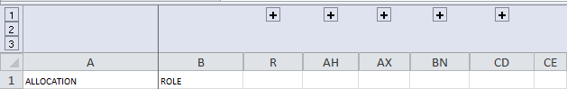

Facilitators should make sure that they understand all of these points, particularly if this is their first time working with the spreadsheet. They should consult a basic Excel tutorial if any of these points are too advanced.

**If facilitators are comfortable with this information, please proceed to the next page.**

**Operating the Round 1-5 Data Tables**

The SimEx exercise is divided up into 5 rounds. Each round has been assigned a separate worksheet to document the exercise’s progress and to calculate resource totals for each following round.

Example data table for a round is shown below (screencap):



The white cells in the data table represent sections where the facilitator may type in resource amounts after players report their allocation preferences. Gray cells should not be filled in, and indicate that these are actions that a player cannot perform. For instance, a Battalion Commander cannot *Threaten/Tax Farmers* (gray), but can conduct *Counter-Narco* operations (white). Similarly, a Drug Lord cannot Plant Poppies, but can *Bribe* the regional government. If a player did not assign a resource number to a category, simply leave the corresponding cell blank in the spreadsheet. Do not type in any other character, as this could disrupt the calculation of resource totals (ie - alphabetical characters will not sum or average with numerical ones).

Note that the columns for State Dept, NGO, and Local Govt are completely grayed out. These columns are not used in the exercise as explained in the Facilitator Guide, but can be developed in the event they are needed and provided that the operator possesses the necessary background to incorporate these roles into the exercise.

Once resources are recorded in the white cells, the spreadsheet formulas will automatically calculate the following (screencap):



It is **crucial** that users do not edit these cells unless they know what they are doing. If the attached formulas are deleted or accidentally altered, it will cripple the functionality of the spreadsheet. Therefore, these cells should only be edited when necessary.

* “This round resources” calculates the total number of resources that were assigned in the white cells above. This number should correspond to the number of resources they were assigned at the beginning of each round.
* “Spent resources” calculates the number of resources that a player has allocated. This number should always be the same as “This round resources,” or else it indicates that an error has occurred, such as a typo or a player misunderstanding instructions. (If a player has misunderstood how to allocate resources, consult the player right away, or the error will likely be repeated each round.)
* “Next round resources” calculates the number of resources each player should have at the beginning of the following round. This number should be the same as “This round resources” on the subsequent rounds.

In some rare instances, players may obtain very low or negative resource scores on the spreadsheet. As a rule of thumb, intervene if the score meets or drops below 2 resources for the next round. Depending on the facilitator’s goals, different intervention points may be used. The following guidance appears in the spreadsheet (screencap):



Facilitators may directly input these new resource values into the “Next round resources” cell. **Take note, however, that doing so will erase the formulas that the edited cell contains**, **and so facilitators should not save over the file at the end of the exercise.** To avoid saving over the file accidentally, it is recommended that all users save the spreadsheet as a new file for each iteration of the exercise (e.g., *SIMEX_Scoring_[today’s date]*).

**Interpreting Impacts from the Round 1-5 Data Tables**

The spreadsheet automatically presents calculations in the table on the right side of each Round worksheet.  
  
*screencap*

Users should not attempt to edit this table unless they know what they are doing. This table contains impacts of each player’s resource allocation in the current round. That is, each resource allocation may carry an impact on one of the metrics presented here. For instance, if the Farmer allocates resources to growing poppies, the result is a small boost in the amount of insurgent activity due to the group’s monetary stake in poppy growth, as well as a small decrease in the populace’s well-being due to increased violence, collateral damage, and vulnerability.

In order to optimize the interpretability of impacts, all impact metrics start at 50 prior to Round 1. After each round concludes, if an impact resulting from resource allocation has a net positive effect on a metric, the sigma/10 column will automatically highlight green, but if the net effect is negative, it will automatically highlight red.

Values presented in the impacts table are automatically referenced in the worksheets that follow, titled “Trend_Data” and “Trend_Graphics_” (Rounds 1-5). These worksheets contain charts that document the relative changes in each impact metric over time. Worksheets are updated with information from each subsequent round of the exercise.

Trend graphics sheets produce 5 charts each, with a number of time points corresponding to the number of rounds that have concluded. Each chart is color-coded so that only players with a specific key/legend for interpretation can understand the outputs. Players will use this information to inform their allocation choices and communications for each subsequent round.

*screencap*

*Developer Notes (for Advanced Users)*

If users wish to change the way that next round resources are allocated, it will require editing the specific formulas (computed in the totals cells) and weights (displayed in the hidden columns, see next screencap). The formulas and weights were initially determined through cultural research and SME discussion of historical data and trends from Afghanistan. It is recommended that any additions to the spreadsheet be documented in similar fashion, and that the spreadsheet be saved as a separate file afterward. Note, edits made to one worksheet will not carry over into other worksheets, so edits will need to be made 5 times in order to be consistent across 5 rounds of the exercise.

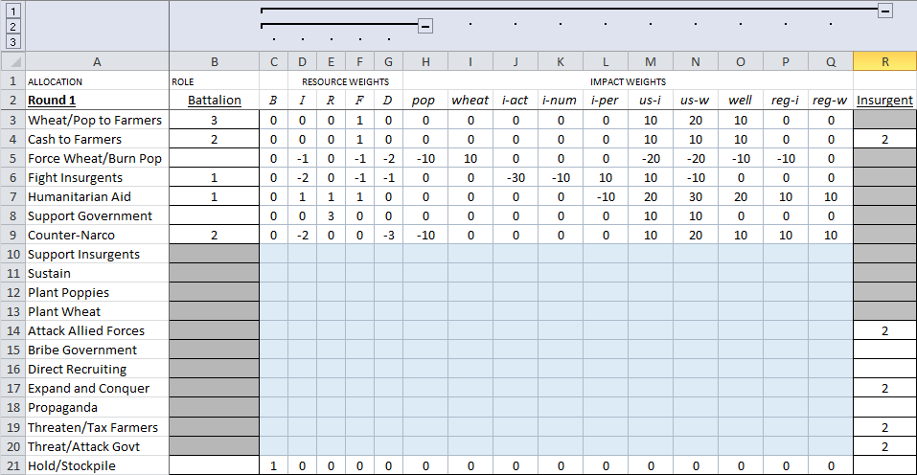

Clicking the “+” icon above a column will maximize the hidden contents. (Clicking the “–“ icon will minimize the groups again.) As before, cells that are white have been determined to be relevant to a player, whereas the blue cells have been left blank as they are irrelevant to a specific profile. Weights for each player’s resource allocations are displayed in columns under “Resource Weights,” while weights for each player’s impact metrics are displayed under “Impact Weights.”

Weights are multipliers for each resource allocation.

Resource weights are grouped by player (columns; **B**- Battalion Commander, **I**- Insurgent Leader, **R**- Regional Governor, **F**- Farmer, **D**- Drug Dealer).

Impact weights are grouped by metrics (**pop**- Poppy production, **wheat**- wheat production, **i-act**- insurgent activity, **i-num**- insurgent numbers, **i-per**- insurgent perception, **us-i**- United States internal perception, **us-w**- United States world perception, **well**- populace well-being, **reg-i**- regional government internal perception, **reg-w**- regional government world perception).

Weights are also grouped by row, such that each allocation results in two calculations, one for resource totals and one for impact metrics. Resource weights range from -3 to +3 and are used only for computing next-round resources, while impact weights range from -30 to +30 and are used in computing guidance metrics relevant to a specific player. Further discussion on the outputs of these calculations is in the following section.

If it is desirable to include State Dept, NGO, or Local Govt roles in addition to the existing roles, new columns will need to be added to correspond to each of these players, as well as tailoring to include the values in these columns in the calculation formulas. As stated before, these edits will need to be replicated on each of the 5 worksheets to ensure consistency. Hence, it is only recommended that edits be made if the user is savvy with Excel.