|  |
| --- |
| Office of the TCM-TADLP |
| ALMS CTE Offering and Course Iteration Setup Guide |
| Version 1.0 |
|  |
| **TADLP Capabilities and Implementation Office, Implementation Branch** |
| **5/2/2013** |

|  |
| --- |
|  |

Table of Contents

Executive Summary 3

Acronym List 4

Glossary of Terms 4

Logging into the ALMS CTE 5

Building a Lesson Template 6

Building an Offering 11

An Offering with no sequencing 12

3-Section Sequencing 19

Building a Course Iteration 31

# Executive Summary

The purpose of this document is to provide step-by-step guidance for structuring content packages on the ALMS CTE for pre-delivery testing and validation. This document provides instructions for using content that has been loaded into the repository for the CTE system to build “Offerings” and “Course Iterations”.

The document is divided into three sections.

The first section provides instructions for logging into the ALMS CTE, and accessing the area of the system where content packages are assembled into registrable objects in the system.

The second section provides instructions for building the container for grouping content packages, and if necessary assembling the content packages into a specific structure to enforce sequencing of multiple packages. This assemblage is known as an “Offering”.

The third section provides instructions for building the container for grouping Offerings into a single registrable object in the system. This assemblage is known as a “Course Iteration”.

For reference, there is a list of the acronyms used in the document and a glossary of terms explaining the meaning of the terms used in the document.

# Acronym List

|  |  |
| --- | --- |
| ALMS | Army Learning Management System |
| CTE | Content Test Environment |
| LMS | Learning Management System |
| SCORM | Shareable Content Object Reference Model |
| TADLP | The Army Distributed Learning Program |
| TCM | Training and Doctrine Command (TRADOC) Capability Manager |

# Glossary of Terms

|  |  |
| --- | --- |
| Content Repository | The shared storage location accessible from within the LMS that contains learning content objects, such as SCORM packages and files. |
| Course Iteration | Container on the ALMS used to create the structure for assembling Offerings to create a single registrable item containing multiple pieces of learning content. |
| Delivery Type | Method used to provide the content to the learner; for asynchronous training the delivery type is "Web Based Training". |
| Domain | Proponent School, Organization or Agency to whom the training belongs. |
| Learning Assignments | Learning content objects that are made available to a learner upon enrollment. |
| Lesson Template | Container on the ALMS used to create the structure for assembling learning content objects from the content repository. |
| Offering | A registrable item in the LMS that allows the learner to access the learning content objects. |
| Publish | Create an entry in the Course Catalog that can be located and allow the learner to register for the Offering. |
| Registrable Item | An entry in the Course Catalog on the LMS that is visible to learners and registrars, and that the learner can enroll in and access the associated learning content, or that a registrar can enroll learners in and grant them access the associated learning content. |
| Sequencing | A specified order with associated rules that enables the presentation of content with the capability to complete specified content for learning credit. |

# Logging into the ALMS CTE

The CTE is located at <https://www.cts.lms.army.mil> . Users can access the CTE by entering their AKO credentials, or with their Combined Access Card credentials.

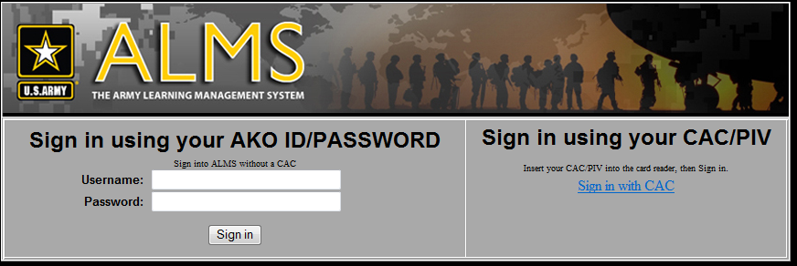

**Figure 1**

On the selection page, choose “Go To ALMS Homepage” to access the CTE.

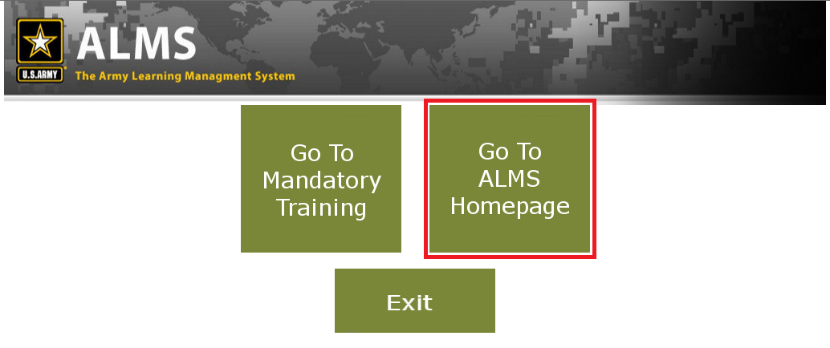

**Figure 2**

# Building a Lesson Template

Select Course/Class/Facility Management from the drop-down menu.

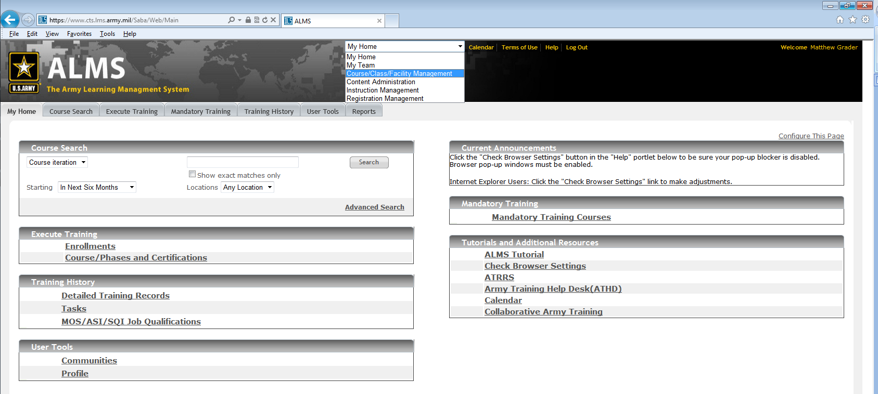

**Figure 3**

Select Lesson Templates from the side menu.

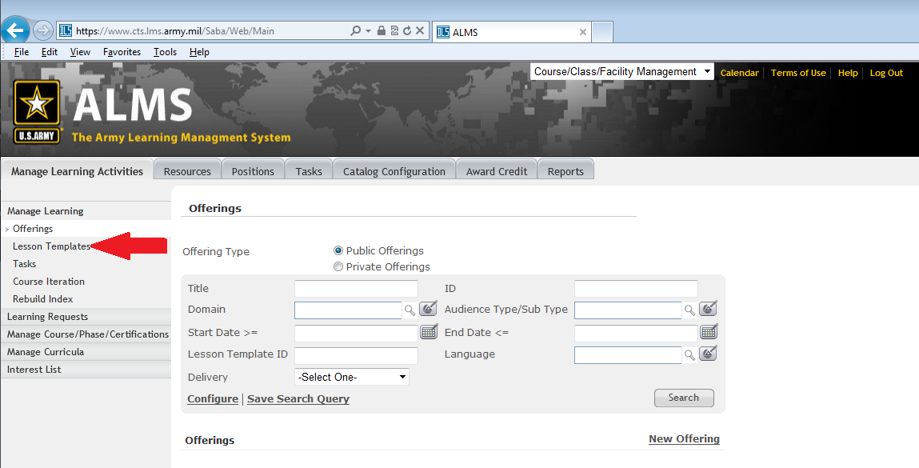

**Figure 4**

Select the Quick Lesson Template link.

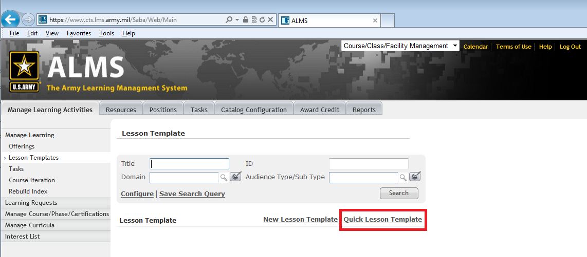

**Figure 5**

In the Delivery Type drop-down box, select Web Based Training.

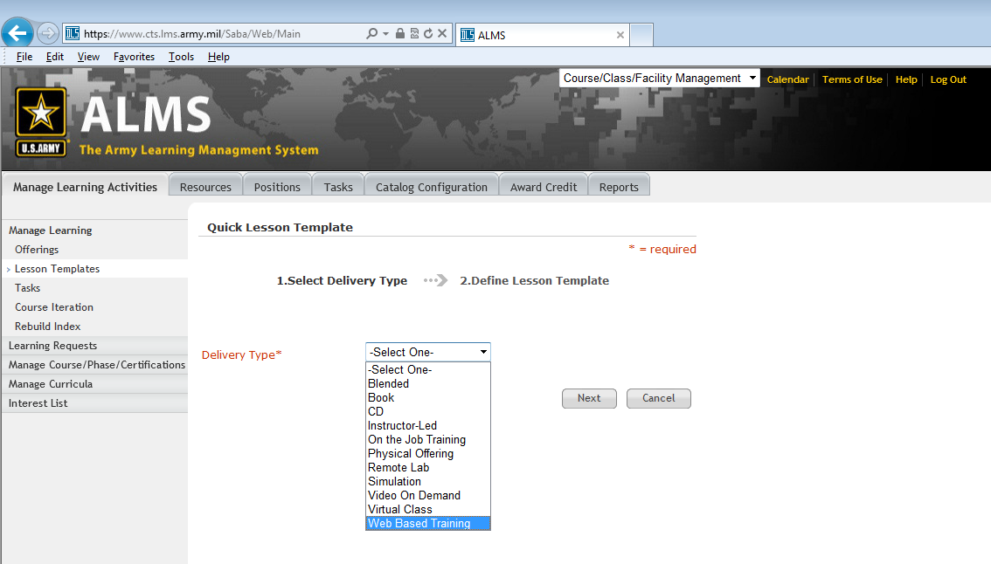

**Figure 6**

After the screen refreshes, click the Next button.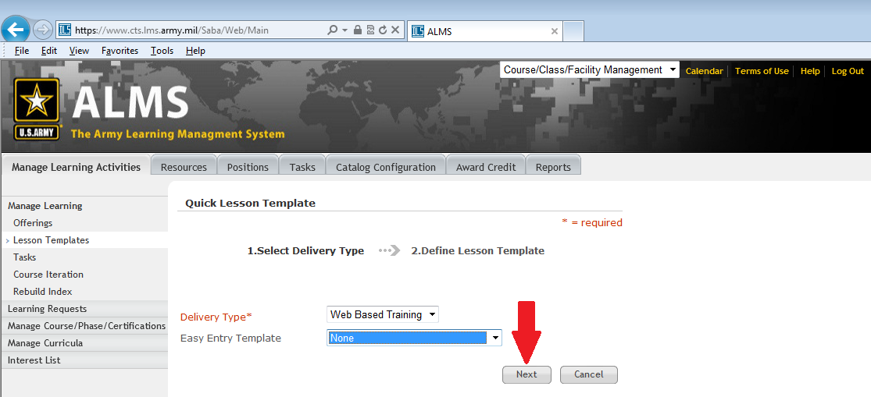

**Figure 7**

The Lesson Template screen will be displayed.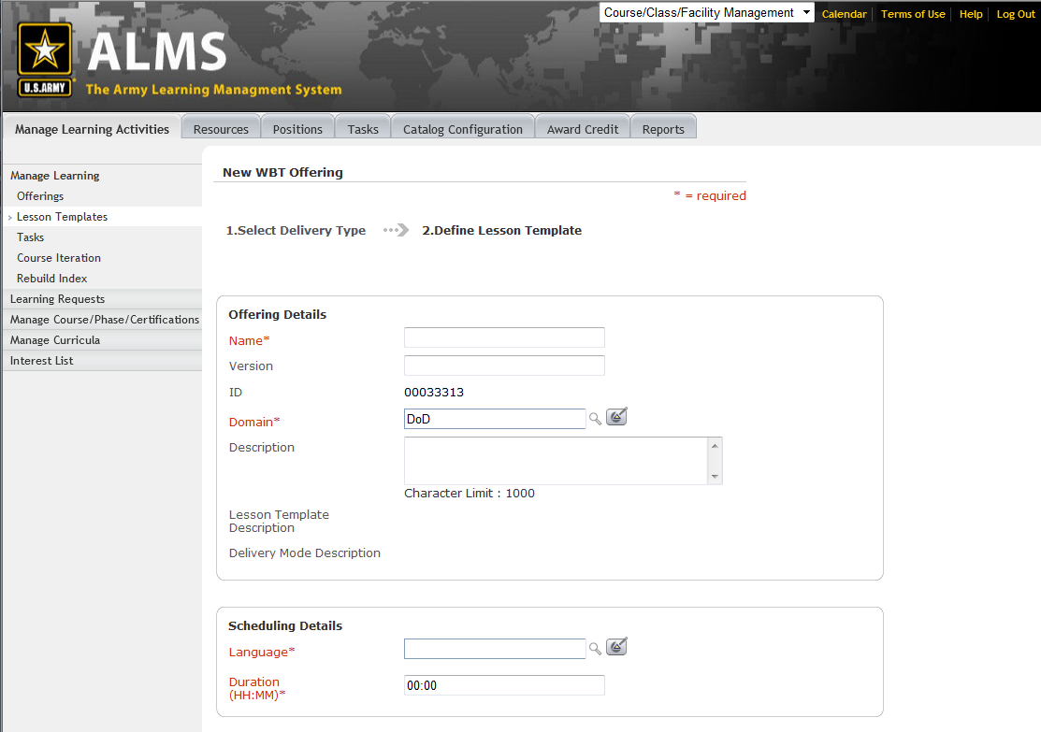

**Figure 8**

Enter a Name for your lesson template.

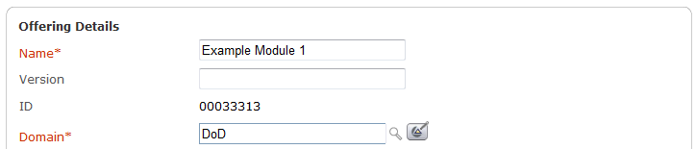

**Figure 9**

Enter part or all the domain name and click the magnifying glass. Click on the domain name in the list to select it. The page will refresh after you make your selection.

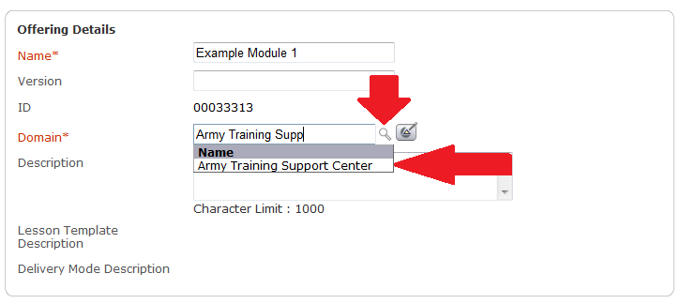

**Figure 10**

Enter English in the Language field and click the magnifying glass. Click on “English” in the list to select it.

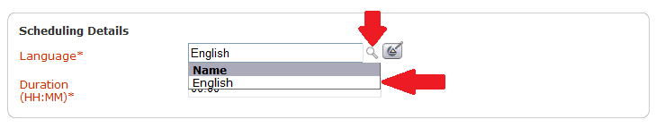

**Figure 11**

Scroll to the bottom of the page and click the Finish button.

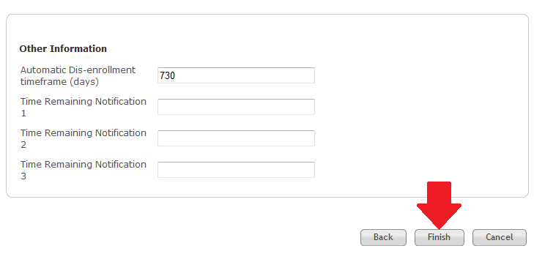

**Figure 12**

# Building an Offering

After the Lesson Template has been saved, click the Learning Assignments tab to begin building an Offering.

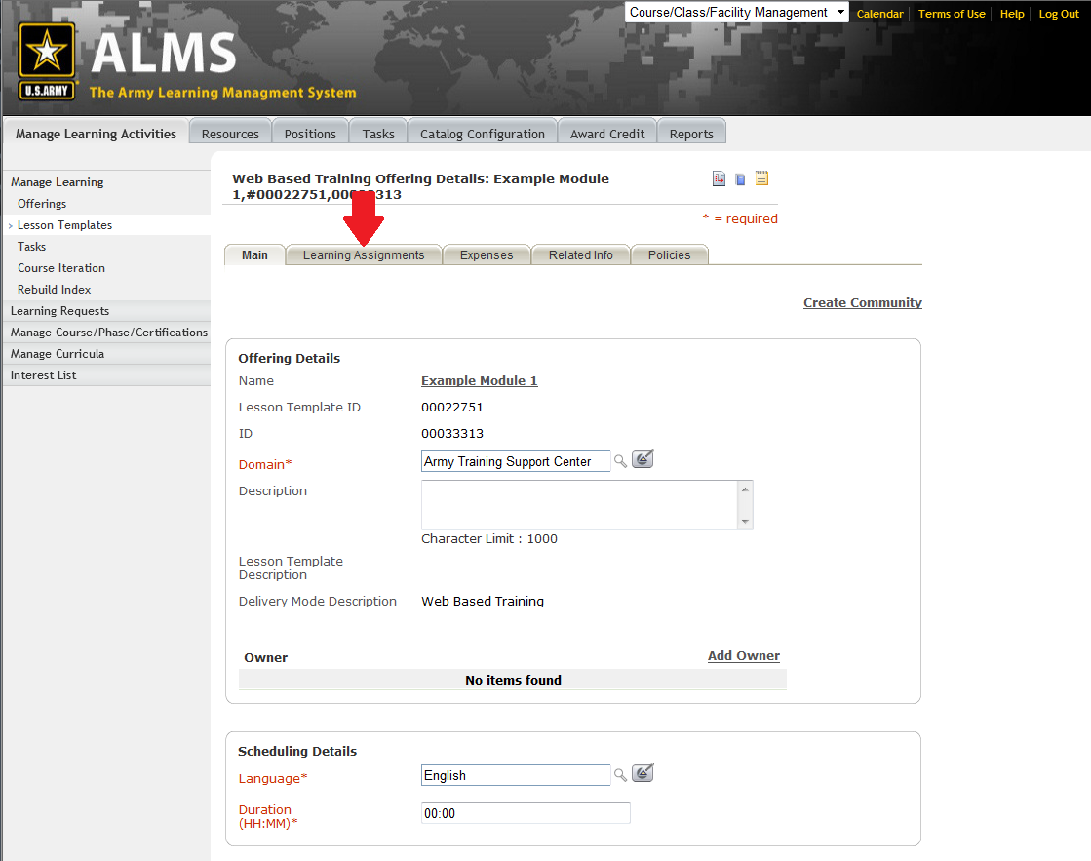

## Figure 13

## An Offering with no sequencing

Below are the instructions for using a Lesson Template to create an Offering that does not use sequencing.

Mouse over the Add Learning Assignments link and select Attach Content to add content and exams to your Offering.

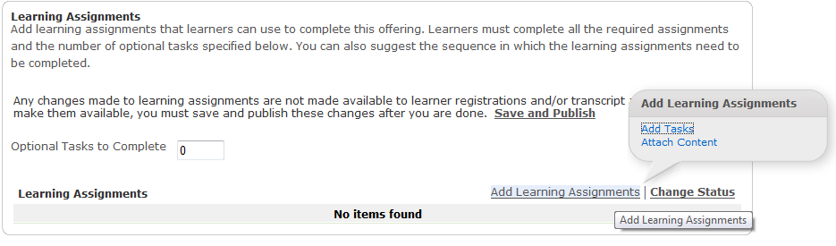

**Figure 14**

There are two ways to locate your file to add it to the Lesson Template. You can browse the catalog and select the file from the Production repository.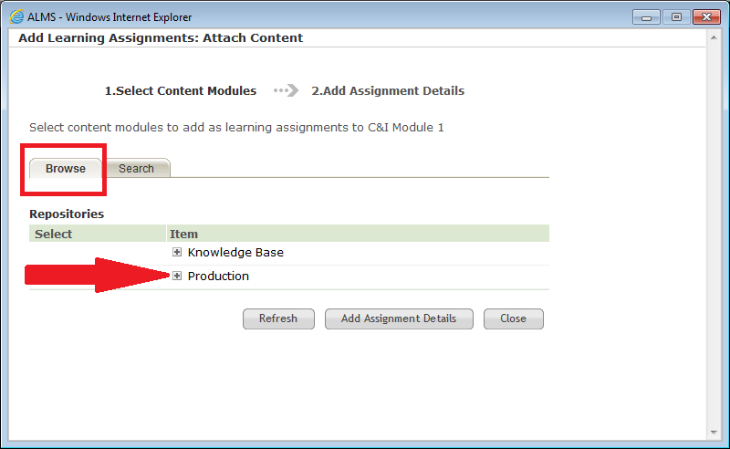

**Figure 15**

Or, if you know the name of your file in the repository, you can use the Search. Either method will locate the file.

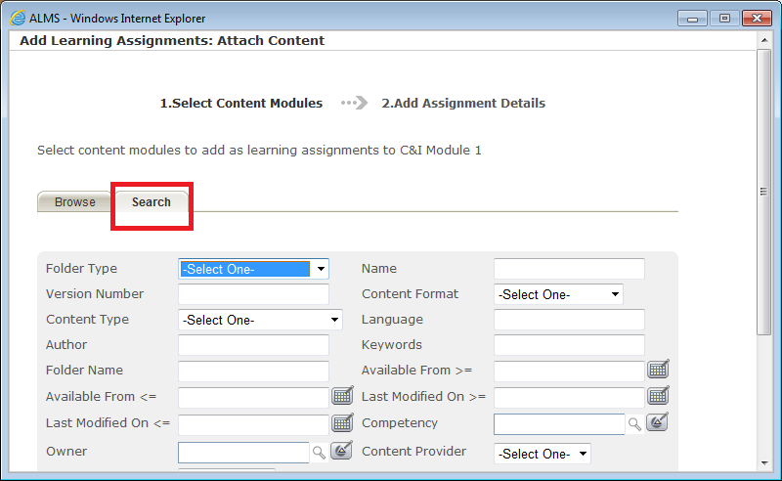

**Figure 16**

Using either method, locate your item in the repository and click the check box to select it. After making your selection, scroll to the bottom of the window and click the Add Assignment Details button.

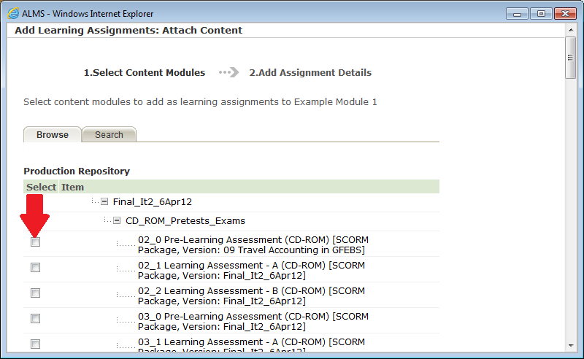

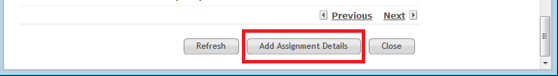

**Figure 17**

Or

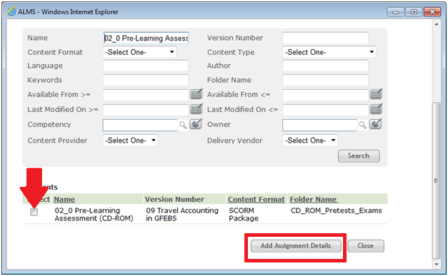

**Figure 18**

On this screen, you identify if the learner will be required to complete the item, and if there is a limit of how many times a learner can launch the item. *NOTE: in the ALMS, launching an item = one attempt.*

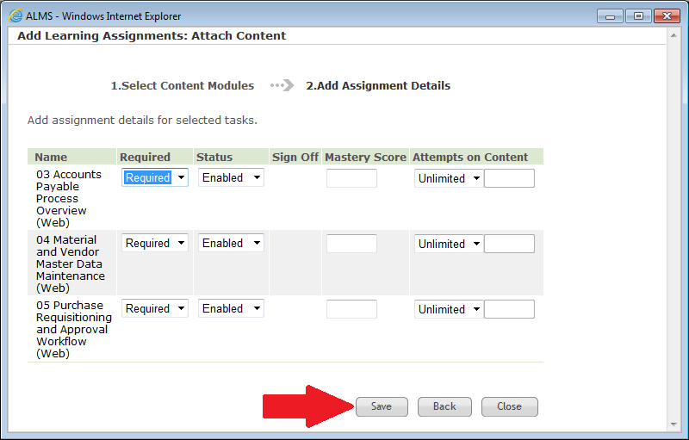

**Figure 19**

To set an attempt limit, select Limited from the drop-down box, and enter a number of allowed attempts. If the default values are applicable, click the Save button.

Use the Up and Down arrows to rearrange the order of the learning content items in the list.

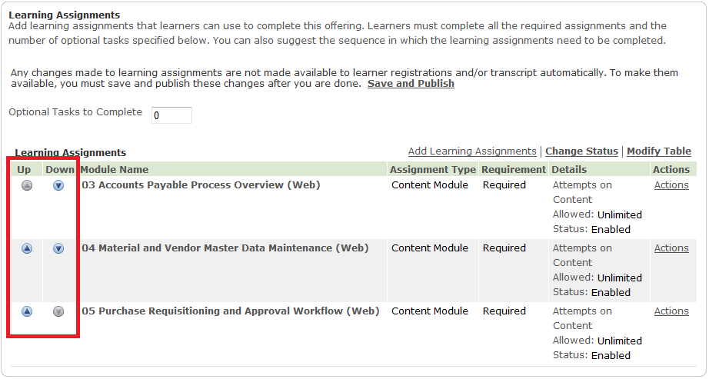

**Figure 20**

Scroll down to the bottom of the page and click the Save and Publish button.

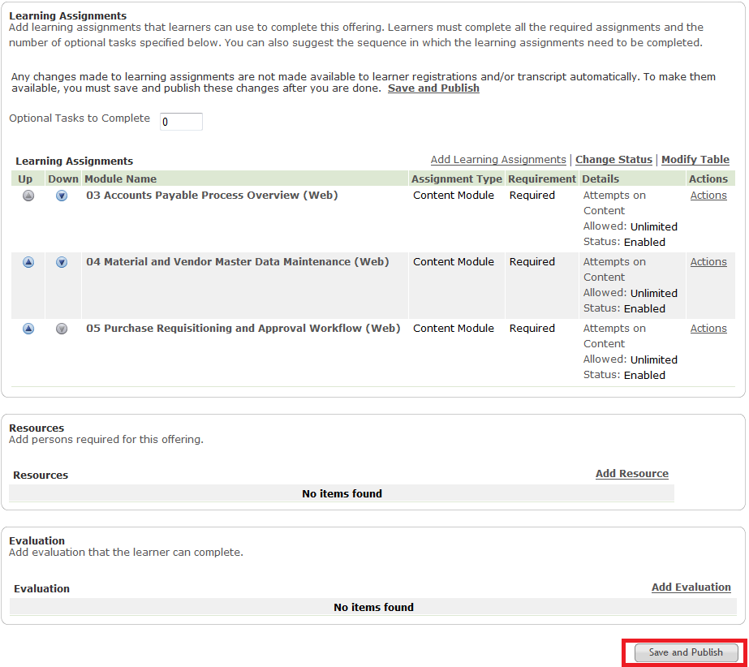

**Figure 21**

A pop-up window will be displayed. If you are creating a new offering, not modifying an existing offering, click the Save button; otherwise, select an option, then click the Save button.

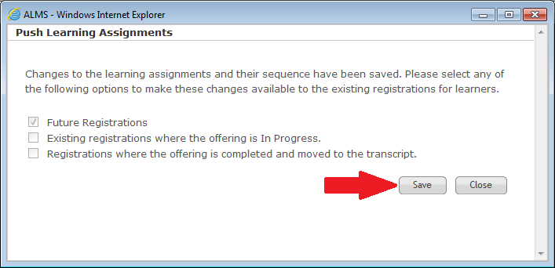

**Figure 22**

The Offering Details screen will refresh and your Offering will be saved.

## 3-Section Sequencing

To use “3-section Sequencing” in your Offering, click the check box above the Learning Assignments portlet on the page. If you do not need to use “3-section Sequencing”, leave the box unchecked.

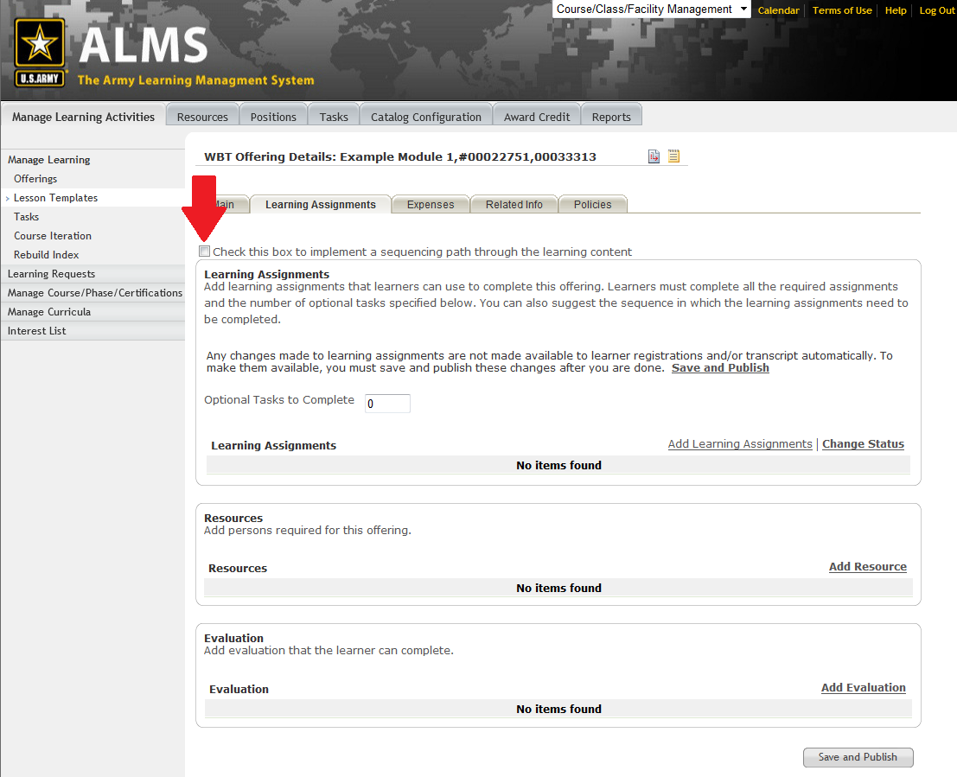

**Figure 23**

After the check box has been clicked, the page refreshes and the Learning Assignments portlet changes. The instructions on the page explain the purpose of each section.

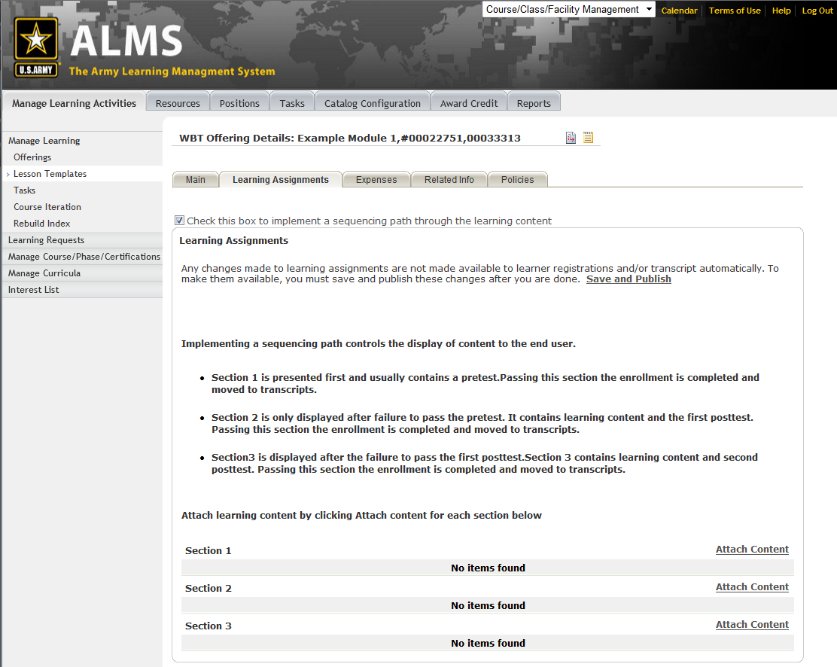

**Figure 24**

Click Attach Content to add exams and content to each section.

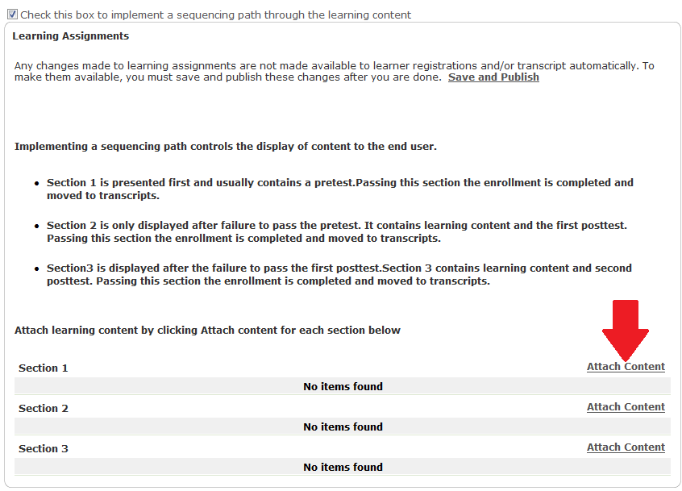

**Figure 25**

Locate your learning content in the content repository either by browsing the Production repository, or by searching by the name of the file.



**Figure 26**

Or

**Figure 27**

On this screen, you identify if the learner will be required to complete the item, and if there is a limit of how many times a learner can launch the item. *NOTE: in the ALMS, launching an item = one attempt.*

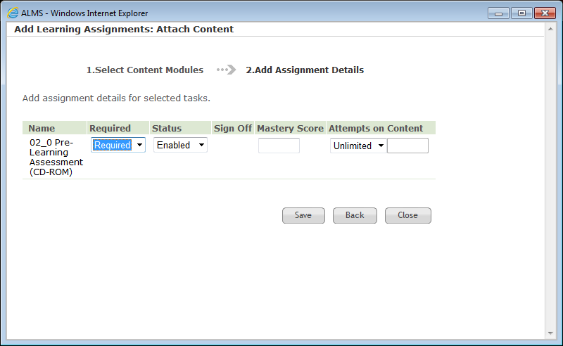

**Figure 28**

To set an attempt limit, select Limited from the drop-down box, and enter a number of allowed attempts. If the default values are applicable, click the Save button.

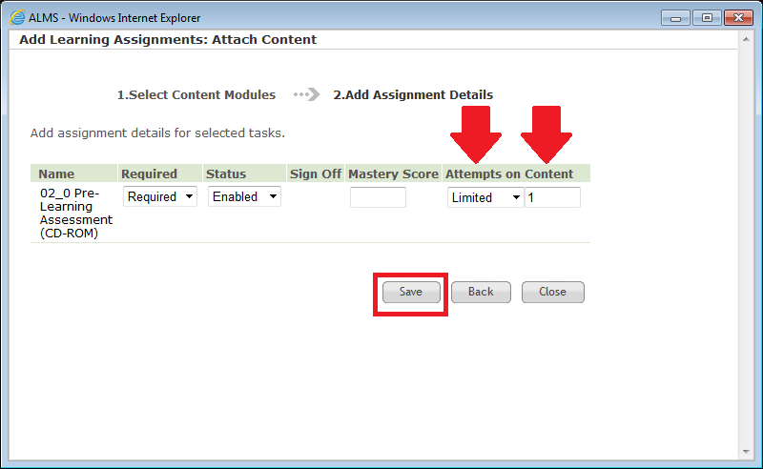

**Figure 29**

The screen will be refreshed and your learning content will be displayed in the section.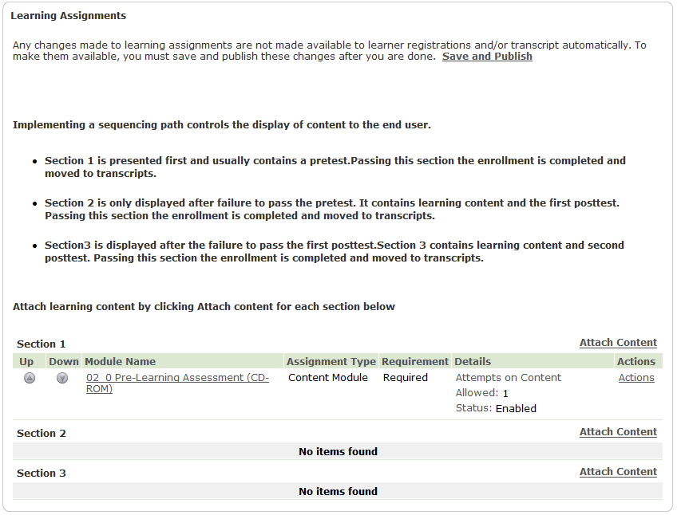

**Figure 30**

Follow the procedure to attach learning content items to the other sections. If you need to change the order of items in a section, use the Up and Down arrows to move items in a section.

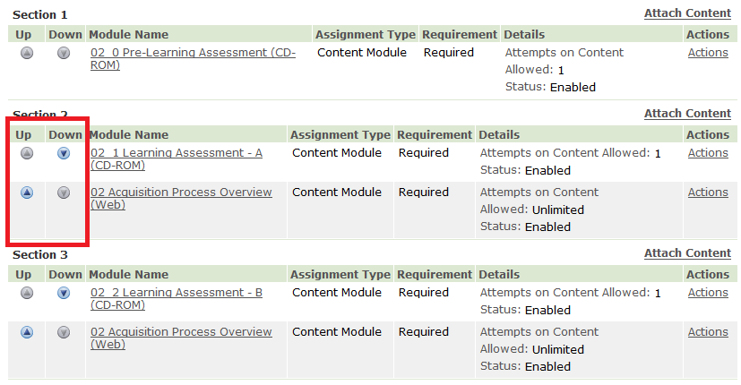

**Figure 31**

If you need to change the assignment details, mouse over the Actions link, and select an item from the callout box.

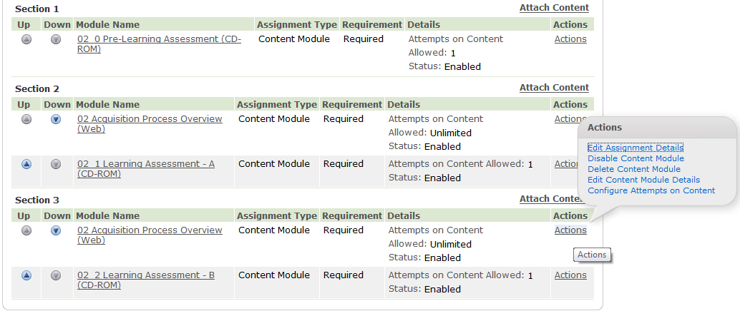

**Figure 32**

When your Offering is completed, scroll to the bottom of the screen and click the Save and Publish button.

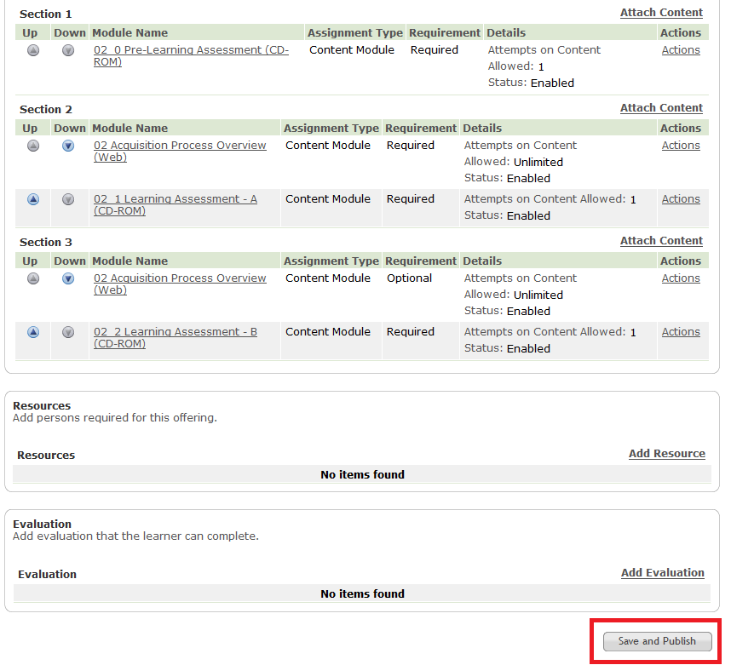

**Figure 33**

A pop-up window will be displayed. If you are creating a new offering, not modifying an existing offering, click the Save button; otherwise, select an option, then click the Save button.



**Figure 34**

The Offering Details screen will refresh and your Offering will be saved.

After you have saved the Offering and Lesson Template, the Lesson Template will look like this: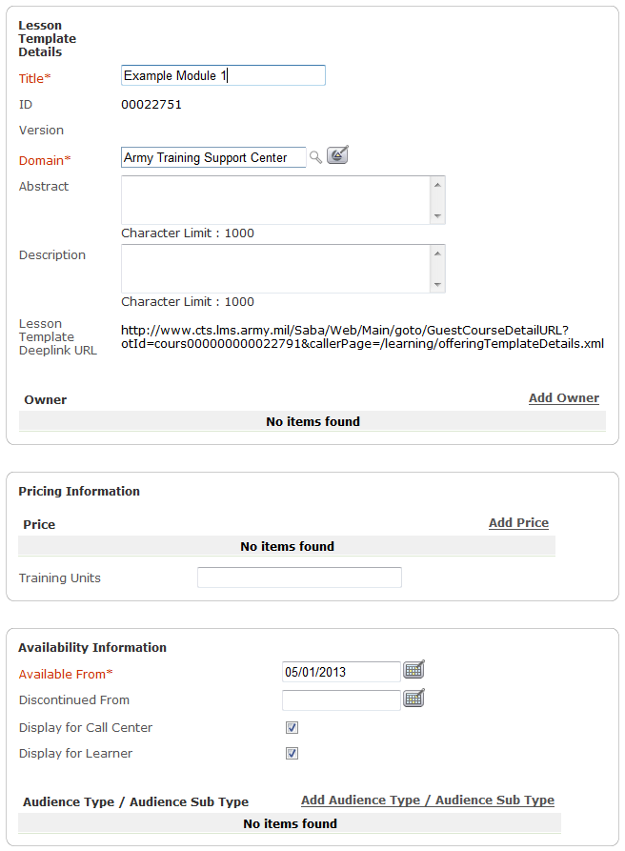

**Figure 35**

If you will be building a Course Iteration using multiple Lesson Templates and Offerings, it is best to uncheck the check boxes for Display for Call Center and Display for Learner. Display for Call Center and Display for Web are checked by default. Display for Call Center makes the Offering visible in the Course Catalog to Registrars. Display For Web makes the Offering visible in the Course Catalog to Learners. Unchecking both item ensures the Registrar or Learner will not be able to register for the individual Offerings instead of the Course Iteration.

# Building a Course Iteration

A Course Iteration is a group of Offerings, and it enables the capability of having a learner register for one catalog item, and automatically registers the learner for all learning content contained in that item.

Select Course Iteration from the sidebar menu.

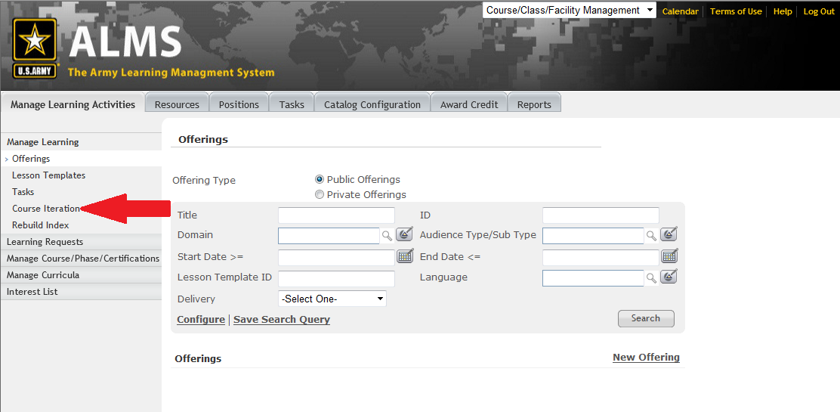

**Figure 36**

Click the New Course Iteration link.

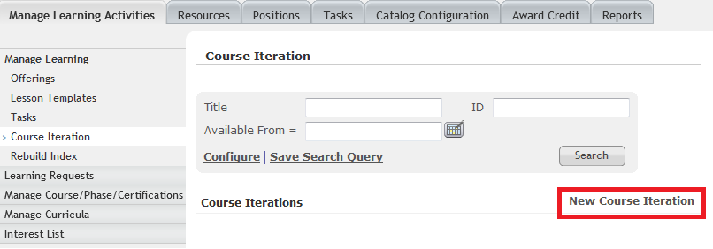

**Figure 37**

The New Course Iteration form will be displayed.

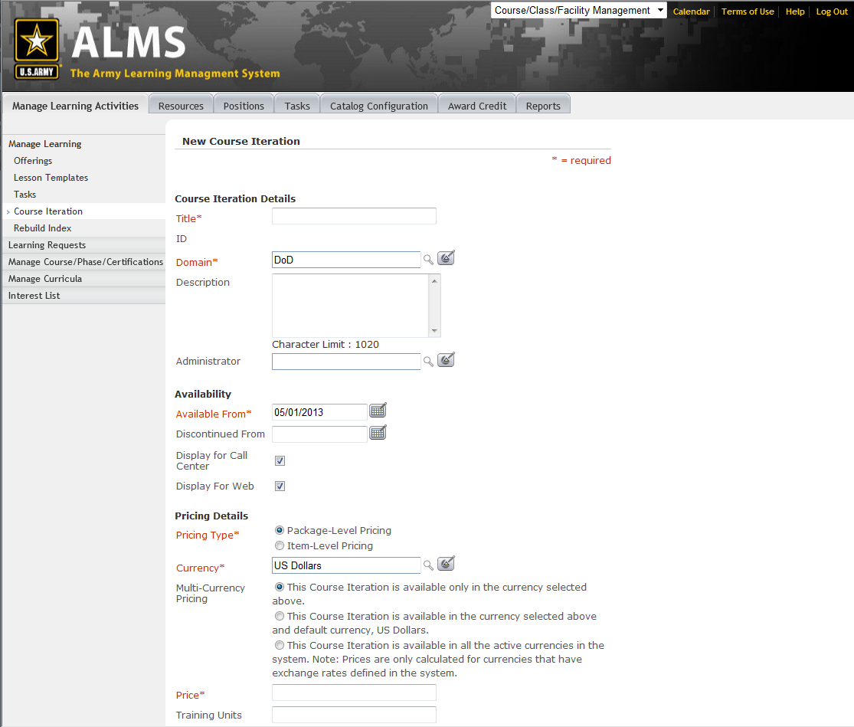

**Figure 38**

Enter a title for your Course Iteration.

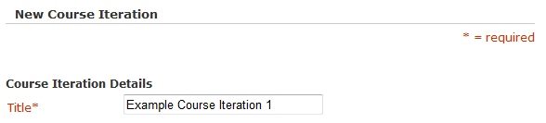

**Figure 39**

Enter part or all the domain name and click the magnifying glass. Click on the domain name in the list to select it. The page will refresh after you make your selection.

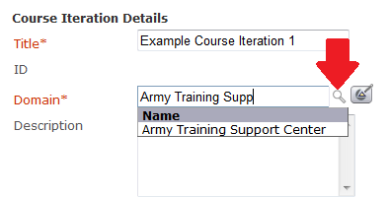

**Figure 40**

If the Course Iteration is not going to be available for learners until a date in the future, enter that date in the Available From field; else, the current date will be entered as the default date.

Display for Call Center and Display for Web are checked by default. Display for Call Center makes the Course Iteration visible in the Course Catalog to Registrars. Display For Web makes the Course Iteration visible in the Course Catalog to Learners.

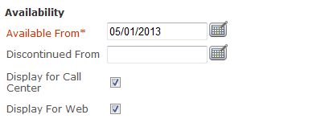

**Figure 41**

In the Price field, enter 0.00.

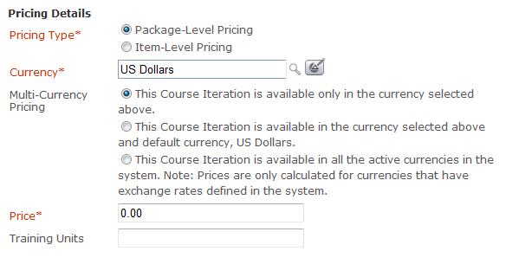

**Figure 42**

Once the information for the Course Iteration has been entered, attach the Offerings to it.

Click the Add Item link to create the links between the Course Iteration and the Offerings.

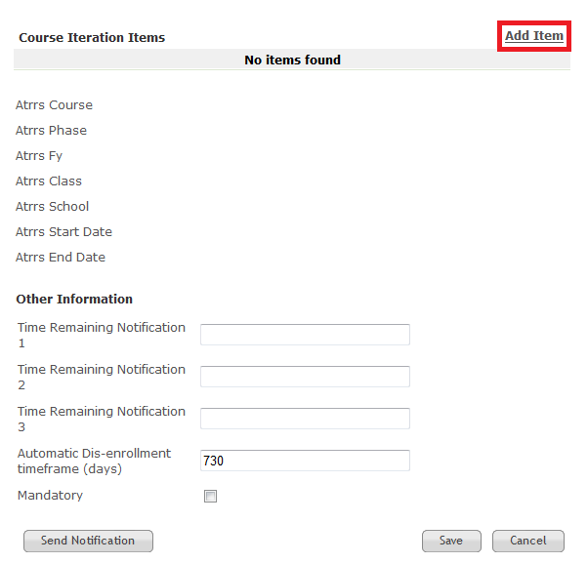

**Figure 43**

A pop-up window will be displayed for adding the Offering to the Course Iteration.

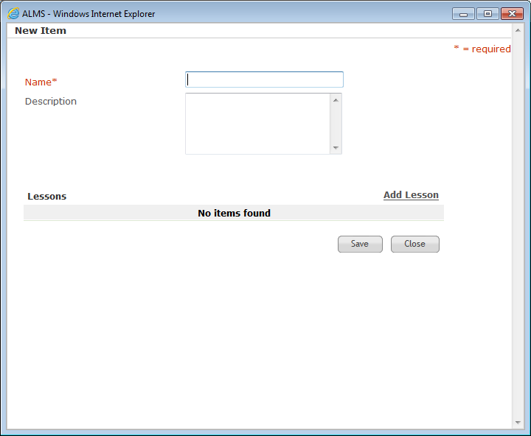

**Figure 44**

In the Name field, enter the name of the Offering you are attaching. This is the name the learner will see on the list of current enrollments.

Click the Add Lesson link to add your Offering.

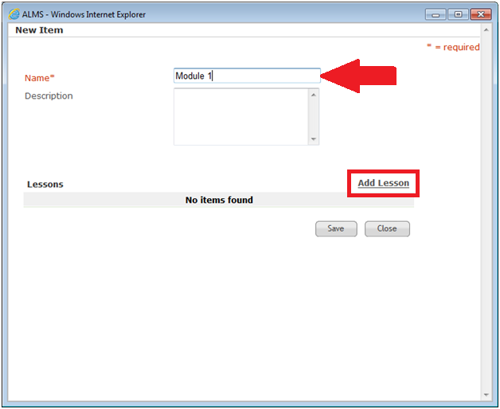

**Figure 45**

An additional pop-up window will be displayed. This window will allow you to search for your Offering.

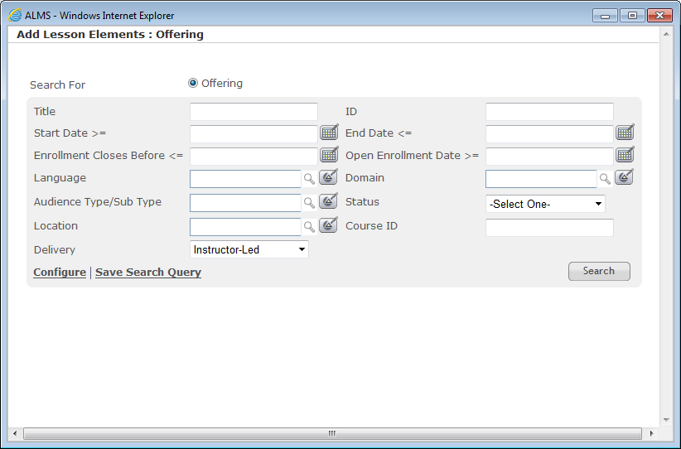

**Figure 46**

Click on the Delivery drop-down and select Web Based Training.

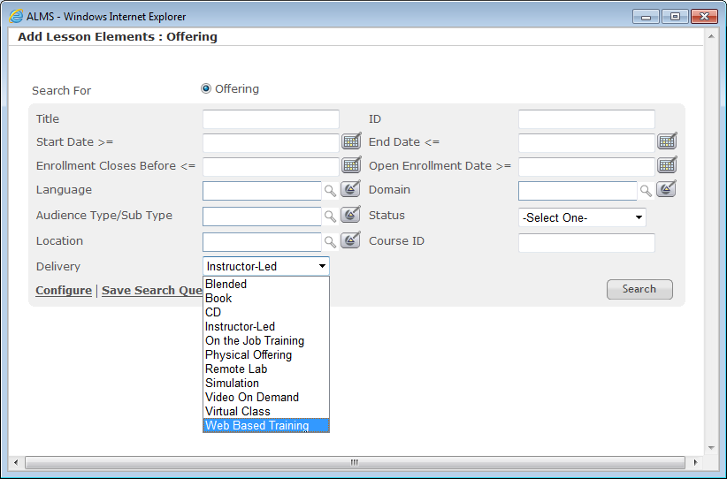

**Figure 47**

The page will refresh and the form will look slightly different.

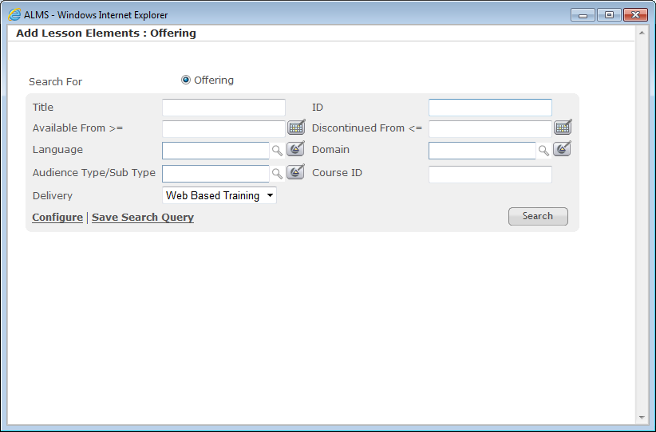

**Figure 48**

Enter your Lesson Template ID in the Course ID field, and click the Search button. *Note: this number is located on the details screen of your Lesson Template.*

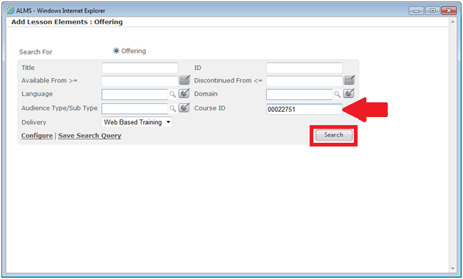

**Figure 49**

The search results will be displayed. Since the search was conducted using a specific ID number, only one item will be returned.

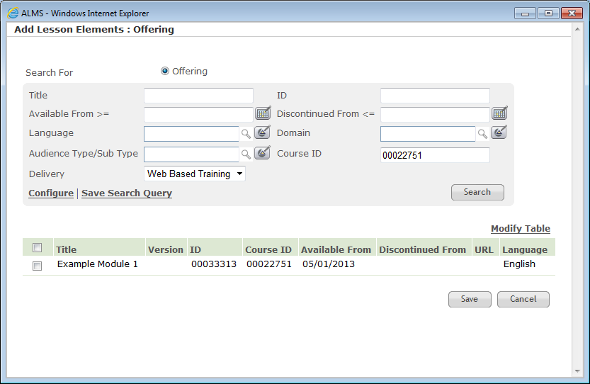

**Figure 50**

Click the check box next to your Offering name, then click the Save button.

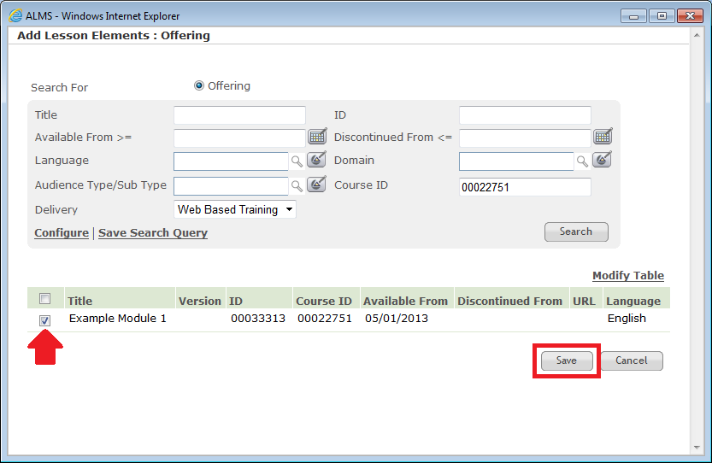

**Figure 51**

The additional pop-up window will close automatically, and the Item Details screen will be refreshed to show the Offering has been added. Click the Save button. *Note: Multiple Offerings can be attached to a single item; however, each Offering must be attached using the Add Lesson link.*

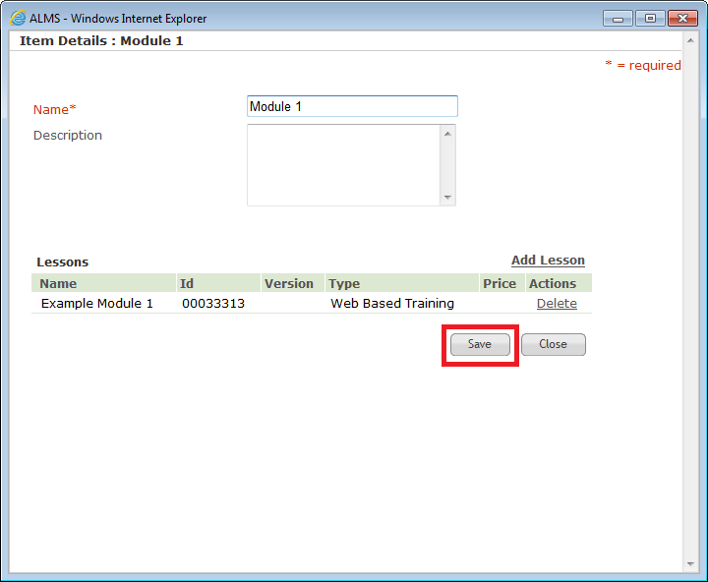

**Figure 52**

When the pop-up window closes, scroll to the bottom of the Course Iteration screen and click the Save button.

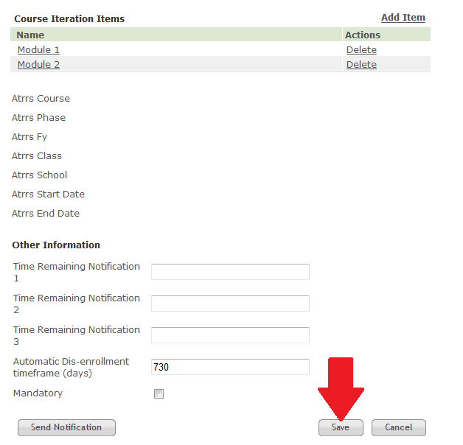

**Figure 53**

The Course Iteration will be visible in the Course Catalog and can be found using the Course Search field on the ALMS CTE homepage.