Instructions for Changing Settings on your Workstation
for the Human Resources Courseware

Launch Internet Explorer.

Click on Tools/Internet Options and the following screen will display:

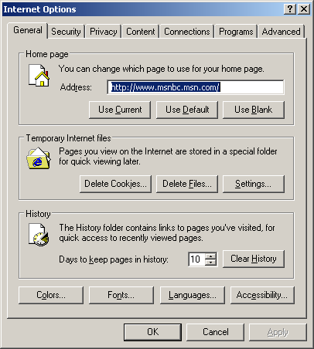

Click on the Security Tab and click on the button "Custom Level". Notice the Internet icon is already selected.

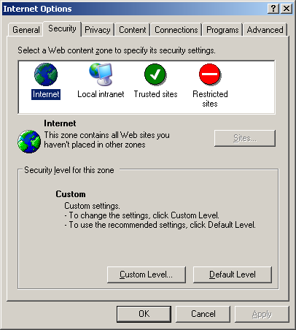

Scroll down to "Active Scripting" and select "enable" and click OK.

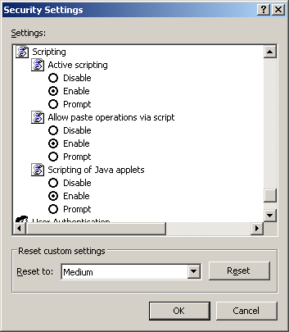

Do the same thing except select "Intranet" at this screen.

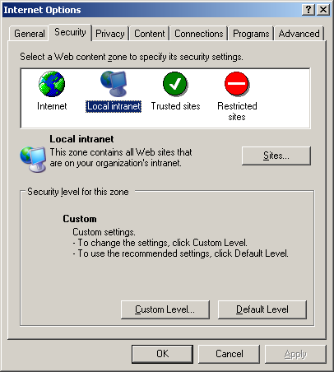

Click on the Advanced Tab and scroll down to the "Security" heading.
Select the first two items—
Allow active content from CDs to run on My Computer and
Allow active content to run in files on my Computer

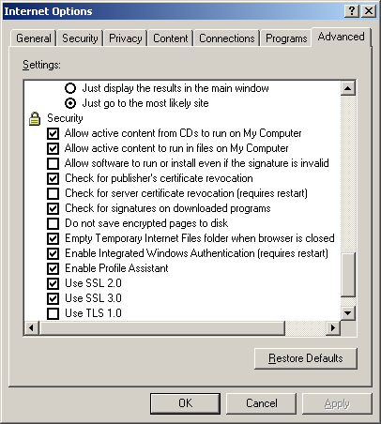

Flash Player Help - Global Security Settings Panel
Change/Verify Macromedia player settings

When running the courseware a “Macromedia Flash Player has stopped a potentially unsafe operation” dialog box appears.

This is a new feature in the Flash 8 Player that is affecting the way some of our courseware works when running from a CD, the local hard drive, or a network drive. It has no affect whatsoever on the courseware running via an LMS or web server. The steps for fixing this issue are listed below. Follow the steps and the courseware will run exactly as it should.

- The Flash object is in the middle of every screen between the title at the top and the navigation buttons at the bottom. Right click on the flash player object and choose settings.

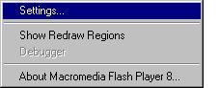

- In the Macromedia Flash Player Setting box privacy tab, choose the Advanced button. (this brings up the Flash Player Help, Settings Manager)

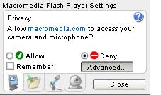

- Select the “Global Security Settings Panel” under the Table of Contents.

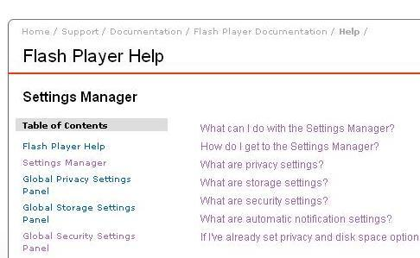

- Select the “Edit Locations…” drop down box and choose “Add Location”

` 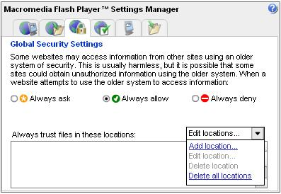

- Choose “Browse for folder….”

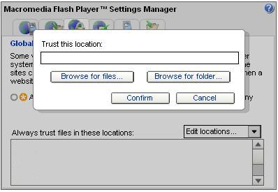

- Select the drive or folder where the courseware resides (CD drive if running from the CD) and choose “OK’

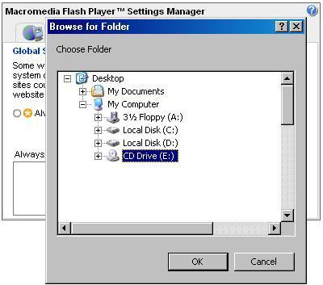

- Restart the courseware and security warning boxes will no longer appear and the courseware will function properly.

