Quick guide to submitting Army DL

Developers must perform steps in sections 1 through 3 below for submission of Army DL for Government acceptance and review:

SCORM Testing Requirements
- (Developers) Proof of SCORM compliance testing (the developer shall determine SCORM requirements according to the Task Order in order to apply the appropriate testing process).

The following tests will be conducted in the order shown below. Only after successfully passing each of these tests shall the developer submit the corresponding log files and the courseware PIF to the Government for compliance and acceptance review.

Required SCORM Compliance Tests by Acceptance Criteria | Deliverables submitted with Initial* “Final Submission Package”
Content Package (CP) Conformance Test  (ADL Test Suite) | Content Package Conformance Logs
SCO Run-Time Environment (RTE) Conformance Test (ADL Test Suite)** | Run-Time Environment Conformance Logs
Army Run Time Validation | Army Multi Log Parser “ParsedOutput.html” file
Army Metadata Validation | Batch Validation “metadataLog.doc” file
Resource Validator | Resource Validator Log File folder
Screenshots captured for all learning paths:  - From CTE for ALMS  - From CVS for Blackboard | Screenshots from the following screens in ALMS CTE:  - Detailed Training Record  - Learning Assignments  - Results by Lesson  - Responses for Exam/Graded Exercise  Blackboard CVS:  - My Grades

*Source files and supporting documentation is not submitted until content passes testing and is accepted by the government.
**The SCO RTE Conformance Test is run as a continuation of the CP Conformance Test, therefore in the remainder of this document, all references to running the ADL test suite Content Package Conformance Test option include running the SCO RTE Conformance Test option

Required Army Final Deliverable Process for submission of each SCORM Content Package:
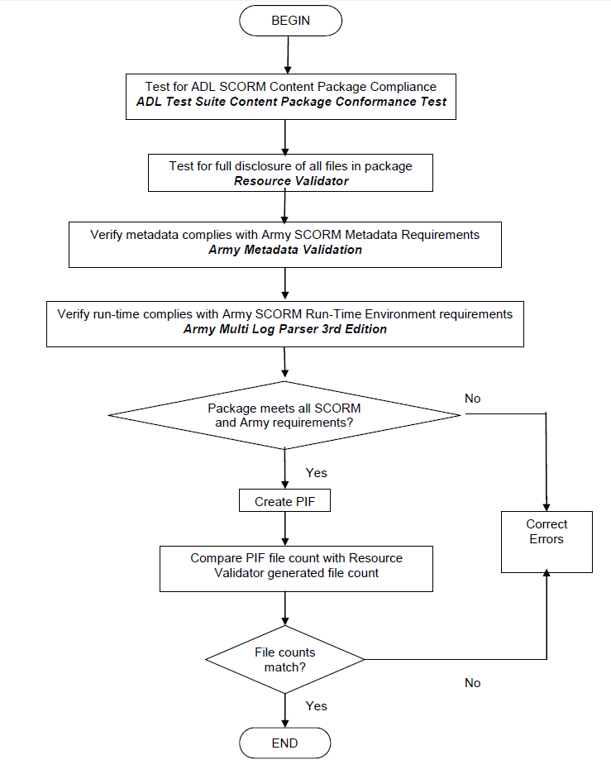

Required SCORM log files

All log files generated by the required tests will be named as follows:

ADL Test Suite Conformance Test Suite log files
  - Zipped into a file with “CP_RTE” in the zip file name.

Army Validate Run Time log file
  - Results from the Army Multi-Log Parser program saved to a file named "ValidateRTE.htm"

Army Validate Metadata log file
  - Results from the Batch Validate test of the Army Metadata Editor saved to a file named "ValidateMD.doc “

Army Resource Validator test program log files
  - Resource Validator log files named "manifest_files_found.html", "manifest_files_missing.html", "packaged_files_found.html", and "packaged_files_missing.html"

- (Developers) Screenshots generated via the Army Learning Management System (ALMS) Content Test Environment (CTE) and the Blackboard Lifelong Learning Center (LLC) Content Validation Server (CVS) showing execution of all instructional strategy paths.

  - LLC
    - Load Content Packages onto CVS and construct entire course to support instructional design of fielded course

    - As a learner, execute all instructional strategy scenarios which lead to course completion, (successful and unsuccessful) by
    - Capturing Blackboard LLC screenshot of “My Grades” for the learner at the lesson and module level
    - Capture LLC screenshots of question interaction items, when available

  - ALMS
    - Load Content Packages onto CTE and construct entire course to support instructional design of fielded course

    - As a learner, execute all instructional strategy scenarios which lead to course completion, successful and unsuccessful and any intentional stalls which require ALMS administrative actions
    - Capture ALMS screenshot of learner progress at course level
    - Capture ALMS screenshots of learner progress at module level
    - Capture ALMS screenshots of learner progress at lesson level
    - Capture ALMS screenshots of question interaction items, when available

Note: Four listed screenshots represent requirements for a single typical path. More or less screenshots may be required by unique instructional strategies, increased or decreased hierarchical depth, and courses with special and unique learner progress requirements.

- (Developers) Verify as complete and accurate: check that all log files are created and named properly; collect and transfer all log files and supporting files to TCM TADLP GAR team (as a submitted deliverable).

Content Development references (with additional guidance and examples)

  - Our TADLP SCORM and content development guidance document, Business Rules and Best Practices (BRBP)
    - http://www.atsc.army.mil/tadlp/contractors/capdl/compliance/scorm.asp

  - The “Business Rules SCORM” link for programmers (helpful information about the Army SCORM Business Rules)
    - http://www.atsc.army.mil/tadlp/contractors/capdl/compliance/scorm_about_business_rules.asp

  - Link to PD-DLS content development guide (with Lectora and Articulate as annexes)
    - https://www.dls.army.mil/ALMS_Standards_Guidelines_and_Best_Practices.pdf

  - Submission requirements for DL hosted on the ALMS (v3.0) and the TADLP “Army acceptance criteria”
    - http://www.atsc.army.mil/tadlp/contractors/capdl/compliance/acceptance_criteria.asp

  - CAPDL Acceptance Criteria for SCORM 2004 3rd Ed testing tools link
    - http://www.atsc.army.mil/tadlp/contractors/capdl/compliance/tools_scorm.asp

  - Tips and guidance for all but the most seasoned SCORM programmers/developers
    - http://www.adlnet.gov/wp-content/uploads/2011/12/SCORM_Users_Guide_for_Programmers.pdf

  - SCORM XML examples
    - http://www.atsc.army.mil/tadlp/contractors/capdl/compliance/scorm_examples.asp

  - ALMS (v3.0) course construction: The individual SCORM packages that collectively provide the content for a course must be loaded into the ALMS V3 repository, assembled into ALMS V3 items and offerings, and in the end aggregated into an ALMS v3 course available for learner consumption. The link below accesses ALMS V3 customized guidance presenting the course administration operations, tasks, and options necessary to construct Army ALMS V3 DL courses.
    - https://atiam.train.army.mil:443/catalog/go/100.ATSC/96D5C208-57B1-4486-8350-BC9E48CB977D-1401213451327

